UAHRA Newsletter
Winter 2015

UAHRA Winter General meeting:Wednesday, January 21, 2015
Meet and Greet at 11:00 a.m., Lunch at 11:30
Spragins Hall Room 109(Varsity Room).

Winter General Meeting

UAHRA will hold its winter general meeting on Wednesday, January 21, at 11:30 a.m. in Room 109 of Spragins Hall. A pot-luck lunch of salads, soups, desserts and drinks will be provided by the Board. Members are also invited to bring a dish of their choosing. In order to insure sufficient serving and dining space, please contact Mary Summerlin (256-536-6214) marylsummerlin@bellsouth.net or Gladys Jones (256-883-6446) GLADYS_JONES@comcast.net to let them know that you will be attending and what you are bringing. If you are bringing food, please arrive no later than 11:15 a.m.

AERA’s two candidates, Jack Bradford (UAB) and Gerald Johnson (Auburn), for the Higher Education position on the AERA Board of Directors, will join us for a “meet and greet” at 11:00 prior to the buffet lunch. They will be formally introduced after lunch.

Jack retired from the University of Alabama at Birmingham in 2001 as the Director of Development and Training. He has served on many boards while at UAB and since that time. Jack was elected to serve as the first UAB Retirees Association President and has repeated that role several times.

Gerald is an Auburn University Emeritus Professor of Political Science (1970-1995) and he also served as Department Head/AssociateDean/ Vice President for Research. He served as the AEA Representative at RSA PEEHIP and Teachers Retirement System Boards.

Ballots will be mailed to all AERA members in January. This is the first time that higher education will have a representative on this critically important board. VOTE!

Following lunch, Jana Seikel, a graduate of UAH with a bachelor’s degree in Communications, will speak. Jana is the Business Development Coordinator for Brookdale Place, Jones Farm. Prior to joining Brookdale, the nation’s largest provider of senior living solutions, she worked for the Huntsville Hospital Foundation and WHNT News 19. Her “Brain Health” presentation will discuss the function of the brain, differentiate between normal symptoms of aging and those of a person with Alzheimer’s disease and offer tips on preventing Alzheimer’s. Jana and her husband, a firefighter for the City of Huntsville, have two sons. She enjoys watching her son, Tyler, play hockey, working in the yard, and outdoor activities.
The UAHRA President’s Message

UAHRA members and their guests enjoyed a very festive holiday party with Bob and Beth Altenkirch at Lowe House on December 10. We thank them for their generous and gracious hospitality, and we wish them both the best for 2015.

Your UAHRA board is planning other events for the coming year, including a box lunch and a tour of the new Charger Union at one of our meetings and a UAH athletics event in the Spring. Your UAHRA newsletter will keep you informed as dates and details are finalized.

A distressing reminder: our retiree benefits continue to be targets for cuts by the legislature. We need to speak with one strong voice to preserve our benefits and support public education. AERA represents you and your interests. If you haven’t joined UAHRA and AERA, or if you haven’t renewed these memberships, please do so now.
Mary Beth Walker

“Everything we do, every thought we’ve ever had, is produced by the human brain. But exactly how it operates remains one of the biggest mysteries, and it seems the more we probe its secrets, the more surprises we find.”
Neil deGrasse Tyson

Community Service Projects

For the January 21 meeeting: Don’t forget to bring items for our three community service projects that were recognized at the April 2012 State-wide AERA meeting and will continue.
And, please let the Board know if you have other projects to suggest.

UAHRA community service projects are:


2000-B Vernon Avenue www.fbofna.org

NEED:
- Canned and nonperishable food items
- Cash donations (Place in fish bowl with designation)

The UAHRA board decided that any undesignated cash will be used for the Secret Meals program administered through the Alabama Credit Unions.

UAHRA contact: Bernard Schroer



West Huntsville Elementary School
3001 9th Ave SW
www.Free-2-Teach.org

NEED:
- School supplies: notebook paper, computer paper, #2 pencils, pens, crayons, washable markers and glue sticks
- Cash donations (Place in fish bowl with designation)

UAHRA contact: Carol Roach



410 Sivley Road S.W. www.hsvfreeclinic.org

NEED:
- Travel sized toiletry items such as shampoos, soap and lotions
- Cash donations (Place in fish bowl with designation)

UAHRA contact: Reet Henze

We Welcome New Members!

If you know UAH retirees who are not members, encourage them to join. If you are a new retiree, please consider joining.

An organization such as ours always needs new ideas, helping hands and the strength that our mutual past brings. Please complete the “Member Information Form” included with this newsletter and mail it along with your check made payable to UAHRA to:

Office of University Advancement
315 Shelbie King Hall
Huntsville, AL 35899
ATTN: Eileen Farris
Our membership year runs from January 1 – December 31.
Minutes, October 8, 2014
Fall General Meeting
A Wellness Clinic with nurses from the Public Health Department was set up in the Raquetball Court and free wellness checks and flu shots were
given beginning at 10:30. PEEHIP provides the services for all their retired enrollees.
Following lunch and a social time the meeting was called to order by Board President Mary Beth Walker at 12:00.
Mary Beth welcomed everyone and introduced new members. She welcomed Mike Ball, Huntsville representative to the Alabama Legislature. She described the support that the Office of Advancement gives to UAHRA through its representative, Eileen Farris. She asked Eileen to stand and presented flowers and a gift certificate in appreciation for all she does. Approximately 40 people attended.
UAH President, Dr. Robert Altenkirch, was the speaker. He gave a very informative overview of changes and progress of UAH. A new building will replace Madison Hall at the main entrance on Sparkman Drive. Student Services are to be located on the first floor. Administrative offices will be on the second floor. Roberts Concert Hall has been renovated extensively and provides a better venue for music and theater. A new UAH entrance is located on University Drive in front of University Place School which is now owned by UAH. That facility will be used by the new College of Education. Changes in curriculum were described that will enhance student enrollment and address current needs. The new addition to the College of Nursing is almost complete and an Honors College has been established. The College of Science curriculum will address wider issues in computer science such as cyber security. Lacrosse teams for men and women will be added to Athletics. Lacrosse players will use existing facilities.
A Q&A period concluded the talk.
After Dr. Altenkirch’s presentation, the results of the Silent Auction were announced. The auction raised $434 from donated items. The money will go to the UAHRA Scholarship Fund. The donors and bidders were thanked for their participation.
Mary Beth called a short Business Meeting to order.
Old Business: The minutes of the May General Meeting which were printed in the Newsletter were approved. The Treasurer’s Report showed a balance of $5,359,04 and was approved. Our philanthropy projects were successful with generous donations to the Food Pantry, Free to Teach and the Free Clinic.
New Business: Mary Beth distributed information on the upcoming theater event, How to Succeed in Business
Without Really Trying, and asked for ideas for future programs and activities. She spoke of the January AERA election. Higher Education candidates for the AERA Board will be on the ballot for the first time. She concluded by reminding everyone to complete the AERA membership form so that Sheila Scruggs can have current addresses, phone numbers and emails.
The meeting was adjourned at 1:00 p.m.

Respectfully Submitted,
Vella Dailey, Secretary

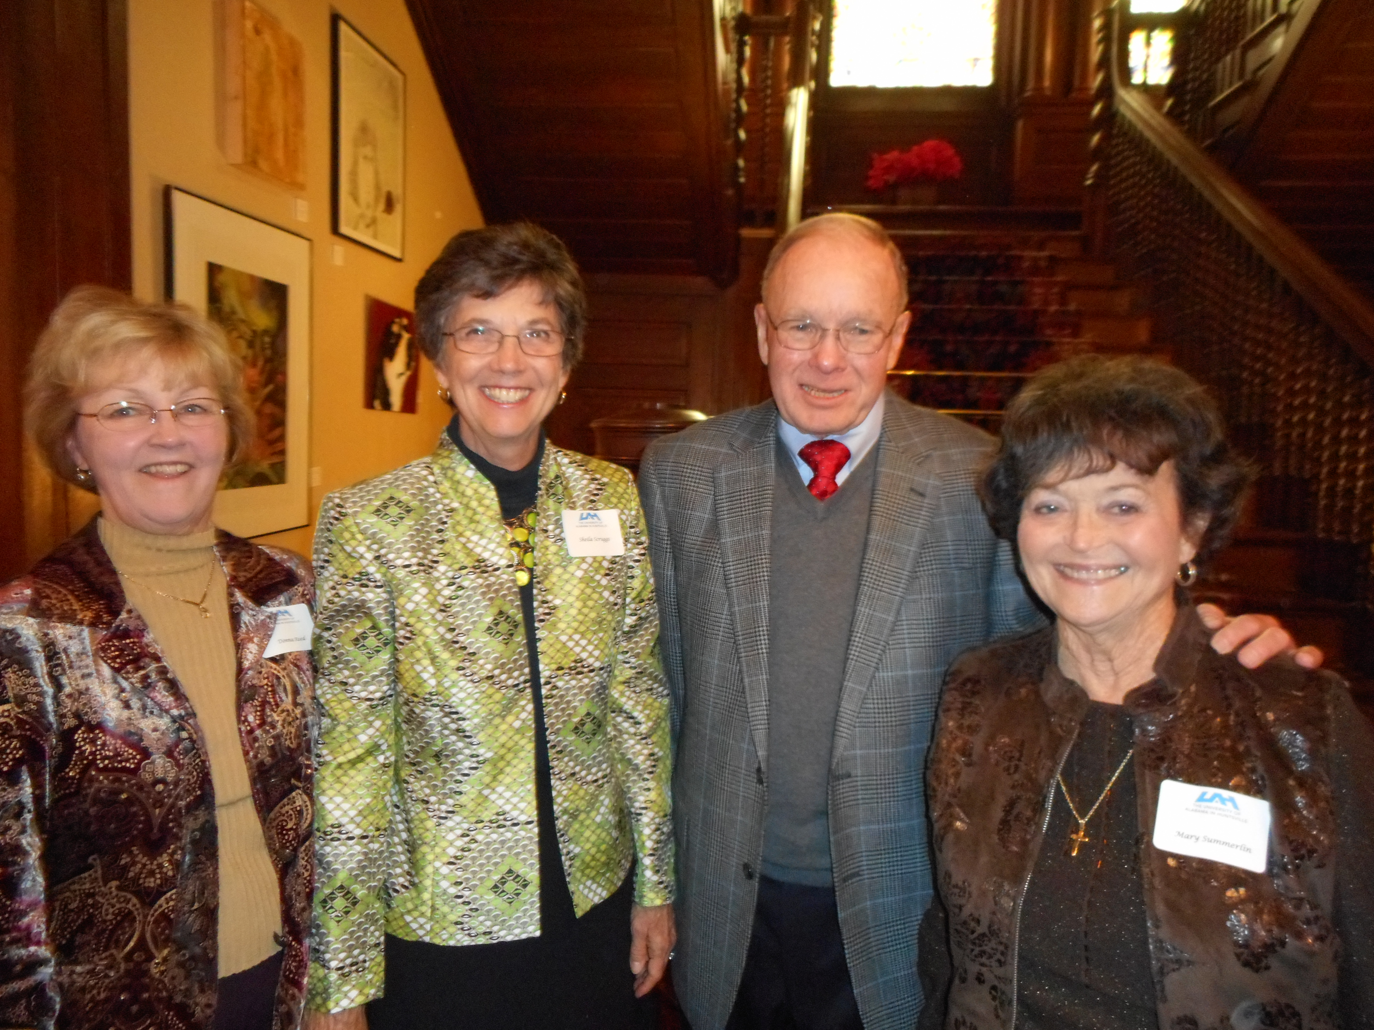
UAHRA Board Members Donna Reed, Sheila Scruggs, Dave Brown, and Mary Summerlin at the UAHRA holiday party at Lowe House on December 10, 2014.
.
Our Own UAHRA Chair
The Board voted to raise money for the “Take a Seat” initiative for the College of Liberal Arts. The goal is to raise $1,000 to name a UAHRA “chair” in the newly renovated Roberts Recital Hall by the May meeting. Details will follow.

IN MEMORIAM
The following colleagues have recently passed away.
Josette Traylor – College of Liberal Arts
Myla Alm – Office of the VP for Research

