UAHRA Newsletter

Winter 2008/2009

UAHRA January Meeting

The first general meeting of 2009 will be Wednesday, January 14, at 11:30 a.m. The meeting will be held in the Hospitality Room of Spragins Hall. There is a handicap parking lot on the west side of the building (enter at the top of the hill across from Roberts Hall). A soup/salad/dessert lunch will be provided by the Board of Directors.

Our guest speaker will be Dr. Vistasp Karbhari, UAHuntsville Provost and Vice President of Academic Affairs. To assist with food planning, please let Faye Hartman (hartmanf@uah.edu or 824-6982) know if you will be coming.

If any non-Board members wish to bring salad or dessert to the meeting, it will be welcomed. You could coordinate with Vella Dailey at daileyv@uah.edu to see what has been committed.

UAHRA Scholarship

If you wish to contribute to the UAHRA scholarship, your check should be made to the “UAHuntsville Foundation” with “UAHRA Scholarship” on the “for” line. This will insure that the funds are credited to our scholarship and that you receive an acknowledgement for tax purposes. Checks can be given to the UAHRA Treasurer at meetings or sent to the Foundation office at: UAHuntsville Office of Advancement, Suite 300 Shelbie King Hall, Huntsville, AL 35899.

UAHRA in the Community

The UAHRA was invited to submit a poster for the Ernst Stuhlinger Symposium which was sponsored by the UAH Salmon Library and held at UAHuntsville on November 18.

A big “thank you” to one of our newest members, Anne Coleman, for preparing the UAHRA poster which saluted Dr. Stuhlinger’s work at UAH as a professor and researcher.

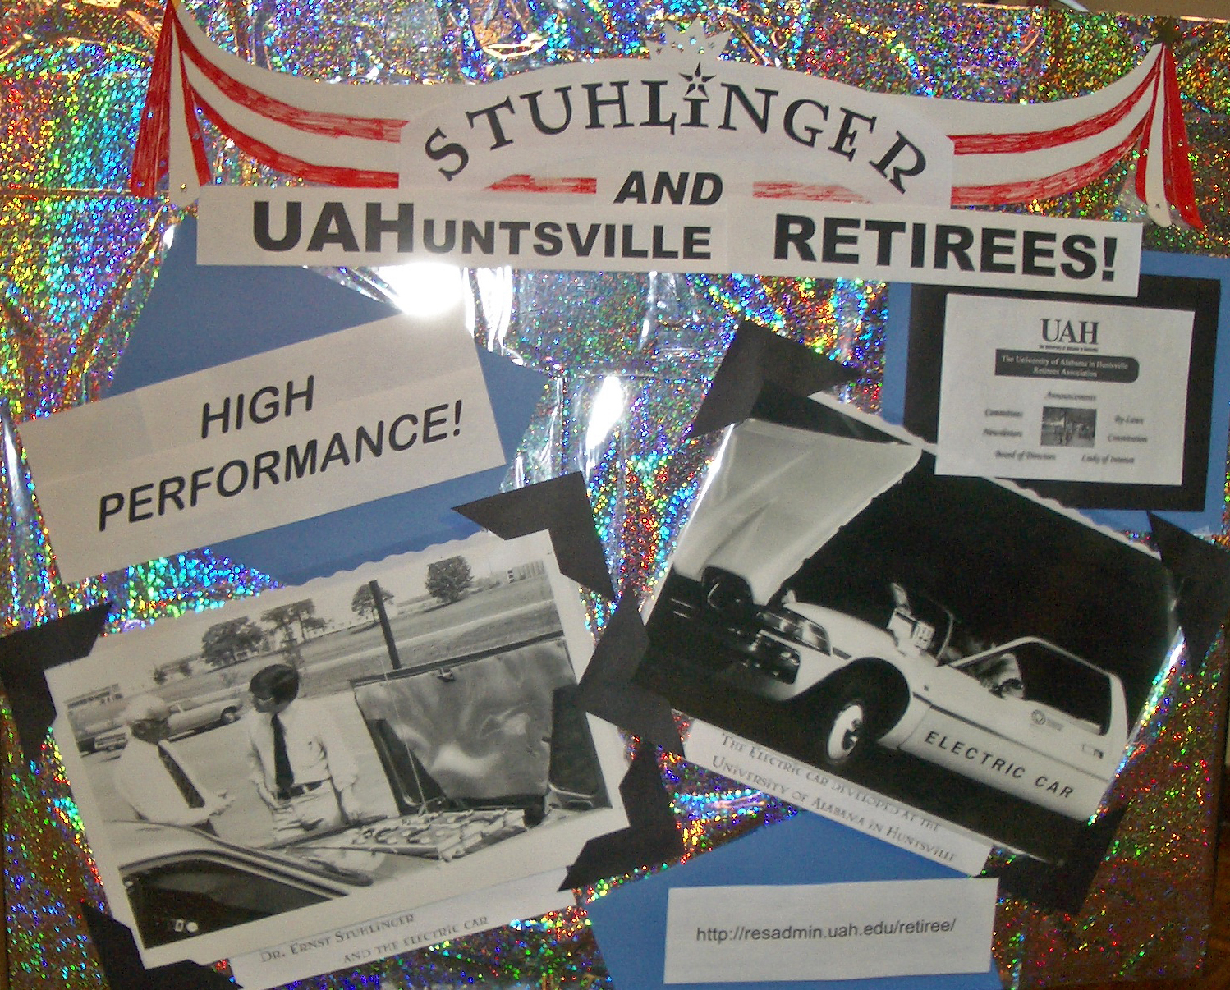

UAHRA is Growing!

Our retirees’ association now has
120 members! We hope to keep growing so if you know any eligible person who is not a member, please invite them to the January general meeting. Checks should be made to “UAH Retirees’ Association” or “UAHRA” and sent to Faye Hartman, c/o Office of the President, Room 370 Shelbie King Hall, UAH, Huntsville, AL 35899. You can also give dues to Joan Williamson, Treasurer, at the meeting. The dues are determined by your membership category and categories can change from year to year as circumstance or preference dictate:

UAH Retiree $10.00
UAH Retiree & Spouse (both UAH retirees) $15.00
UAH Retiree & Non-UAH Retired Spouse $17.50
UAH Retiree & non-retired Spouse $20.00
Surviving spouse of UAH retiree $10.00
Other individual applicants (as approved by the Board) $20.00
Associate Member (UAH employee within 5 years of retirement eligibility) $10.00

2009 Dues

Our organization operates on a calendar year which means our 2009 dues are payable between January 1-March 31. If you haven’t paid by the end of March, you will not be eligible to vote in the election of new Board members in April.

Board Elections

Three members who have served for three years will be rotating off the Board at the May general meeting. Prior to that time, the Board President will appoint a nominating committee and ballots will be sent to all members.

If the nominating committee asks you to consider a spot on the ballot, please agree. No Board position is burdensome but it does take a degree of time and commitment. There is usually a monthly meeting and there may be tasks assigned at those meetings or committee appointments.

An organization is as strong as the willingness of its members to work to support and promote the aims and goals of the organization. It takes all of us!

In Remembrance

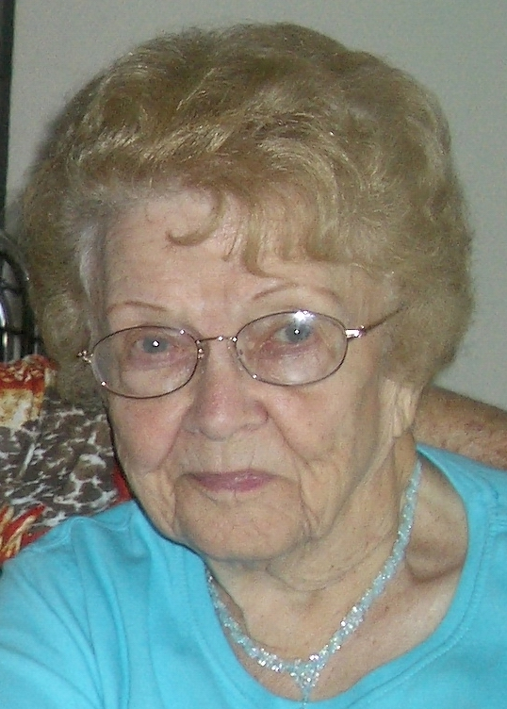
Lynn Cronin, who retired from the (then) Office of Research Administration in 1994, died at her home in Florida in early November. Lynn started working at UAH in the early 1970s after her husband retired from the US Air Force and they settled in Huntsville. One of her main tasks was administering the payroll verification for contract employees. These were called P.R.’s (remember that?) and were predecessors to the PAF/PARs and the BLLRs. Her other main task was to work closely with the Material Control Office under Business Services to insure that the government property inventory was accurate. After retirement Lynn moved to Georgia and then Florida but maintained close contact with her friends in Huntsville and she was a member of UAHRA from it’s inception.

Campus Changes

If you are interested in up-to-date information about campus changes, visit the Office of Facilities and Operations website at http://www.uah.edu. Go to:
Faculty & Staff =>Administration => Facilities => Campus Architect. Within the same site (go to back to Facilities and then Grounds) where you will find an interesting list of all the different types of trees on campus and for those interested in horticultural matters, there is a good resource link.

One of the most notable changes is the new Intermodal Transportation Building at the south west corner of the intersection of Holmes Avenue and John Wright Drive. The Office of Public Safety is now housed in this building.

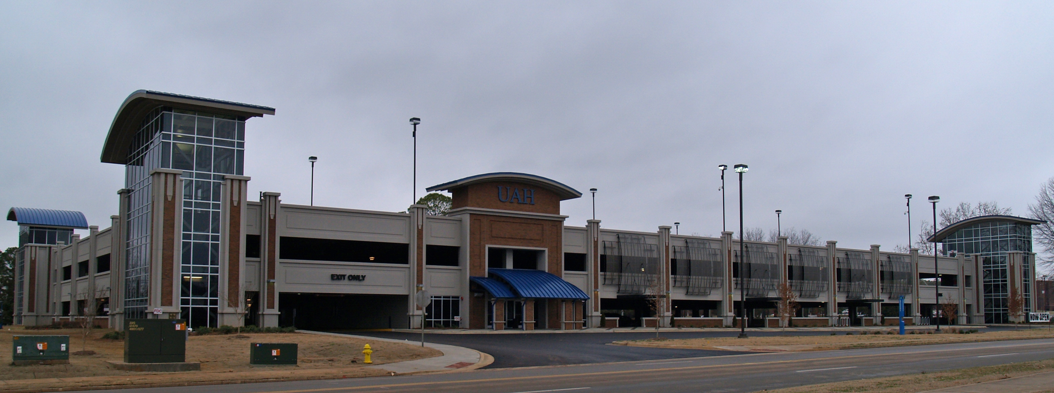

Meet a Board Member

Vella Dailey was elected to the UAHRA Board in May and currently serves as the organization’s Secretary. She was asked for her memories of her time at UAH and advice for those contemplating retirement and answered below:

“I was at UAH first as a student in the history department and received my degree in 1976. I went to work at UAH in the (then) Personnel Office in 1982 and retired in 2007. I was fortunate to work with several people at UAH to whom I owe life-long debts.

The first was Dr. Johanna Shields. She was an inspiration teaching history. Her enthusiasm for the subject kept us on our toes. She taught students ideas and their antecedents, not just dates.

There were several people in Personnel, Human Resources who must be thanked. Gerry Moore was often UAH’s best friend although many did not know it. She worked diligently behind the scenes. Phyllis Hollins worked steadfastly in the background most of the time. The only times I saw her ruffled was when someone was insisting that she be photographed.

Nancy Sutherlin was also a great person to work with. Her credo was, ‘Work like a duck. Look smooth and unruffled above the water but paddle like (the dickens) below.’

I thoroughly enjoy retirement, doing . . . whatever I happen to want to do (or must do) at any given time. Flexibility from the rigors of the workday is what I enjoy most.

Advice for those thinking of retirement? Keep on thinking! Think about the things (make a list of at least 20 things) you enjoy doing. Go to the UAH Benefits Office and talk with them. Anything you say or dates you might be thinking of retiring—will be kept in strictest confidence! No, they do not discuss you among themselves! Faculty and Staff typically call many times just to review their options and do not have to act on them for years. Call the Teachers’ Retirement System of Alabama and talk with them. Look at the TRSA website and do ‘what if’ calculations for yourself.

Thinking about retirement is the hard part. Retirement is great!”

UAHRA Webpage

Information about UAHRA (constitution, by-laws, current board members and officers), past information (newsletters) and announcements of future meetings can be found at the UAHRA Webpage. Go to the UAH homepage: http://www.uah.edu and then click on “Visitor” and “UAH Retirees Association”.

How’s Your Memory?

Anne Coleman, in the UAH Salmon Library Archives, has a box of unidentified photographs of UAH employees. If you have a few hours to give, have a good recall of names and faces and want to take a trip down Memory Lane, give Anne a call at 824-6523 to set up a time to visit the Library Archives on the lower level.

Minutes

Minutes of the last general meeting in October are attached. Please review and, if you have any corrections or discussion, let us know at the January meeting.

Did You Know . . . ?

Did you know that UAHuntsville now has a theater program and stages performances several times a year? The next two programs scheduled are:

Little Shop of Horrors (musical)

7:30 p.m. Feb. 26, 27, 28, March 5, 6 7, 2:30 p.m. February 29
5:30 p.m. March 4.
All performances are in Chan Auditorium. Call 824-6909 for ticket information.

Couples Counseling Killed Katie (back by popular demand)

5:30 p.m. April 8 and April 10
7:30 p.m. April 9 and 10.
All performances are in Morton Hall Studio 106.
Call 824-6909 for ticket information.

