UAHRA Newsletter

Winter 2008

UAHRA January Meeting

The next general meeting of the UAHRA will be Wednesday, January 23, 2008 at 11:30 a.m. The meeting will be held in the Hospitality Room (109) of Spragins Hall and a soup and salad (and dessert) lunch will be provided by the Board of Directors. Our guest speaker will be Dr. David Williams, UAHuntsville’s new President. A handicapped accessible entrance parking lot is on the west side of the building. To assist with food planning, please let Faye Hartman (824-6982 or hartmanf@uah.edu) know if you will be coming.

President’s Message

The University of Alabama in Huntsville Retirees’ Association (UAHRA) will soon complete its third year as an organization. The major purpose of the organization is to support the ongoing operations of the University and to assist UAHuntsville retirees by informing the University Administration and the public about issues and concerns of retirees. The UAHRA is one of 81 local units that comprise the Alabama Education Retirees Association (AERA) which is the statewide organization that serves as the voice for all Alabama education retirees. Membership in AERA is separate from membership in UAHRA. According to the last information received, AERA has 24,268 members out of the approximately 62,000 people receiving monthly checks through the Teachers Retirement System (TRS). Of the 24,268 AERA members, 76 are retirees from UAH. It is AERA that works with the Governor’s Office, the State Legislature, AEA, and TRS to secure Cost of Living Adjustments (COLA’s) and minimizing the cost of PEEHIP coverage for retirees. AERA currently has an ad hoc COLA committee that is studying the COLA situation and meeting with the TRS staff and a TRS actuary to formulate a plan that will, hopefully, provide future COLA’s. The AERA Annual Meeting will be held at the Cahaba Grand Conference Center in Birmingham on Tuesday, March 18, 2008. Each local unit is allowed a certain number of voting delegates to the annual meeting based on the number of retirees that belong to AERA. The total number of delegates eligible to attend the meeting is 589 and the UAHRA is entitled to three delegates.

UAHRA membership dues for 2008 can be paid at the January 23rd meeting. These dues are payable on February 1 and should be paid no later than April 1. I encourage all current members to plan on attending the meeting and to bring other UAH retirees that are not currently members of UAHRA. Copies of the UAH 2007-08 Telephone Directory, one of the benefits to members, will be available at the meeting. Copies will be mailed to those members who are not able to attend the meeting. We hope to have a large crowd as President Dave Williams will be the guest speaker.

As previously reported, the Board of Directors has worked with April Harris, Director of University Relations, to establish a Retirees section in the Alumni Commemorative Pavers located in front of Salmon Library. I would like to encourage each of your to consider purchasing one of the pavers. The cost of the pavers is tax-deductible as a charity contribution.

I look forward to seeing each of you at the meeting on January 23rd.

Dave Brown
UAHRA Board President

UAHRA Scholarship Recipient

A $500 scholarship provided by UAHRA has been awarded to Gregory Lamar Barnett for the 2007-08 school year. Mr. Barnett is a senior majoring in Mechanical Engineering.

Bring a Potential New Member to the January 23rd Meeting

Please consider bringing a potential new member to the January general meeting. Checks should be made to “UAH Retirees’ Association” or “UAHRA” and sent to Faye Hartman, Office of the President, Room 118 Madison Hall, UAH, Huntsville, AL 35899. You can also give dues to Joan Williamson, Treasurer, at the meeting. The dues are determined by your membership category and categories can change from year to year as circumstance or preference dictate:

UAH Retiree $10.00
UAH Retiree & Spouse (both UAH retirees) $15.00
UAH Retiree & Non-UAH Retired Spouse $17.50
UAH Retiree & non-retired Spouse $20.00
Surviving spouse of UAH retiree $10.00
Other individual applicants (as approved by the Board) $20.00
Associate Member (UAH employee within 5 years of retirement eligibility) $10.00

Nomination and Election of
New Board Members

A nominating committee will be appointed in the next few months and ballots will be sent to the general membership to elect individuals to replace the three out-going Board members. If you are approached by the nominating committee, please consider volunteering to serve as a UAHRA Board Member. It does not take a great amount of time and the association needs the support of all of its members to continue to grow and be a worthwhile organization supporting UAH Retirees.

In Remembrance

The University and this organiza-tion were saddened by the recent loss of two long time University employees, Dr. Benjamin B. Graves and Dr. Aldo Forte.

Dr. Graves, who passed away on October 19th, was the first president of The University of Alabama in Huntsville, serving from 1969 to 1978. In addition to this position, he served as a professor of business administration at UAHuntsville from 1971 to 1999 and, following his UAHuntsville retirement, he made many contributions of time and talent to local civic causes.

Dr. Aldo Forte retired from UAHuntsville in 1991 after serving as a professor of mathematics for over twenty-five years. He continued teaching mathematics as a professor emeritus until 2004 and indulged his interest in guitar making and playing classical guitar in his free time. He passed away in Huntsville on November 20th.

Know the Facts and Get Involved

In matters that sometimes seem large, complicated and beyond our control (such as government, medical matters and pension issues) it is easy to become complacent and let someone else handle it. This leaves us with little to do but worry and complain. The “over sixty” segment of the US population is a tremendous, yet underutilized, political force. It’s time to start flexing our political muscles.

You owe it to yourself and future generations, to educate yourself about matters that affect you and to become personally involved in bringing about changes that will positively affect your life. While we all would like annual Cost of Living Adjustments in our pension distribution, there are some hard facts that we need to recognize. Please read the January 2008 front page article “Retiree ‘Push Back’ ” in the RSA Advisor.

Zostavax® Now Covered Under PEEHIP

Zostavax®, the single dose vac-cine for prevention of shingles in patients over sixty, is now covered under PEEHIP. Members would be required to meet a 50% co-pay. This vaccine is covered under both the medical and prescription plans of PEEHIP policies.

Zostavax® must be administered within ½ hour of removal from storage. Physicians are the usual source of the vaccine but some pharmacists within the state are authorized to administer the vaccine. A list of Alabama pharmacists approved to administer the vaccine and additional information about the vaccine and the PEEHIP coverage can be found on the AERA website at: http://www.aerainc.org and then go to “current news”.

Board of Directors

Dave Brown (Facilities & Operations) – President
Steve Bruce (University Center) – ex officio Board member
Sam Campbell (Biological Sciences) -- Secretary
Lee Cook (Mathematics)
Graeme Duthie (Physics)
Gladys Jones (Research Security & Immigration)
Carol A. Roach (Communication Arts) – Vice President
Val Seaquist (Sponsored Programs)
Nancy Sutherlin – Human Resources/ Benefits
Joan Williamson (Nursing) – Treasurer

Meet Some of Your Board Members

Joan Williamson retired from UAH’s College of Nursing in 2007 after thirty-four years. When asked to share a particular memory from this time her comment was, “The most enjoyable time for me was working with incredible folks on the Faculty and Staff Chill-out where we had legislators (remember the year the governor came?), cooked hotdogs and gave out prizes. I think we helped to change the way the legislature thinks about universities in general and UAH in particular. I can still see Lloyd Hillman with his ‘Will Teach for Food’ tee-shirt.”

Since retiring, Joan has found great enjoyment in traveling, reading more and sleeping late. Her advice to anyone contemplating retirement is “When you retire, stay away at least one semester before your teach or work part-time. The semester after I retired, it cost me more than I made to teach here!”

Sam Campbell retired from UAH after thirty years in the Biological Sciences Department. He served as Department Chairman for the last eleven of those years.

He enjoys having time now for reading and belongs to an evening book club. He also enjoys lunch with friends and Saturday morning breakfast at Mullins to have roundtable discussions of all topics with two retired friends. Future plans include more traveling and playing around with digital photography.

His advice to those contemplating retirement is to not be afraid to step into the water because “everyone I know who is retired thinks it’s wonderful.”

Carol Roach retired from UAH in 1993 after 25 years in the English and Communication Arts Departments: “I was hired as a member of the English Department to teach the speech courses required of teachers at that time. Later, we developed a minor in Communication Arts and then a major. I retired as Chairman of Communication Arts.” She also taught for ten years in UAH’s Professional Development Program following retirement.

Two people regarded as her professional mentors were Dr. Frances Roberts and Dr. Robert Welker. “Dr. Roberts told me I had to join the American Association of University Women and Dr. Welker told me I had to join the newly formed Huntsville Literary Association. I have been an active member of both organizations for forty years.”

Carol keeps busy volunteering for several community organizations, acting as historian for her family and running her small company, Ashburn Roach Consulting. Her advice is to “spend time with people whose eyes light up when you enter the room.”

Gladys Jones first came to work at UAH in 1967 (back then she worked for the University of Alabama Extension Center in the Division of Natural Science and Mathematics) as Dr. Ben Graves’ assistant. In March 1972 she was the second UAH employee to take the “new” maternity leave benefit. IN 1981 she returned to UAH as Administrative Assistant to Dr. Ken Thompson who was Director of Contracts and Grants and Special Services. She took over for the Security Assistant when she left and after Dr. Charles Lundquist became her supervisor, she became Security Officer. The position grew into Administrator of the Office of Security and Immigration Administration and Gladys retired in 2003. In early 2007, she began working part time in the new International Students and Scholars Office in Enrollment Services.

Two important memories stand out: The two individuals having the greatest impact on her career were Drs. Lundquist and Graves who encouraged staff members to grow, take responsibility and mature in their careers. The second memory is the fact that she has been able to work for four UAH presidents as well as working with Dr. Joe Dowdle and Jerry Quick to finally secure a site for an on-campus building to house the Alabama Credit Union which has been a great benefit to the campus and the community.

Retirement time is spent with Gladys’s retired husband, Charlie, and family, friends, church and travel. Her oldest son and daughter-in-law live in Pulaski, TN, where Gladys and Charlie have a small cattle farm with their sons. Their youngest son and daughter-in-law in Louisiana have enhanced Gladys’ retirement with her first grandchild and a second is expected in the summer.

Gladys advises UAH employees contemplating retire to talk with former co-workers in our organization to get an idea of things that did and didn’t work for them as outlined in all the brochures, literature, etc., and, as always, you will have a degree of “learning as you go.” Gladys, one of the founders of the UAHRA, has served as Secretary and as Treasurer of the Board and her three-year Board term expires this year.

Val Seaquist started her UAH employment in the summer of 1975 as a receptionist in the U.S. Department of Transportation Auto Check project. Over the next few years she worked in several departments connected with solar energy research in the (then) Johnson Environmental and Energy Center. When a funded projected ended in 1981, she returned to school to finish her BA degrees in history and, on graduating, was hired in the Office of Research Administration (now Office of Sponsored Programs) where she worked for twenty years, the last four as Director of the office.

“I’ve been fortunate to have several influential mentors but would have to cite Dr. Charles Lundquist as the most memorable. His patience, trust and encouragement were invaluable and my take on his life philosophy “Life is a Great Adventure” has been applied to all areas of my life—and the adventure continues in retirement. UAH provided the opportunity to meet so many wonderful people and to travel to some interesting places.”

“Retirement has turned out much better than I imagined. I envisioned that without the structure of work my life would degenerate to that of a strange little thirty-cat bag lady and have been pleased (probably not nearly as pleased as my husband) to be heading into completion of my fourth year of retirement with only one cat and no sign of a bag. I haven’t finished one thing on my “Things To Do When I Retire” list but have found so many other interests that I’m surprised how quickly the time passes.”

My advice to future retirees? “Take particular care with your health; it will influence your capability to live your dreams and enjoy retirement to the fullest. Plan to give something back to UAH or society in general because we receive so many gifts along the way from the experiences of others; it’s our turn now. Look forward to retirement, not as an “escape from” but a “moving toward” something new and exciting—it really is a Great Adventure. Lastly, learn to accommodate change because nothing will go exactly as planned.”

Campus Changes

If you haven’t been on campus lately, there is one word for what you will see: changes. The University has a new main entrance on Sparkman Drive. It is a lovely “formal” entrance with the new expanded lake on both sides. After entering campus, the immediately noticeable change is the new Shelby Applied Sciences Building which houses most of the University’s science classrooms and laboratories.

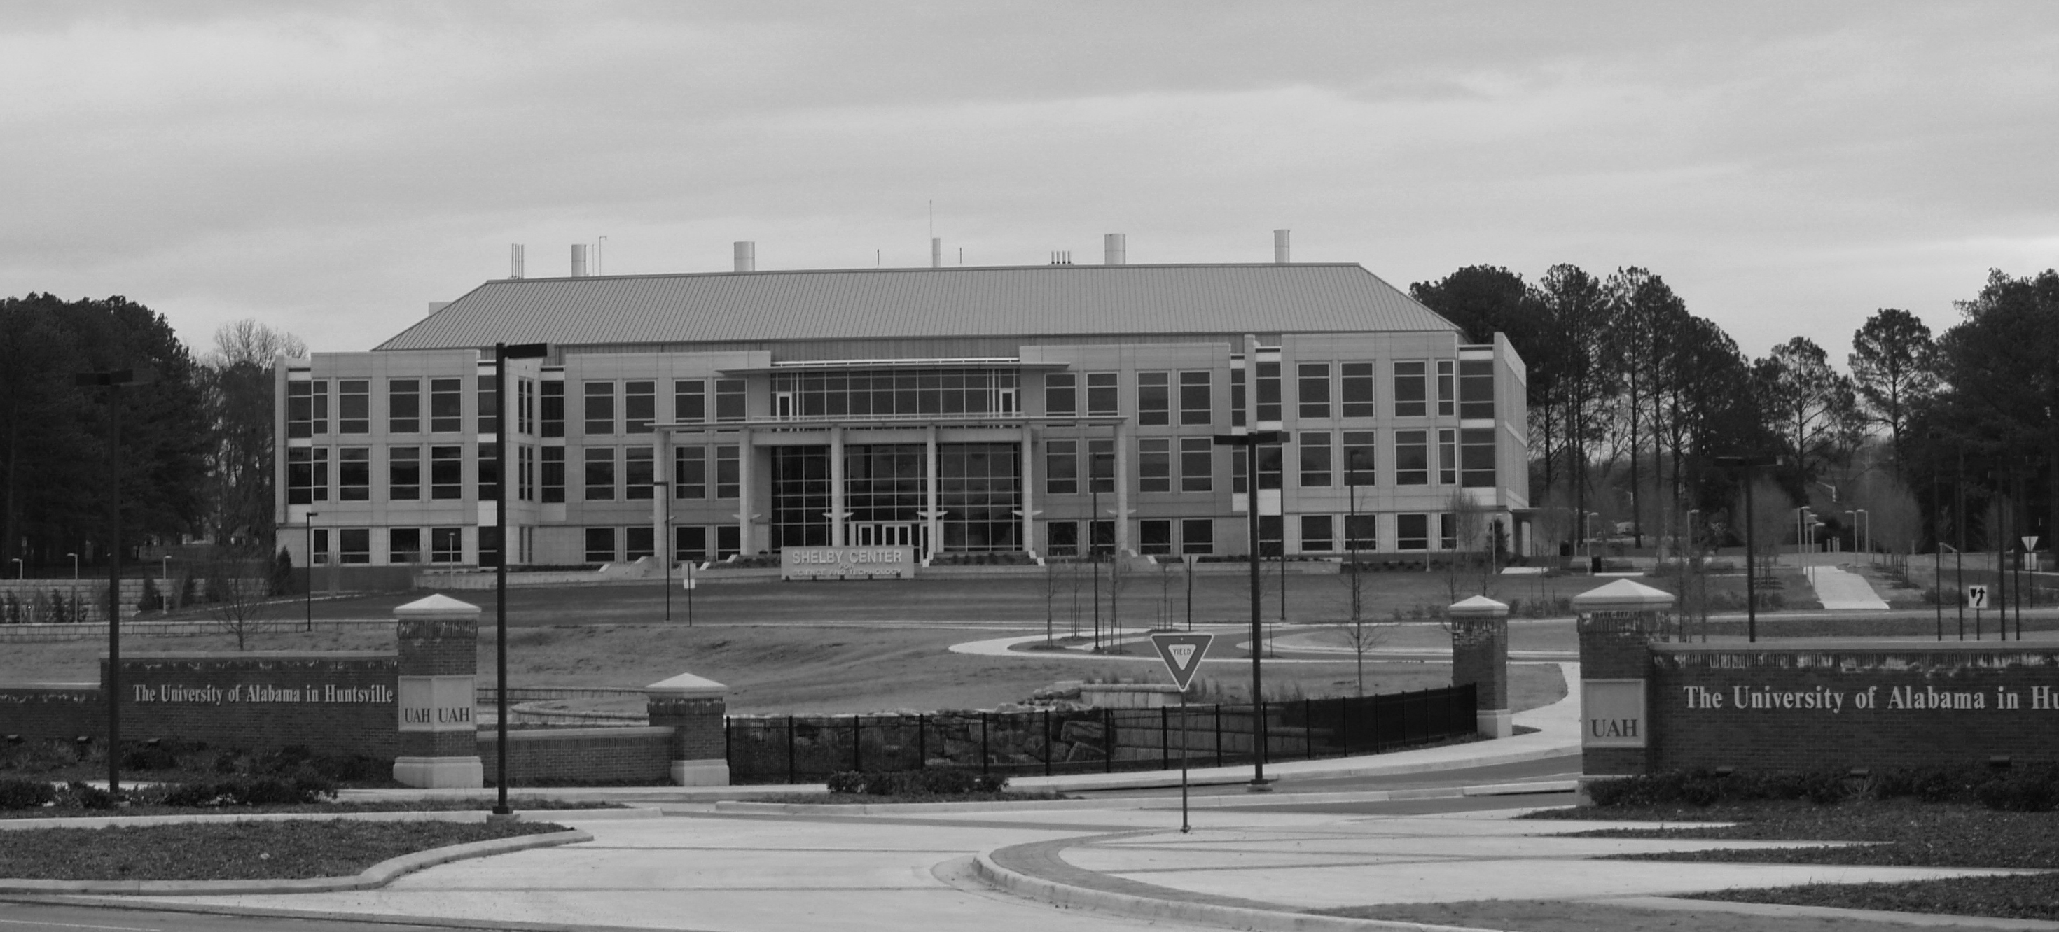

UAHuntsville’s new main entrance with the Shelby Applied Sciences Building in the background

Other changes are the disappearing houses in the little neighborhood behind Madison Hall. This area is to be a greenway between the north and south ends of the campus. Directly north of this area and across from the Fitness Center, is the construction for the Intermodal Transportation Center which will provide parking for a large portion of the campus. On the southeast side of John Wright drive you can see the new baseball and softball fields and a parking lot.

TRS Board of Control Runoff Election

A runoff election for Teachers’ Retirement System (TRS) Board of Control position “Retired Position #2” will take place January 7, 2008, through February 11, 2008. All TRS members will receive a ballot in the mail at their home address and the ballot must be returned to TRS by 4:00 p.m. February 11, 2008. The candidates in this runoff election are Dr. Sandra Sims-deGraffenried of Orange Beach and Mrs. Sallie B. Cook of Tuscaloosa. A short biographical sketch of the two candidates will be provided with the ballot.

UAHRA Webpage

Information about UAHRA (constitution, by-laws, current board members and officers), past information (newsletters) and announcements of future meetings can be found at the UAHRA Webpage. Go to the UAH homepage: http://www.uah.edu and then click on “Visitor” and “UAH Retirees Association”.

