UAHRA Newsletter
Spring 2013

Announcements

UAHRA Spring general meeting: Wednesday, May 8th, 11:30 a.m., Hospitality Room Spragins Hall. Don’t forget your donation items!

UAH Contact Person: Our UAH contact person is Eileen Farris, Donor Relations Coordinator in University Advancement. Her telephone number is: 256-824-4123 and her e-mail address is: epf0001@uah.edu.

Spring General Meeting
Our Spring general membership pot-luck salad/dessert luncheon meeting will be held Wednesday, May 8th, at 11:30 a.m. in the Hospitality Room of Spragins Hall.

- Let Val Seaquist (256-851-7423) or Gladys Jones (256-883-6446) know if you will attend and if you are bringing a dish. This information will allow us to plan for sufficient serving and dining space.
- If you are bringing a dish, please arrive before 11:30 a.m. so the food can be on the table before members begin serving themselves.
- If you need a ride to the meeting, let Val or Gladys know and someone will contact you to arrange this.

The main speaker for the meeting will be Mark Noble who will speak on the subject “Fitness for Seniors.” David Ragsdale, Chair of the UAH Department of music will give a brief overview of plans for the UAH Music Department.

UAHRA Board President’s Message

Spring is here! The trees are budding, the flowers are appearing, and the weather is finally warmer! We think it is the perfect season to have a general meeting of UAHRA. Our next meeting is scheduled for May 8, 2013, at 11:30. Details of the meeting are found in this newsletter. Our speaker will be Mark Noble. He will talk with us about a subject dear to our hearts: “Fitness for Seniors.” We are looking forward to seeing you in Spragins Hall, enjoying lunch and learning how to stay fit.

After lunch, David Ragsdale, Chair, Department of Music, will tell us about exciting plans for the Concert Hall in Roberts Hall. David has creative ideas for raising the money needed, and we hope you will support this much needed project. Mark will follow with his talk on fitness followed by our business meeting. We will want to thank Board members whose terms expire this year, Lee Cook, Val Seaquist, Carol Roach and Joan Williamson. This past year Val has been our secretary and newsletter editor and Joan has been treasurer and membership chair. Mary Beth Walker is our vice-president and president-elect and she will introduce our new Board members. She will also give a report on the state of our endowed scholarship.

Val, Mary Beth and I went to the State AERA meeting in Montgomery. I will give a short report on the meeting during our business meeting. We are concerned about the current legislation in Montgomery.

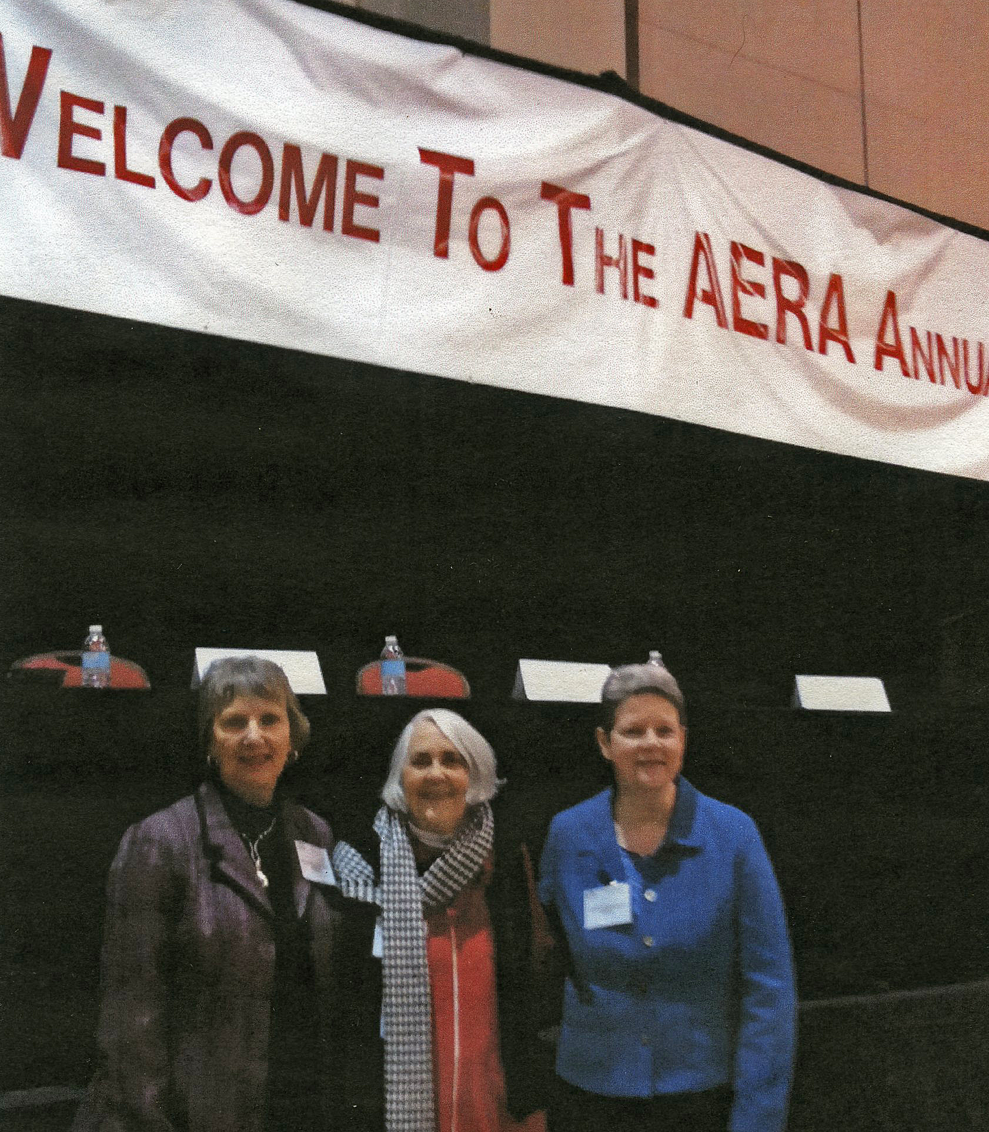
Hope to see you all in May. I thank you for your support of UAHRA this year. It has been my honor to serve as your president.

As ever, Carol
(UAHRA Board President)

UAHRA Board of Directors
The UAHRA Board of Directors urge the members to contact them with suggestions, questions, complaints, offers of assistance. We need your input to insure that we are meeting the needs of all the members. The Board and Officers are listed below:

*Carol Roach, President
cashroche@bellsouth.net
Mary Beth Walker, Vice-President/
President elect
Walker_mb@bellsouth.net
*Joan Williamson, Treasurer
Coachwill@aol.com
*Val Seaquist, Secretary
VJimval@aol.com
*Lee Cook
flc6714@comcast.net
Sam Campbell
psamcampbell@comcast.net
Donna Reed djr45@bellsouth.net
Jim Simpson
simpsonj@uah.edu
Gladys Jones
charglad@knology.net

*Term expires in May.

Community Service Projects
UAHRA has continued to support the three community service projects that we had last year. Your generosity is greatly appreciated by all who benefit. The community service projects are:

- Collection of cans, nonperishable food items or checks for the North Alabama Food Bank which distributes to over 200 food pantries, soup kitchens, shelters and churches across north Alabama.
- Collection of school supplies such as paper (both notebook and computer), #2 pencils, pens, crayons, washable markers, and glue sticks. These support a local “school supply store” under the “Free2Teach” program. Checks are also accepted. This program has set up a volunteer-run store where teachers can obtain class-room supplies at no cost.
- Toiletries for the Community Free Clinic clients. Our donations of travel-sized toiletry items are bagged and distributed to CFC clients.

Reet Henze Nominated

The UAHRA Board nononated Reet
Henze for award consideration under the AARP/NRTA and Chapter/Retired Educator’s Association Community Service Award. The nomination is based on Reet’s years of volunteer service at the Community Free Clinic and her idea to collect toiletries for the clients. This idea has become one of UAHRA’s community service projects.

Membership Directory Changes/Corrections
Please make the following changes to your copy of the membership directory:

New or renewed members:
Dr. Faye Anderson
2014 Katie Drive, S.W.
Decatur, AL 35603

Rozella Coggin
15545 Ham Road
Athens, AL 35611
256-206-0486
256-431-1697
coggin@uah.edu

Kenneth Harwell
1916 Country Club Drive
Tullahoma, TN 37388
harwell-k@msn.com

Sharon Harwell
1916 Country Club Drive
Tullahoma, TN 37338
harwell-s@msn.com

Dr. Gerry Karr
7803 Horseshoe Trail
Huntsville, AL 35802
karr@end.uah.edu

Chinnasami Krishnasami
104 Holbrook Drive
Huntsville, AL 35806
256-655-8241

James McCullars
3114 Adonna Drive
Huntsville, AL 35810
256-852-7918
jimmccullars@gmail.com

Michael A. Perry
5000 Maysville Road
New Market, AL 35761
256-852-1607
captainperrymusic@yahoo.com

Mary Ann Sonnenburg
1110 County road 184
Gurley, AL 35748
sunfort@hiwaay.net

Richard M. Wyskida
1509 Chandler Drive
Huntsville, AL 35801
256-881-2341

Victor Zhan
7422 Logan Drive
Huntsville, AL 35803
zhanv@yahoo.com

Corrections:
Robert James
3109 Constellation Drive, S.W.
Huntsville, AL 35802
jamesrob@hiwaay.net

Carol Raney
carolraney@knology.net

Note: a new directory will be printed some time in the future. Until then, please mark up your current directory with the changes in the newsletters. If you lose your directory, please contact Eileen Farris for a replacement.

Retiree Parking Placards are Now Available—Free!
UAH retirees can now obtain free parking placards at the Public Safety Office in the Intermodal Transportation Center (parking garage across from the UAH Fitness Center).

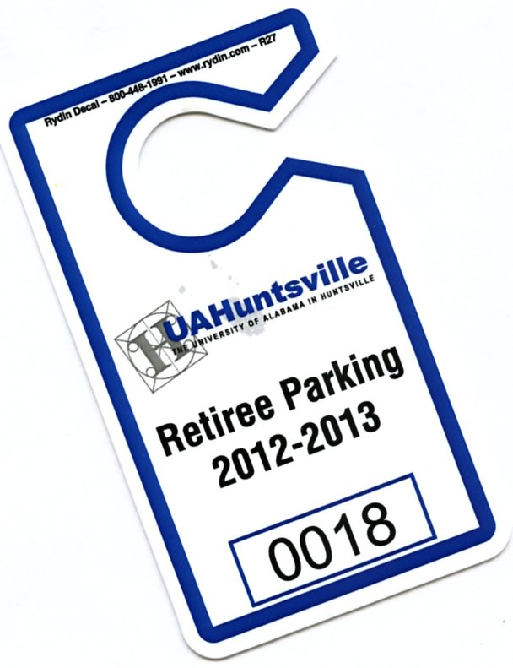
- You must complete a registration form for each RETIREE vehicle placard (form attached to this newsletter).
- These placards are not for student or employee vehicles.
- Placard hangs on your front mirror so it will be visible to officers during parking checks.
- You must renew your placard at the end of 2013.
- There will be a charge for replacement of a lost placard.
- You are subject to all the UAH traffic/parking rules just as you were as an employee.

Thank you to Chief Snellgrove for facilitating this privilege for the UAH retirees!

Board Nomination/Elections
An approval ballot for the four Board positions which will be filled in May has been mailed. Please return it to Eileen Farris as soon as you can. Your new Board members will be introduced at the May meeting.

Don’t Forget to Track your Volunteer Hours

At the January meeting members were asked to complete a form listing their volunteer hours for the past year. “Volunteer” means just about any activity outside your home/family which will help others. The UAHRA volunteer total of 8,386 hours was submitted to AERA to be included in the state-wide total.

Always Looking for New Members
If you know UAH retirees who are not members, please encourage them to join. An organization such as ours always needs new ideas, helping hands and the strength that our mutual past brings. The UAHRA fee structure is listed below and a membership application form accompanies this newsletter. Our membership year runs from January 1 – December 31.

Type of membership:
- UAH retiree ($10.00)
- UAH retiree spouses–both UAH retirees ($15.00)
- UAH retiree and non-UAH retired spouse ($17.50)
- UAH retiree and non-retired spouse ($20.00)
- Surviving spouse of UAH retiree ($10.00)
- Associate member* (UAH employee within five years of retirement eligibility) ($10.00)
- Other individual applicants* (as approved by the Board) ($20.00)
- Lifetime (UAH retiree $100.00/UAH retiree & spouse ($150.00)

*Cannot vote or hold office

To remain current in the UAHRA files and be listed in the directory, please insure that your dues are current. (Lifetime members are exempt.)

UAHRA General Meeting Minutes
January 23, 2013

The UAHRA Members’ Winter Meeting was held in Spragins Hall on January 23, 2013. After a pot-luck lunch, President Altenkirch announced that the UAH hockey program was recently accepted into the Western Conference. The hockey team needs local support and we were urged to attend games in the von Braun Center arena.

The minutes of the last general meeting, October 10, 2012, were distributed to the members in the newsletter early this month. They were approved as written.

Our 2012-13 scholarship recipient, Melissa Berry, was introduced. She spoke of her academic progress and plans and thanked the members for their support.

Our main speaker was Janice Charlesworth, Executive Secretary of the Alabama Education Retirees Association (AERA). AERA is the retirees branch of the Alabama Education Association (AEA). She spoke on several topics of interest:

- The PEEHIP decision to change its provider for Medicare Part D. This was based on the promise that PEEHIP could save money while the benefits remained the same. If it does not work as planned, PEEHIP will probably go back to the former plan. Retirees under this plan were cautioned to not let their prescriptions lapse—the cost will go up if you do. Questions about PEEHIP should be directed to 877-517-0020.
- The legislative session begins on February 5th. It is believed that a retiree COLA will be requested as well as a raise for active education employees. Several other bills are going to be coming up which could have a negative impact on retirees, the pension fund, and AERA. Members are urged to closely follow the legislative action and contact your legislators with your opinions.
- We were reminded of the AERA Annual Meeting in Montgomery on March 26th.

Members were asked to volunteer to be on the ballot for new officers if they wished to serve.

Carol announced the intent to nominate Reet Henze for award consideration under the AARP/NRTA & Chapter/Retired Education Association Community Service Award.

The Treasurer’s report stated that the combined UAHRA accounts at the Alabama Credit Union totaled $5,663 and we had a total of 55 members including 24 life time members (note: the membership number is always low this time of year as many of the renewals haven’t come in yet.)

The meeting was closed at 1:10 p.m.

Respectfully submitted,
Valerie Seaquist
Secretary

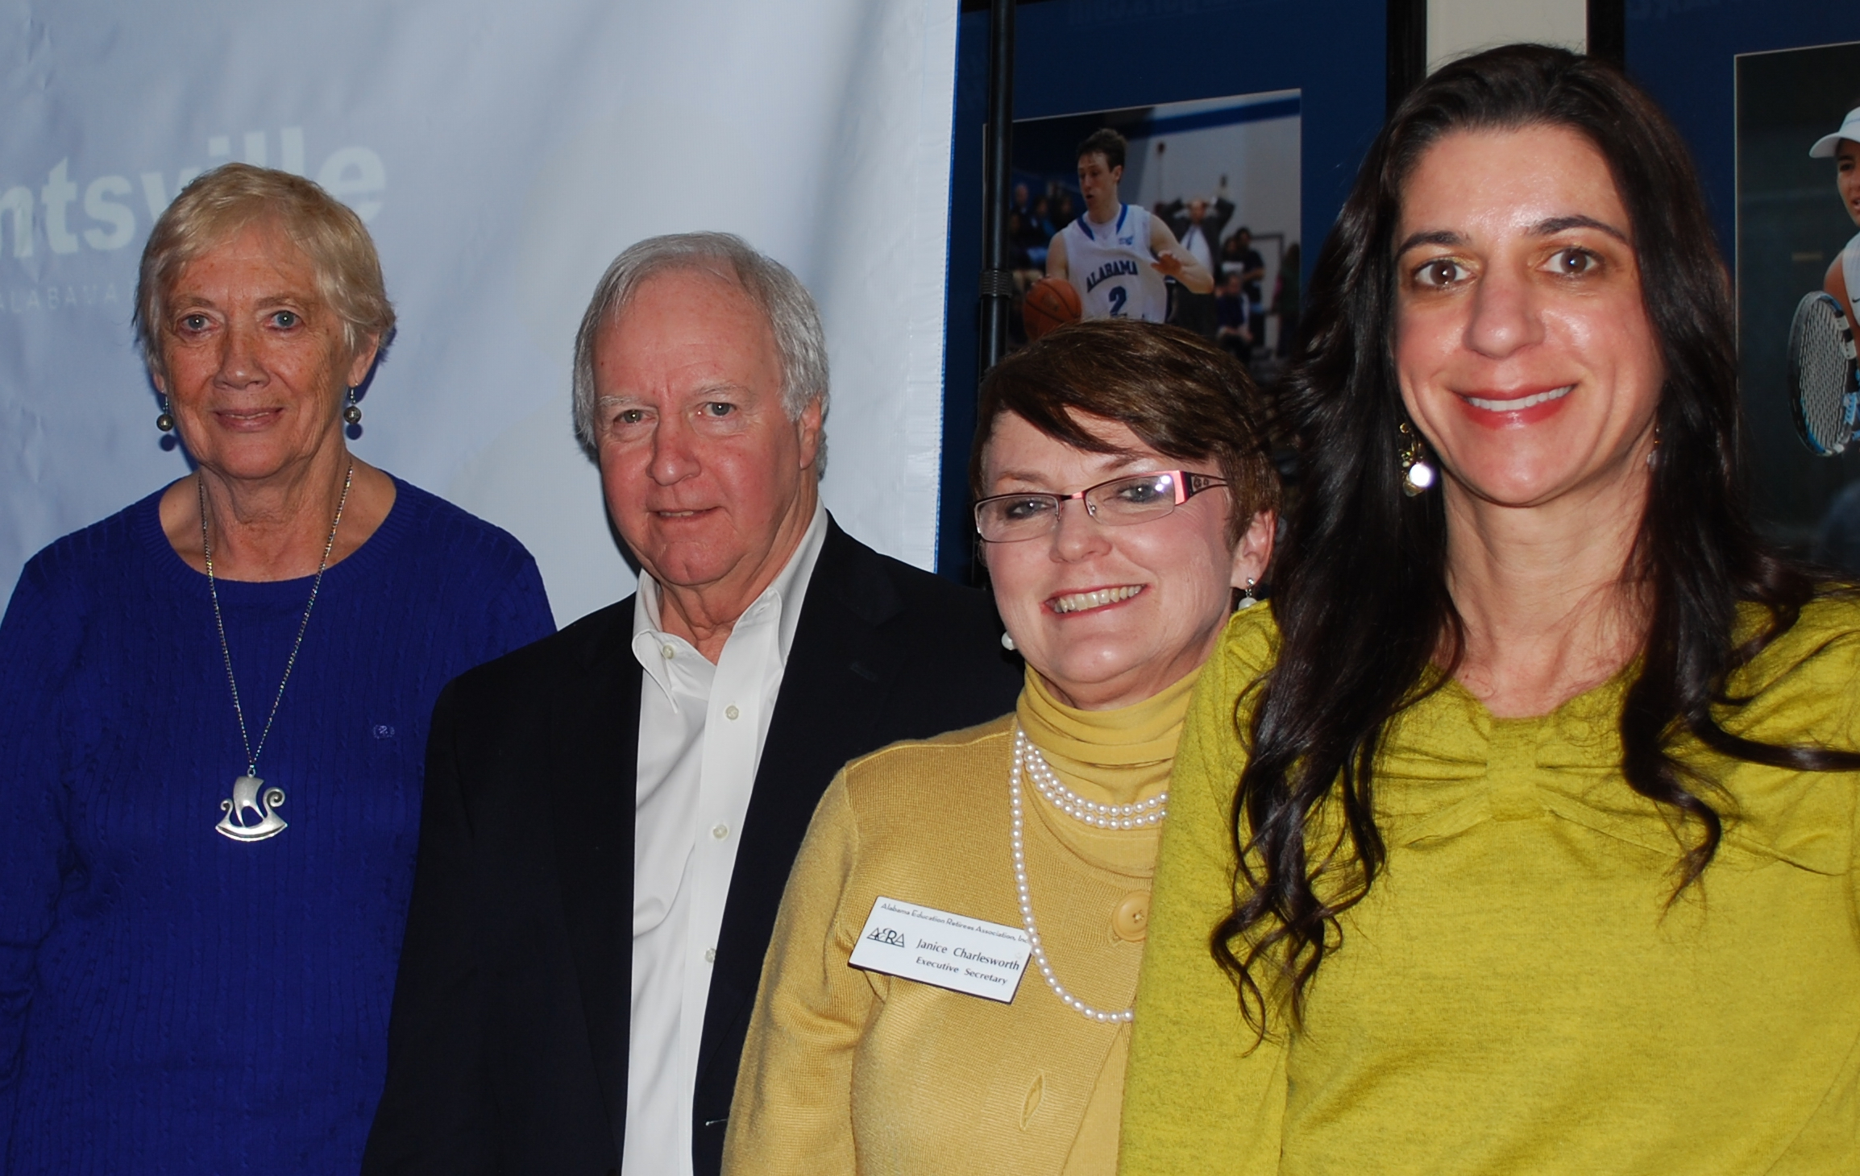
Dr. Reet Henze, award nominee; Dr. Robert Altenkirch, UAH President; Ms. Janice Charlesworth, AERA Executive Secretary; Ms. Melissa Berry, UAHRA scholarship recipient

