UAHRA Newsletter
Summer 2012

Meet Your New Board Members

Donna Reed
Donna Reed, a Huntsville native, distinctly remembers being anxious when she arrived for her first class as a freshman at UAHuntsville in 1979, but she knew right away she had made a good choice. As thoroughly as she enjoyed her student experience at UAHuntsville, Donna found working there was even better! She began working at the University in March 1984 and has since served in several positions at UAHuntsville including Director of Internal Audit (three times), Assistant Vice President for Finance and Administration, Assistant Professor of Accounting, Director of Planning and Budgets and Controller.

After twenty-six years at UAHuntsville, Donna retired December 31, 2010. At that time she stated, “The most rewarding part of working here is the opportunity to work with so many first-rate people. I get up each morning and look forward to working in an organization that is dynamic and complex, and has provided me with wonderful professional and personal experiences. The fact that I have had the opportunity to serve as a mentor and advisor to students is just icing on the cake.”

Donna and her husband Jimmy have two daughters and three grandchildren. Part of her retirement plan is to

spend more time with her family. However, she will continue to maintain ties with UAHuntsville through the Alumni Association, the UAHuntsville Retirees’ Association and teaching in the college. Several years ago Donna and Jimmy established an endowment for a scholarship in accounting which they continue to support.

Mary Beth Walker
Mary Beth Walker was Sr. Executive Assistant to the University’s President for 23 years from 1988-2011. She worked for six UAHuntsville presidents—John Wright through Malcolm Portera. During that time she witnessed and was a part of the significant transitions and changes that UAHuntsville went through from its early status as a regional institution to its new status as Carnegie Research Foundation institution and more residential campus.

Mary Beth strongly believed that support for the President’s Office should include participation in activities other than day-to-day tasks. Over the years she served as a host for the Office of International Programs, the executive board of Phi Kappa Phi, and the University Women’s Club. She is a current member of the President’s Council and she was one of the early donors to the Friends of Women’s Studies.

Following her retirement on October 1, 2011, Mary Beth joined the Alumni Association Board. She has also been traveling: Cuba in January, Wisconsin with children and grandchildren, and she plans to visit Eastern Europe and the Ozarks in the fall.

Mary Beth’s most haunting memory of UAHuntsville is the day of the shootings in the Shelby Center in 2010 and the months that followed. She especially appreciates the staff and administrators who served with her on the Crisis Management Team and how they dealt with and brought tenuous closure to that tragic event.

UAHRA Board of Directors

The UAHRA Board of Directors urge the members to contact them with suggestions, questions, complaints, offers of assistance. We need your input to insure that we are meeting the needs of all the members. The Board and Officers are listed below:

Carol Roach, President
cashroche@bellsouth.net
Mary Beth Walker, Vice-President/
President elect
Walker_mb@bellsouth.net
Joan Williamson, Treasurer
Coachwill@aol.com
Val Seaquist, Secretary
VJimval@aol.com
Lee Cook
flc6714@comcast.net
Sam Campbell
psamcampbell@comcast.net
Donna Reed djr45@bellsouth.net
Jim Simpson
simpsonj@uah.edu
Gladys Jones
charglad@knology.net

Community Service Projects

The three UAHRA community service projects for which we were recognized at the April State-wide AERA meeting will continue. Please let the Board know if you have other projects to suggest. Our next collection will be at our October 2012 General Meeting which is scheduled for October 10th. You will receive more information as we move closer to that date. The community service projects are:

- Collection of cans, nonperishable food items or checks for the North Alabama Food Bank which distributes to shelters and churches across north Alabama.
- Collection of school supplies such as paper (both notebook and computer), #2 pencils, pens, crayons, washable markers, and glue sticks. These support a local “school supply store” under the “Free2Teach” program. Checks are also accepted. This program has set up a volunteer-run store where teachers can obtain class-room supplies at no cost.
- Toiletries for the Community Free Clinic clients. Our donations of travel-sized toiletry items are bagged and distributed to CFC clients.

AERA Membership Renewal Time

Those of us who belong to the Alabama Education Retirees Association (AERA) have received our renewal notices for the coming year. For those who are not members but might wish to join, you can obtain a membership form at the AERA website:http://www.aerainc.org/. Dues are $136.00 per year and can be paid in full or via “payroll” deduction (only retiree pensions, not active employee payroll) of $11.34/month.

AERA has close to 25,000 members and is an important force in insuring your pension and insurance benefits are maintained.

PEEHIP Open Enrollment Period

If you have a new enrollee, wish to make changes to your plan or terminate PEEHIP coverage, now is the time. The PEEHIP Open Enrollment Period began on July 1st and will continue through August. Paper applications to the program must be postmarked no later than 31 August 2012 and on-line applications no later than 10 September 2012. Go to the PEEHIP information page at http://www.rsa-al.gov/PEEHIP/peehip.html for a wealth of information about PEEHIP. STAY INFORMED!

Directory Changes/Corrections

Please make the following changes to your copy of the membership directory:

Dr. Hugh Comfort: email correction:
hughcom@comcast.net

Dr. Jefar Hoomani: address change:
34 Hope Farm Road
Missouri City, TX 77459

May General Meeting

We had a good meeting on May 9th and the minutes will be included with the next newsletter prior to the October General Meeting. Dr. Robert Witt, new Chancellor of the University of Alabama System and past president of the University of Alabama, was our speaker. He spoke of some of the pending changes in the interaction of the Chancellor’s Office and the UAHuntsville and UAB campuses.

We also welcomed Nadia Araiinejad, our UAHRA scholarship recipient for this past year. She graciously thanked us for our support and provided information about her plans for the future.

The photo below was taken at the meeting and shows Ms. Araiinejad, Dr. Witt, Dr. Joan Williamson, UAHRA Board President (at the time of the meeting) and UAHuntsville President Dr. Robert Altenkirch.

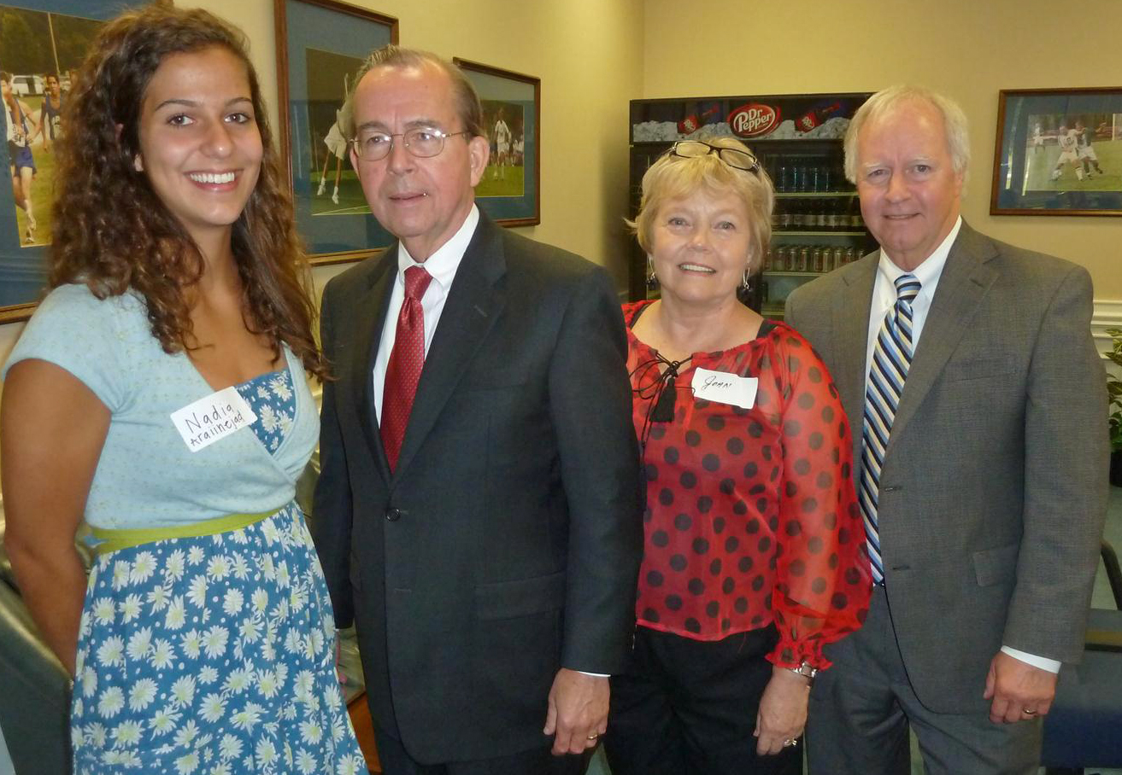

Scholarship Recipient’s Report

Our scholarship recipient, Nadia Araiinejad, sent a note to Carol Roach recently
expressing her appreciation and letting her know what she is doing this summer. An excerpt follows: “I just wanted to thank you and the rest of the retirees for your generous scholarship again! Words seriously cannot accurately convey my gratefulness.

I have been working at Mandeville Physical Therapy for over a month now as a summer job. I love it and can’t wait to begin my future studies at Physical Therapy school; I am currently applying now! I studied for the GRE during June and took the test last week. I passed with the score I needed and more. I will keep you updated on my progress through my senior year.”

At our May meeting Nadia mentioned her trip to Iran last summer and she provided this link if anyone would like to see the video of the trip that she compiled: https://vimeo.com/27388306

Remember When?

The photo below was taken at the UAHuntsville retiree reception preceding the Staff Award Luncheon on March 4, 2004. Many present and former UAHRA members are pictured.
Back row: Nancy Sutherlin, Doris Freeman, Judy Duvall, Gerry Moore, Fay Rhodes, Carol Roach, Margaret Bond, Linda Hooper, Pembroke Rees, Lee Cook, Robert Thurstone, Joseph Dowdle, Gloria Anderson, Mrs. Robert Thurstone, Katherine Orr, and Marge Phillips.
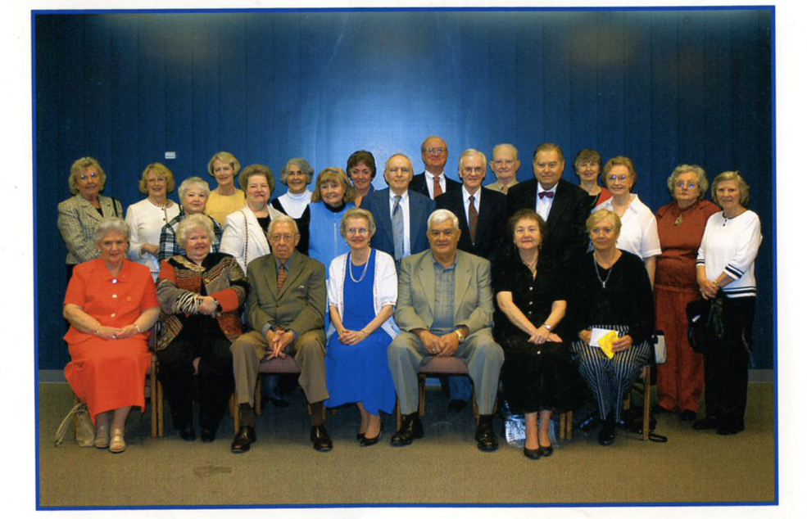
Thelma Pannell, Roberta Carson, Benjamin Graves, Gladys Jones, Clarence Driggers, Mary Thompson, Reet Henze.

