UAHRA Newsletter
Fall 2012

Announcements

UAHRA Fall general meeting: Wednesday, October 10th, 11:30 a.m., Room 108 Spragins Hall. Health Fair begins at 10:30 a.m.

New UAH Contact Person: Our new UAH contact person is Eileen Farris, Donor Relations Coordinator in University Advancement. Her telephone number is: 256-824-4123 and her e-mail address is: epf0001@uah.edu.

Fall General Meeting
UAHRA will hold its Fall General Meeting on Wednesday, October 10th, at 11:30 a.m. in room 108 (Hospitality Suite) of Spragins Hall. This will be a pot-luck lunch and all members are encouraged to bring a salad, dessert or another dish if they can. In order to insure sufficient serving and dining space, please let Eileen Farris know if you will be attending and what you are bringing. She can be reached at 256-824-4123 or epf0001@uah.edu. IF YOU NEED A RIDE TO THE MEETING, LET EILEEN KNOW AND SOMEONE WILL CONTACT YOU TO ARRANGE THIS.

The speaker for the meeting will be Mike Finnegan, Assistant Vice President—Facilities. Mike has been our speaker several times and has always provided interesting information concerning the ever-changing campus.

THE NURSES ARE BACK: UAHRA is again hosting a PEEHIP-provided Health Fair in Spragins Hall before and after the luncheon meeting. The Health Fair, which is free to UAHRA members, includes a cholesterol reading, bone density check and a flu shot. YOU MUST HAVE YOUR PEEHIP CARD TO TAKE ADVANTAGE OF THIS SERVICE.

UAHRA Board President’s Message
President Robert Altenkirch was installed as the 6th President of The University of Alabama in Huntsville on August 21, 2012. I was asked to speak, as president of UAHRA, on behalf of the retirees. As I said in my speech, UAHRA was honored to be included in the ceremony and to join Dr. Altenkirch’s vision of “Looking Forward.”

Thanks to everyone who helped me with the form and content of the speech. Gladys Jones took time to write an email from a meeting in Tuscaloosa to tell me that Dr. Wright and Dr. Graves were both supportive of the idea of a UAH retirees organization as was Dr. Franz. In fact, Drs. Wright and Graves invited the faculty/staff planning group to lunch! Mary Beth Walker took her editing pencil to the script and made it better! Oh, and Val polled the membership to learn that as faculty/staff we invested 2,392 years in UAH. Dr. Franz was in the audience and he led the applause when I announced the number of years we have invested.

I look forward to seeing each of you at our October 10th meeting. We always have fun being together, sharing our ideas, and supporting UAH. We are excited that we were included in the Installation Ceremony and we are “Looking Forward” to a new climate on campus!

Carol
(UAHRA Board President)

President Altenkirch’s Installation
UAHRA was pleased to be a part of President Altenkirch’s Installation on August 21st. Carol Roach, UAHRA Board President was invited to give a short speech during the ceremony. In preparation for that, we asked UAHRA members to let us know their years of service in order to provide a combined total. With about 85% of members responding, we had 2,392 years! Carol’s remarks follow:

Dr. Witt, Board of Trustees, Honored Guests, UAH Faculty and Staff, Students, Community Leaders, Dr. Altenkirch:
Dr. Altenkirch asked me to represent the University of Alabama in Huntsville Retirees’ Association—UAHRA. It is an honor to be included in this very special ceremony.

I bring greetings from UAHRA. Dr. Altenkirch has chosen “Looking Forward” as the theme of this installation. We retirees want to participate in this vision and are ready to Charge On.

With the encouragement of President Franz and former Presidents Wright and Graves, UAHRA was organized in 2005 by Lee Cook, Gladys Jones, the late Jim Johannes and the late Jim Wilson. The purpose was to “help enhance the scholarly and other objectives of UAH so that it is able to effectively serve the students and citizens of the State and nation in the years ahead.”

The key is “the years ahead”. Val Seaquist, our UAHRA Secretary and Newsletter editor, asked members to confirm the number of years they had each worked at UAH. The total is 2,392 years . . . 2,392 years looking forward!

Here’s a brief look at our past! When I was hired in 1968, all undergraduate classes were held in Morton Hall. Before Morton Hall, classes were taught at Butler High School, then located on Governors Drive. We called the ground floor of Morton Hall “the basement”; it housed our library, the psychology department and the student lounge. Students could buy snacks and drinks there and play cards. If my students didn’t show up on time for class, I went to the basement to get them!

Now, UAH has forty-five buildings including the new student center (groundbreaking is today), an athletic complex and residence halls.

Although, in the past, we often felt we were taking two steps forward and one step back . . . we believe we are ready to take all our steps forward. Dr. Altenkirch, we welcome you to campus. Congratulations on this important occasion in UAH History.

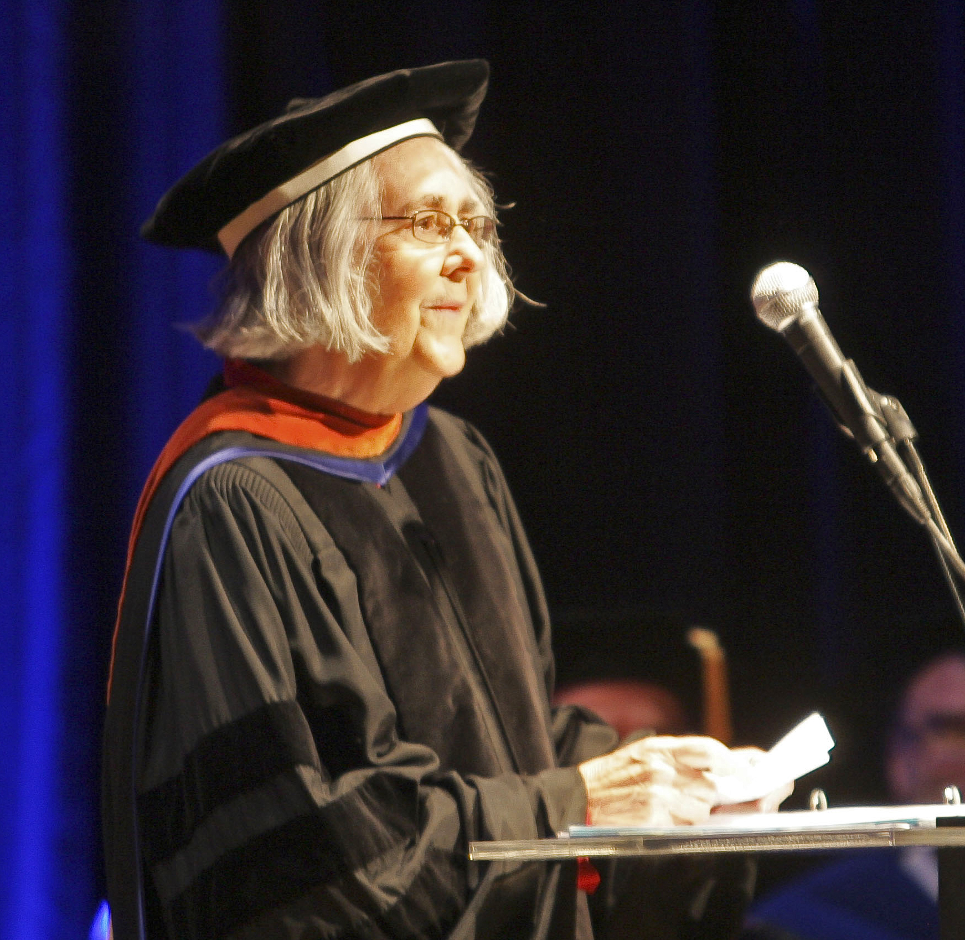

AERA District 2 Meeting Report
On August 12, UAHRA Board members, Donna Reed, Carol Ashburn Roach, Mary Beth Walker and Joan Williamson traveled to Boaz to attend the AERA District 2 meeting. Attendees were welcomed by District 2 Director Joe McFerrin. Janice Charlesworth, AERA Executive Secretary, provided updates and reports including information on our community-wide service project: SOAR. The group also received updates from the TRS/PEEHIP Board and information on MedImpact. After the meeting, a delicious meal was enjoyed in the Snead State College cafeteria.

UAHRA Board of Directors
The UAHRA Board of Directors urge the members to contact them with suggestions, questions, complaints, offers of assistance. We need your input to insure that we are meeting the needs of all the members. The Board and Officers are listed below:

Carol Roach, President
cashroche@bellsouth.net
Mary Beth Walker, Vice-President/
President elect
Walker_mb@bellsouth.net
Joan Williamson, Treasurer
Coachwill@aol.com
Val Seaquist, Secretary
VJimval@aol.com
Lee Cook
flc6714@comcast.net
Sam Campbell
psamcampbell@comcast.net
Donna Reed djr45@bellsouth.net
Jim Simpson
simpsonj@uah.edu
Gladys Jones
charglad@knology.net

Community Service Projects
The three UAHRA community service projects for which we were recognized at the April State-wide AERA meeting will continue. Please let the Board know if you have other projects to suggest. Our next collection will be at our October 2012 General Meeting which is scheduled for October 10th. The community service projects are:

- Collection of cans, nonperishable food items or checks for the North Alabama Food Bank which distributes to over 200 food pantries, soup kitchens, shelters and churches across north Alabama.
- Collection of school supplies such as paper (both notebook and computer), #2 pencils, pens, crayons, washable markers, and glue sticks. These support a local “school supply store” under the “Free2Teach” program. Checks are also accepted. This program has set up a volunteer-run store where teachers can obtain class-room supplies at no cost.
- Toiletries for the Community Free Clinic clients. Our donations of travel-sized toiletry items are bagged and distributed to CFC clients.

Membership Directory Changes/Corrections
Please make the following changes to your copy of the membership directory:

Mary Boucher: boucherp22@hotmail.com

Rosemary Latham:
Latham6511@pclnet.net

Bernard Levine:
8607 Esslinger Ct., S.E.
Huntsville, AL 35802
256-690-3160
nardlevine@hotmail.com

Marian Lewis:
bo325sky@earthlink.net

Renata Limmer:
limmerr@gmail.com

James McCollum:
mccollj@uah.edu

UAHRA Scholarship Recipient (2012-2013)
Last month, the UAHRA Board of Directors was notified of its 2012-2013 scholarship recipient, Melissa Berry. Ms. Berry, a student in the College of Business Administration, sent the following thank-you note:

Dear Members of the Board,

Thank you so much for selecting me as the recipient of the UAH Retirees’ Association Annual Scholarship. As a non-traditional student, UAH has made my transition back to college life a smooth one. I have met so many helpful professors, staff members and students.

I was hired as a PASS leader in the spring and in the fall I intend on tutoring as well. Through this program, along with my own classroom experiences, I have been able to feel the desire for every student at UAH to succeed.

As a wife and mother of three, I spend much of my time juggling family with work and studies, but it is worth it. I am currently enrolled in the JUMP program and I fully intend to complete my MBA after I receive my undergraduate degree. This scholarship will help me in completing these educational goals.

I sincerely appreciate your generosity and thank you so much for having enough confidence in me to present me with your annual scholarship.

Sincerely, Melissa Berry

Ms. Berry has been invited to our October luncheon.

Don’t Forget to Track your Volunteer Hours
The winter 2012-2013 newsletter will contain a form for members to submit their volunteer hours. These hours will be forwarded to the AERA office for inclusion in their State volunteer hours total. Our impressive number of volunteer hours last year was a factor in AERA awarding UAHRA the State Community Service Award. These hours can be any time devoted to non-family members—such things as: tutoring, providing transportation, donating blood, organized volunteer activities, public litter clean up, etc. The State “year” for this activity is February 1 – January 31 so count your hours accordingly.

Always Looking for New Members
If you know UAH retirees who are not members, please encourage them to join. An organization such as ours always needs new ideas, helping hands and the strength that our mutual past brings. The UAHRA fee structure is listed below and a membership application form is accompanies this newsletter. Our membership year runs from January 1 – December 31 but anyone joining now will be covered for the entire year of 2013.

Type of membership:
____ UAH retiree ($10.00)
____ UAH retiree spouses–both UAH retirees ($15.00)
____ UAH retiree and non-UAH retired spouse ($17.50)
____ UAH retiree and non-retired spouse ($20.00)
____ Surviving spouse of UAH retiree ($10.00)
____ Associate member* (UAH employee within five years of
retirement eligibility) ($10.00)
____ Other individual applicants* (as approved by the Board) ($20.00)
____ Lifetime (UAH retiree $100.00/UAH retiree & spouse ($150.00)

*Cannot vote or hold office

Thank you to Janice Temmen for your assistance over the past few years!

Minutes of the May 9th Membership Meeting follow

The University of Alabama in Huntsville Retirees’ Association

Minutes
of
the General Membership Meeting
(May 9, 2012)

The meeting was called to order by out-going Board President Joan Williamson who introduced several guests:

Lenny Acuff, UAH Men’s basketball coach. The success of UAH’s men’s and women’s teams was noted:

E.J. Brophy, UAH Athletic Director who gave the status of the different UAH teams and commended the academic quality of the athletes;

Nadia Araiinejad, UAHRA’s scholarship recipient for 2011-2012 who thanked us for the scholarship and told us a bit about her plans for the future;

Dr. Robert Altenkirch, UAH President who was given UAHRA’s three AERA award plaques; and

Dr. Robert Witt, Chancellor of UA System who addressed the group.

Dr. Witt laid out some of the changes in the UAH/Chancellor’s Office interaction. Effective next week, a satellite office for the Chancellor will open in Shelbie King Hall. The University of Alabama Systems Office Board will meet in Huntsville four times a year. He anticipates a much higher degree of interaction between the three U of AL institutions with a emphasis of sharing successful practices and cooperation in research efforts.

The minutes of the February 1st General Meeting, which had been distributed with the newsletter in late April, were approved with no change.

The directory has been distributed to all members and future changes will be noted in newsletters.

The Board has determined that the three current service projects: food donations to the North Alabama Food Bank, collection of school supplies for the Free To Teach project, and collection of toiletries for the Community Free Clinic will continue.

The Treasurer’s report stated a balance (as of 4/30/12) of $5,402.39 in our four accounts in the Alabama Credit Union. We have a total of 110 paid members, of whom 24 are lifetime members.

A motion was proposed to award a $1,000 scholarship from UAHRA at the beginning of the 2012-2013 school year. The motion was passed and Reet Henze will write a check to the Advancement Office to fund this scholarship.

Joan gave the members a report on the AERA Annual Meeting at which UAH won the Unit of Excellence Award and the Community Service Award as well as the State Community Service Award. She also reported on the failure of the proposal (joint effort by the presidents of UAH, UA, UAB and AU retirees’ associations) to change the AERA constitution to create an position for a higher education retiree. This was resoundingly defeated.

Reet Henze and S.T. Wu, outgoing Board members were thanked. As the Nominating Committee, they reported that Donna Reed and Mary Beth Walker had been selected to replace them and their tenures on the Board will start in June and last for three years.

Carol Roach was acknowledged as the in-coming UAHRA President.

Several door prizes were awarded and the meeting was adjourned.

Respectfully submitted,

Valerie Seaquist
UAHRA Secretary

