UAHRA Newsletter
Winter 2012-2013

Announcements

UAHRA Winter general meeting: Wednesday, January 23rd, 11:30 a.m., Room 108 Spragins Hall. Don’t forget your donation items!

UAH Contact Person: Our UAH contact person is Eileen Farris, Donor Relations Coordinator in University Advancement. Her telephone number is: 256-824-4123 and her e-mail address is: epf0001@uah.edu.

Winter General Meeting
Our winter general membership pot-luck soup/salad/dessert luncheon meeting will be held Wednesday, January 23rd, at 11:30 a.m. in room 108 (Hospitality Suite) of Spragins Hall.

- Let Val Seaquist (256-851-7423) or Gladys Jones (256-883-6446) know if you will attend and if you are bringing a dish. This information will allow us to plan for sufficient serving and dining space.
- If you are bringing a dish, please arrive before 11:30 a.m. so the food can be on the table before members begin serving themselves.
- If you need a ride to the meeting, let Val or Gladys know and someone will contact you to arrange this.

The speaker for the meeting will be Janice Charlesworth, Executive Secretary for AERA. She will speak on recent legislative actions affecting education retirees and likely issues to be addressed in the upcoming legislative session.

UAHRA Board President’s Message
Happy New Year! May 2013 bring you and your family health and happiness!

2012 was a very good year for UAHRA. I want to thank the UAHRA Board for their generous gifts of time, energy and financial support. As you know, UAHRA won three awards at the AERA annual meeting in April. One of the awards was the State Community Service Award! Of our three UAH projects: Yes we CAN Feed Alabama!, SOAR (helping public schools with supplies), and our Community Free Clinic project, we feel the awards committee was most impressed with our Community Free Clinic project. Reet Henze, our Treasurer and Membership Chair in 2011-2012 suggested our members donate small toiletries for patients of the clinic. In 2012, UAHRA members donated over 300 toiletry items with an approximate value of $450.00. Reet has volunteered at the clinic Tuesday-Thursday 3-7 p.m. since 2000. UAHRA is nominating Reet for the Annual Chapter Community Service Award given on behalf of the AARP/NRTA and the Chapter Retired Educators Association..

We were happy to announce at our annual meeting in October the generous gift of Tony and Kathy Chan to help establish a UAHRA endowed scholarship. Mary Beth Walker, UAHRA Vice-President/President elect, accepted the leadership role for fundraising for this scholarship. See Mary Beth’s article in this newsletter for details.

Our annual winter meeting is January 23rd, 2013. Janice Charlesworth, AERA Executive Secretary, will be our speaker. She will speak on Legislative Action. We will meet in Spragins Hall at 11:30 for lunch to be followed by the speaker and a short business meeting. Details are in the newsletter.

Hope to see you on January 23rd! We want to see your face in 2013! We need your continued support!

As ever, Carol
(UAHRA Board President)

UAHRA Members Meet and Surpass the Chan Challenge: $19,710 Paid into the UAHRA Endowed Scholarship Fund
At the October 10th UAHRA meeting, Carol Roach, UAHRA Board president, announced that Tony and Kathy Chan pledged $10,000 to The University of Alabama in Huntsville to help establish the UAHRA Endowed Scholarship. Tony also challenged UAHRA members to augment his contribution with an additional $5,000 by December 31st. Immediately, the UAHRA Board made preliminary pledges and several other members attending the meeting contributed. Carol Roach and Bob Lyon, Vice-President for University Advancement, sent letters to all UAHuntsville retirees about the scholarship and, as of December 31st, a total of $19,710, including the Chan’s initial donation, has been paid into the fund. We need to raise an additional $5,290 to reach the $25,000 required for our scholarship to be fully endowed. Your Board will continue to inform you about the progress. We look forward to reaching that goal soon.

Suggestion: Want to honor a UAH colleague, retired or active, for his or her dedication and service to UAH? Make a donation to the UAHRA endowed scholarship in his or her honor? Many of the UAHRA members have done exactly that. This is an effective way to give a personal and meaningful gift that also helps our students. And, it’s a perfect retirement gift for retiring UAH employees! The Advancement Office will personally notify the colleague(s) whom you choose to honor with your donation.

Thanks to all who have contributed so quickly and generously!

UAHRA Board of Directors
The UAHRA Board of Directors urge the members to contact them with suggestions, questions, complaints, offers of assistance. We need your input to insure that we are meeting the needs of all the members. The Board and Officers are listed below:

Carol Roach, President
cashroche@bellsouth.net
Mary Beth Walker, Vice-President/
President elect
Walker_mb@bellsouth.net
Joan Williamson, Treasurer
Coachwill@aol.com
Val Seaquist, Secretary
VJimval@aol.com
Lee Cook
flc6714@comcast.net
Sam Campbell
psamcampbell@comcast.net
Donna Reed djr45@bellsouth.net
Jim Simpson
simpsonj@uah.edu
Gladys Jones
charglad@knology.net

Community Service Projects
The three UAHRA community service projects for which we were recognized at the April State-wide AERA meeting will continue. Please let the Board know if you have other projects to suggest. Our next collection will be at our January 2013 General Meeting which is scheduled for January 23rd. The community service projects are:

- Collection of cans, nonperishable food items or checks for the North Alabama Food Bank which distributes to over 200 food pantries, soup kitchens, shelters and churches across north Alabama.
- Collection of school supplies such as paper (both notebook and computer), #2 pencils, pens, crayons, washable markers, and glue sticks. These support a local “school supply store” under the “Free2Teach” program. Checks are also accepted. This program has set up a volunteer-run store where teachers can obtain class-room supplies at no cost.
- Toiletries for the Community Free Clinic clients. Our donations of travel-sized toiletry items are bagged and distributed to CFC clients.

Membership Directory Changes/Corrections
Please make the following changes to your copy of the membership directory:

Addition:
Telse Platt Davis
16121 Shropshire Drive
Huntsville, AL 35803
256-881-6061 (h)
256-603-9144 (c)
barnedavis@aol.com

Note: a new directory will be printed some time in the future. Until then, please mark up your current directory with the changes in the newsletters. If you lose your directory, please contact Eileen Farris for a replacement.

Are You a Member of AERA? Want to save money?
Many UAHRA members are also members of AERA, the education retiree section of the Alabama Education Association (AEA). How many times do you receive information from a group you are associated with but don’t really pay attention? Guilty! It has been brought to the Board’s attention that there are many discounts available to AERA members—you just have to know what, where and when and ask for your discount.

Go to www.myaera.org and look under “member benefits”. A check of the website the first week of January revealed 170 discount opportunities such as movies, restaurants, hotels, retail stores, appliance purchase and many, many more. If you can’t find your AERA membership card (which probably went the way of the information packets you didn’t read), you can log in on the site and obtain your membership number.

Retiree Parking Placards are Now Available—Free!
UAH retirees can now obtain free parking placards at the Public Safety Office in the Intermodal Transportation Center (parking garage across from the UAH Fitness Center).

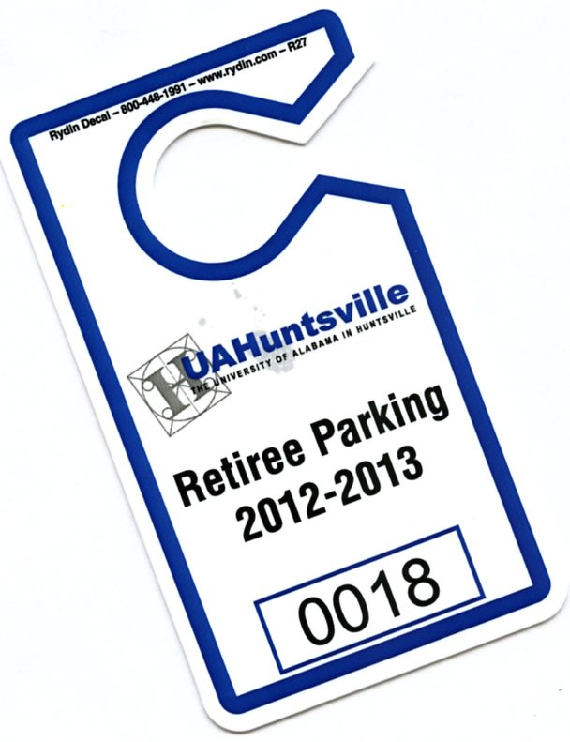
- You must complete a registration form for each RETIREE vehicle placard (form attached to this newsletter).
- These placards are not for student or employee vehicles.
- Placard hangs on your front mirror so it will be visible to officers during parking checks.
- You must renew your placard at the end of 2013.
- There will be a charge for replacement of a lost placard.
- You are subject to all the UAH traffic/parking rules just as you were as an employee.

Thank you to Chief Snellgrove for facilitating this privilege for the UAH retirees!

Board Nomination/Elections
Four of our Board members’ terms expire this year and new members must be nominated and elected. Departing members are Lee Cook, Val Seaquist, Joan Williamson and Carol Roach. These members will form a nominating committee to solicit nominations and commitments to serve if elected. A ballot will be sent to all active members in early April. “Active” means you are a lifetime member or your annual dues have been paid by March 31.

Please call one of these members to volunteer to be placed on the ballot or consider accepting if approached. The Board meets for an hour almost every month and there are some administrative duties for the officers and committee members but nothing is burdensome and it all goes toward maintaining a viable organization to support ALL OF US in retirement.

Don’t Forget to Track your Volunteer Hours
The UAHRA Board needs to record your volunteer hours for the year. (Note: for the purpose of this report, the “year” is February 1, 2012 – January 31, 2013.) These hours will be forwarded to the AERA office for inclusion in their State volunteer hours total. Our impressive number of volunteer hours last year was a factor in AERA awarding UAHRA the State Community Service Award. These hours can be any time devoted to non-family members—such things as: tutoring, providing transportation, donating blood, organized volunteer activities, public litter clean up, etc. Please call (256-851-7423) or email VJimval@aol.com to Val Seaquist before February 1st. Thank you!

Send Directory corrections/ changes to Val Seaquist at VJimval@aol.com

Always Looking for New Members
If you know UAH retirees who are not members, please encourage them to join. An organization such as ours always needs new ideas, helping hands and the strength that our mutual past brings. The UAHRA fee structure is listed below and a membership application form accompanies this newsletter. Our membership year runs from January 1 – December 31.

Type of membership:
- UAH retiree ($10.00)
- UAH retiree spouses–both UAH retirees ($15.00)
- UAH retiree and non-UAH retired spouse ($17.50)
- UAH retiree and non-retired spouse ($20.00)
- Surviving spouse of UAH retiree ($10.00)
- Associate member* (UAH employee within five years of retirement eligibility) ($10.00)
- Other individual applicants* (as approved by the Board) ($20.00)
- Lifetime (UAH retiree $100.00/UAH retiree & spouse ($150.00)

*Cannot vote or hold office

Minutes of the October 10th Membership Meeting are attached

UAHRA dues should be paid before March 31, 2013, to maintain your membership. (Lifetime members and new members since October 2012 are exempt.)

Remember when?

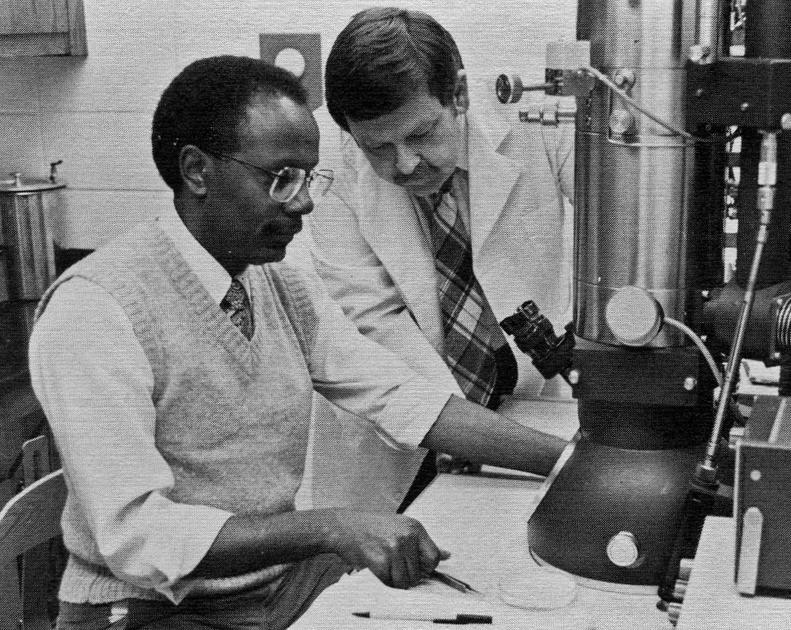
Harold Wilson & Sam Campbell

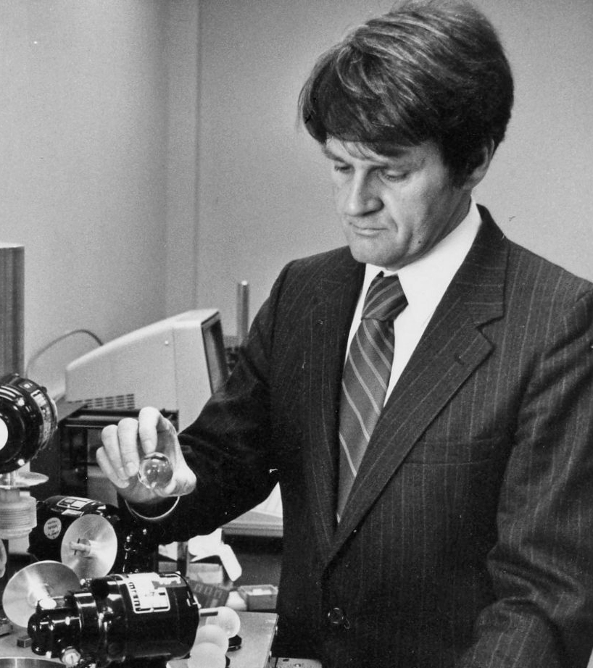
Gerry Karr

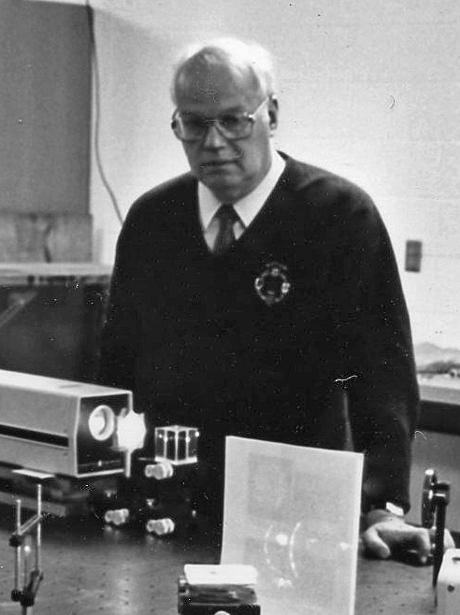

Graeme Duthie

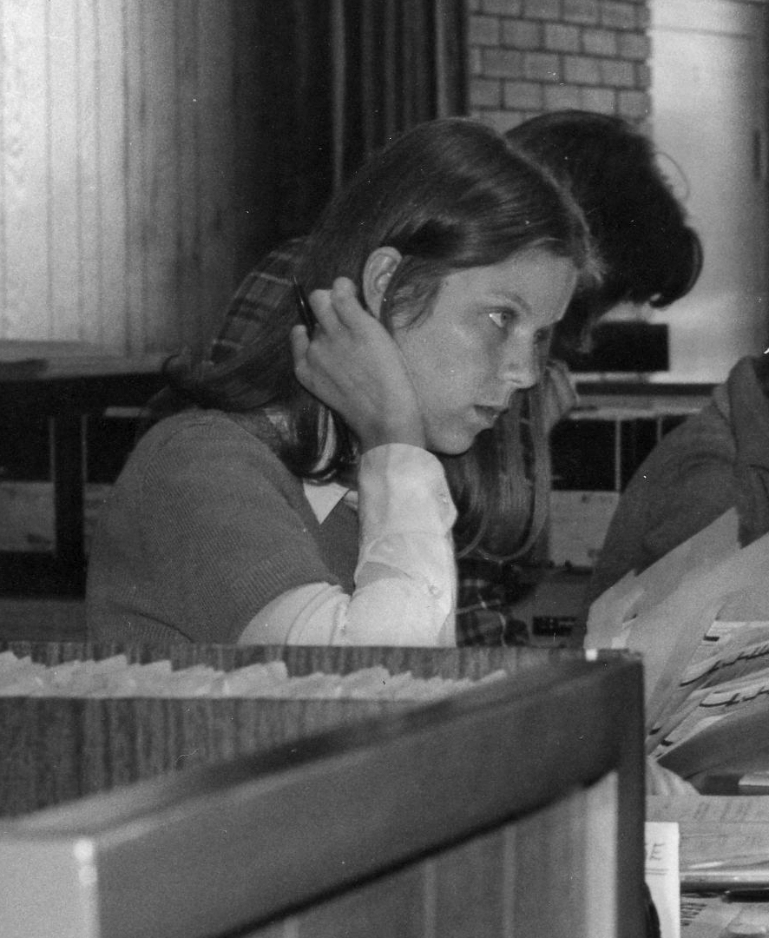
Val Seaquist
(remember Auto Check?)

