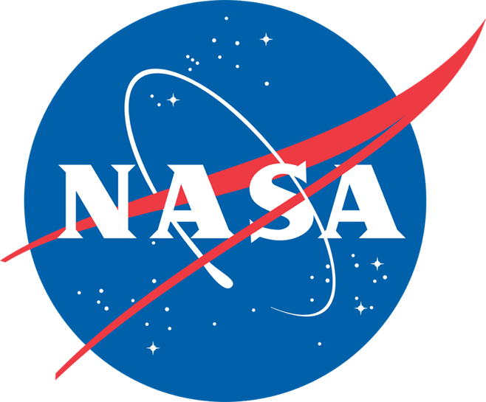
- The Marshall Space Flight Center is offering Faculty Fellowships for qualified STEM faculty at U.S. colleges and universities to conduct research with NASA colleagues during a ten-week residential program in Huntsville, Alabama.
- Faculty Fellows will receive stipends of $15,000 (Assistant Professor, Research Faculty), $17,000 (Associate Professor), or $19,000 (Professor).
- A relocation allowance of $1,500 will be provided to those fellows who live more than fifty miles from MSFC and a $500 travel supplement for one round-trip.
- Applicants must be U.S. citizens who hold full-time teaching or research appointments at accredited U.S. universities or colleges.
- During the ten-week program, fellows are required to conduct their research on-site at the Marshall Space Flight Center. A written final report is required at the end of the Fellowship.

Women and under-represented minorities, and persons with disabilities are encouraged to apply.
Website : https://www.uah.edu/asgc/applications/marshall-faculty-fellowship

Application Deadline February 15, 2019

June 3, 2019 – August 9, 2019

Marshall Faculty Fellowship Program
NASA Marshall Faculty Fellowship Program

Program Description

- The Marshall Faculty Fellowship program is a residential research experience. Fellows are required to conduct their research, during the ten-week program, on-site at the Marshall Space Flight Center.
- Participants cannot receive remuneration from other entities or other programs or other university or government sources during the Faculty Fellowship 10-week period.
- An oral presentation by the Fellow to the Marshall group with which s/he has been affiliated is required, near the end of the fellowship period.
- A written final report is required at the end of the Fellowship.
- A written evaluation of the program by the Fellow is expected at the end of the Fellowship.

Eligibility

- US citizen
- Full time teaching or research appointment at accredited US university or college.
- Fellowship is awarded for one summer period, but Fellow may apply again for a second year.
- Women, under-represented minorities, and persons, with disabilities are encouraged to apply.

Selection

The applications selected to be Faculty Fellows will be chosen by the Marshall group which has been assigned the area of investigation (concentration) chosen by the applicant.

Marshall Collaborator

A Marshall Collaborator will be identified to serve as the co-investigator and day-to-day contact. Near the end of the ten-week period, the Faculty Fellow and the Marshall Collaborator will prepare a white paper summarizing the summer effort, including results and recommending follow-up work.

Compensation

Stipends for Faculty Fellows are set as follows for the 10-week period:
Assistant Professors and Research Faculty $15,000
Associate Professors $17,000
Professors $19,000

A relocation allowance of $1,500 will be provided to fellows who live more than fifty miles from the Marshall Center.

A travel supplement of $500 will be provided to those fellows receiving the relocation allowance.

Website : https://www.uah.edu/asgc/applications/marshall-faculty-fellowship
Application

2019 Marshall Faculty Fellowship Program
NASA Marshall Space Flight Center
Applicant’s Full Name:
Permanent Home Address:
Email Address:
Home Telephone:
Cell Phone:
Applicant’s University Name and Work Address:
Present Academic Rank/Position:
Area of Current Research or Interest:
Work Telephone:
Fax Number:
Date of Birth:
Citizenship:
Gender:
Ethnicity (optional):
Starting Date at MSFC: | June 3, 2019
Ending Date at MSFC: | August 9, 2019
Ending Date should be at least 10 weeks after start date above – please add additional weeks if you will need time off for a conference or vacation
Designated MSFC Areas of Concentration in Which You Wish to be Engaged. If more than one area, rank them according to your interest.
(Choose from attached list Marshall Areas of Concentration; area should match your research expertise)
Name & Contact Info of MSFC Researcher with whom you have been in contact (if any – not required):

Please attach a resume/CV and this completed application form to an e-mail and send it to Debora Nielson at Debora.nielson@uah.edu by the deadline of February 15, 2019. If you have any questions, please call (256) 824-6800.

Applicant’s Signature Date

__________________________________________________
Printed Name

Marshall Space Flight Center
75 Areas of Concentration
Propulsion Systems
- Launch Propulsion Systems, Solid & Liquid
- In Space Propulsion (Cryogenics, Green Propellants, Nuclear, Fuel Elements, Solar-Thermal, Solar Sails, Tethers)
- Propulsion Testbeds and Demonstrators (Pressure Systems)
- Combustion Physics
- Cryogenic Fluid Management
- Turbomachinery
- Rotordynamics
- Solid Propellant Chemistry
- Solid Ballistics
- Rapid Affordable Manufacturing of Propulsion Components
- Advanced Manufacturing of Propulsion Elements
- Materials Research (Nano Crystalline Metallics, Diamond Film Coatings)
- Materials Compatibility
- Computational Fluid Dynamics
- Unsteady Flow Environments
- Acoustics and Stability
- Low Leakage Valves
- Propulsion Systems for Small Spacecraft
- Reaction Control Systems
- Rocket Plume / Regolith Interaction
- Propellant Storage and Transfer
Space Systems
- In Space Habitation (Life Support Systems and Nodes, 3D Printing)
- Mechanical Design & Fabrication
- Small Payloads (For International Space Station, Space Launch System)
- In-Space Object Awareness (Automated Rendezvous & Capture, De-Orbit, Orbital Debris Mitigation, Proximity Operations)
- Radiation Shielding
- Thermal Protection / Control
- Electromagnetic Interference
- Advanced Communications
- Small Satellite Systems (CubeSats)
- Structural Modeling and Analysis
- Spacecraft Design (CAD)
- Energy Storage Technologies
- Adaptive Computer Systems
- Flight Software
- Intelligent Agent Systems
Space Transportation
- Mission and Architecture Analysis
- In-Space Advanced Manufacturing
- Digital Manufacturing Technologies
- Space Environmental Effects and Space Weather
- Lander Systems and Technologies
- Small Spacecraft and Enabling Technologies (Nanolaunch Systems)
- 3D Printing/Additive Manufacturing/Rapid Prototyping
- Meteoroid Environment
- Friction Stir and Ultrasonic Welding
- Advanced Closed-Loop Life Support Systems
- Composites and Composites Manufacturing
- Wireless Systems
- Ionic Liquids
- Guidance, Navigation and Control (Autonomous, Small Launch Vehicle)
- Vehicle and Systems Health Management
- Martian Navigation Architecture/Systems
- Planetary Environment Modeling
- Autonomous Systems (reconfiguration, Mission Planning)
- Digital Thread / Product Lifecycle Management (for AM and/or Composites)
- Material Failure Diagnostics
Science
- Replicated Optics
- Large Optics (IR, visible, UV, X-Ray)
- High Energy Astrophysics (X-Ray, Gamma Ray, Cosmic Ray)
- Radiation Mitigation/Shielding
- Gravitational Waves and their Electromagnetic Counterparts
- Solar, Magnetospheric and Ionospheric Physics
- Causes of Space Weather
- Planetary Geology and Seismology
- Planetary Dust, Space Physics and Remote Sensing
- Surface, Atmospheres and Interior of Planetary Bodies
- Lunar Surface Science
- Earth Science Applications
- Convective and Severe Storms Research
- Lightning Research
- Data Informatics
- Disaster Monitoring
- Energy and Water Cycle Research
- Remote Sensing of Precipitation
- Lightweight Sensors for Aircraft and CubeSats
10/19/2018

