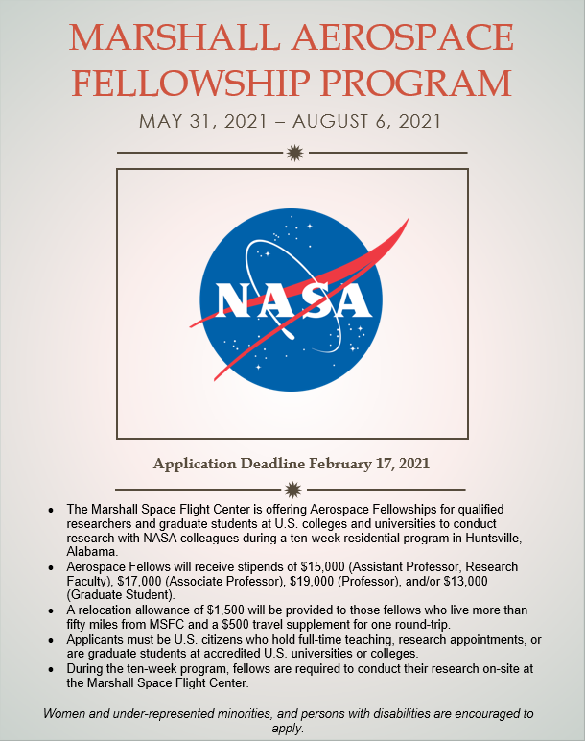

Application

2021 Marshall Aerospace Fellowship Program
NASA Marshall Space Flight Center
Applicant’s Full Name:
Permanent Home Address:
Email Address:
Home Telephone:
Cell Phone:
Applicant’s University Name and Work Address:
Present Academic Rank/Position:
Area of Current Research or Interest:
Work Telephone:
Fax Number:
Citizenship:
Gender:
Ethnicity (optional):
Starting Date at MSFC: |  | May 31, 2021
Ending Date at MSFC: |  | August 6, 2021
Ending Date should be at least 10 weeks after start date above – please add additional weeks if you will need time off for a conference or vacation
Designated MSFC Areas of Concentration in Which You Wish to be Engaged. If more than one area, rank them according to your interest.
(Choose from attached list Marshall Areas of Concentration; area should match your research expertise)
Name & Contact Info of MSFC Researcher with whom you have been in contact (if any – not required):

Please attach a resume/CV and this completed application form to an e-mail and send it to Brooke Graham at brooke.graham@uah.edu by the deadline of February 17, 2021. If you have any questions, please call (256) 824-6076.

Applicant’s Signature Date

__________________________________________________
Printed Name

NASA Marshall Aerospace Fellowship Program

Program Description

- The Marshall Aerospace Fellowship program is a residential research experience. Fellows are required to conduct their research, during the ten-week program, on-site at the Marshall Space Flight Center.
- Participants cannot receive remuneration from other entities or other programs or other university or government sources during the Aerospace Fellowship 10-week period.
- An oral presentation by the Fellow to the Marshall group with which s/he has been affiliated is required, near the end of the fellowship period.
- A written final report is required at the end of the Fellowship.
- A written evaluation of the program by the Fellow is expected at the end of the Fellowship.

Eligibility

- US citizen
- Full time teaching or research appointment, or graduate student appointment at an accredited US university or college.
- Fellowship is awarded for one summer period, but Fellow may apply again for a second year.
- Women, under-represented minorities, and persons with disabilities are encouraged to apply.
- Graduate student applicants must be chosen by the Faculty Researcher who is applying, and both must be matriculated at the same university. Each must submit a completed application. If selected by Marshall, the faculty member and the graduate student would be a team engaged in the same research project at Marshall. To be selected, the graduate student must remain enrolled at the same university for a minimum period of two years following the summer research, teaming with the faculty researcher.

Selection

The applicants selected to be Aerospace Fellows will be chosen by the Marshall group which has been assigned the area of investigation (concentration) chosen by the applicant.

Marshall Collaborator

A Marshall Collaborator will be identified to serve as the co-investigator and day-to-day contact. At the end of the ten-week period, the Aerospace Fellow and the Marshall Collaborator will prepare a white paper summarizing the summer effort, including results and recommending follow-up work.

Compensation

Stipends for Aerospace Fellows are set as follows for the 10-week period:
Graduate Students $13,000
Assistant Professors and Research Faculty $15,000
Associate Professors $17,000
Professors $19,000

A relocation allowance of $1,500 will be provided to fellows who live more than fifty miles from the Marshall Center.

A travel supplement of $500 will be provided to those fellows receiving the relocation allowance

Marshall Space Flight Center
62 Areas of Concentration

Propulsion Systems

- Launch Propulsion Systems, Solid & Liquid
- In Space Propulsion (Cryogenics, Green Propellants, Nuclear, Fuel Elements, Solar-Thermal, Solar Sails, Tethers)
- Propulsion Testbeds and Demonstrators (Pressure Systems)
- Combustion Physics
- Cryogenic Fluid Management
- Turbomachinery
- Rotordynamics
- Solid Propellant Chemistry
- Solid Ballistics
- Rapid Affordable Manufacturing of Propulsion Components
- Materials Research (Nano Crystalline Metallics, Diamond Film Coatings)
- Materials Compatibility
- Computational Fluid Dynamics
- Unsteady Flow Environments
- Acoustics and Stability
- Low Leakage Valves

Space Systems

- In Space Habitation (Life Support Systems and Nodes, 3D Printing)
- Mechanical Design & Fabrication
- Small Payloads (For International Space Station, Space Launch System)
- In-Space Asset Management (Automated Rendezvous & Capture, De-Orbit, Orbital Debris Mitigation, Proximity Operations)
- Radiation Shielding
- Thermal Protection
- Electromagnetic Interference
- Advanced Communications
- Small Satellite Systems (CubeSats)
- Structural Modeling and Analysis
- Spacecraft Design (CAD)

Space Transportation

- Mission and Architecture Analysis
- Advanced Manufacturing
- Space Environmental Effects and Space Weather
- Lander Systems and Technologies
- Small Spacecraft and Enabling Technologies (Nanolaunch Systems)
- 3D Printing/Additive Manufacturing/Rapid Prototyping
- Meteoroid Environment
- Friction Stir and Ultrasonic Welding
- Advanced Closed-Loop Life Support Systems
- Composites and Composites Manufacturing
- Wireless Data & Comm. Systems
- Ionic Liquids
- Guidance, Navigation and Control (Autonomous, Small Launch Vehicle)
- Systems Health Management
- Martian Navigation Architecture/Systems
- Planetary Environment Modeling
- Autonomous Systems (reconfiguration, Mission Planning)
- Digital Thread / Product Lifecycle Management (for AM and/or Composites)
- Material Failure Diagnostics

Science

- Replicated Optics
- Large Optics (IR, visible, UV, X-Ray)
- High Energy Astrophysics (X-Ray, Gamma Ray, Cosmic Ray)
- Radiation Mitigation/Shielding
- Gravitational Waves and their Electromagnetic Counterparts
- Solar, Magnetospheric and Ionospheric Physics
- Planetary Geology and Seismology
- Planetary Dust, Space Physics and Remote Sensiong
- Surface, Atmospheres and Interior of Planetary Bodies
- Earth Science Applications
- Convective and Severe Storms Research
- Lightning Research
- Data Informatics
- Disaster Monitoring
- Energy and Water Cycle Research
- Remote Sensing of Precipitation

November 2019

