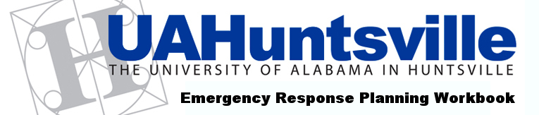

MISCELLANEOUS RESOURCES

Use this form to list the basics to make your recovery site operational, such as office furniture, safes, mail bins, and other items needed for the recovery location. Consider any unique recommendations for people with special needs.

You can download copies of this form from: http://facilities.uah.edu/erp/forms.htm
Save a blank version so you can make additional copies as needed.

Item | Quantity | Primary Supplier/Vendor | Alternate Supplier/Vendor | Recovery Install Location
Chairs
Desks
Extension cords
Drop cords
Surge protectors
Power strips
File cabinets
Mail bins
Portable air conditioners / fans
Safes
Tables
Waste baskets
Other
Explain:

