Charleston Farmhouse, near Firle, Sussex

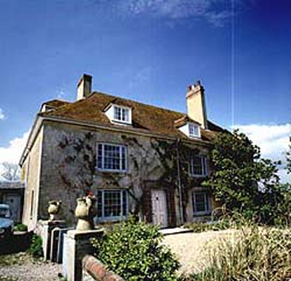  "It's most lovely, very solid and simple, with...perfectly flat windows and wonderful tiled roofs. The pond is most beautiful, with a willow at one side and a stone or flint wall edging it all round the garden part, and a little lawn sloping down to it, with formal bushes on it." Vanessa Bell (qtd from Charleston website www.charleston.org.uk/ ) | Vanessa Bell and her family lived 6 miles away from Virginia Woolf’s country house at Rodmell, near the hamlet of Firle, in a farmhouse called Charleston. Vanessa began renting Charleston in October 1916, encouraged by Virginia, who found the place, and also by the fact that her friends Duncan Grant and David Garnett needed a farm to work on in order to maintain their conscientious objector status during WWI. Duncan and Vanessa took on the interiors of the house itself as an art project, painting walls and furniture, turning it into one big studio. Vanessa, Duncan, and Vanessa’s husband Clive Bell spent summers there for the rest of their lives (Vanessa died in 1961, Clive in 1964, Duncan in 1978). It was the place that all three of Vanessa’s children thought of as home.  They always rented, never owned it, and when Duncan Grant died, it had fallen into disrepair. Amazingly, it contained “nearly 2,000 works of art, including paintings, murals, decorated furniture, ceramics, and textiles” (Mark Hussey: Virginia Woolf A-Z, 55). It has been preserved as a museum by a London art dealer, who set up the Charleston Trust in 1980, which bought it in 1981, and opened it to the public in 1986. The gift shop sells works inspired by the Charleston artists, including pottery by Vanessa’s son, Quentin Bell.  The house is open Wed-Sun, 2-6 pm, April through October.

Charleston became the center of Bloomsbury in the country. Vanessa frequently entertained house guests. Lytton Strachey (pronounced. STRAY-chee) and Maynard Keynes (pronounced as in “canes”) were regulars. Mark Hussey says “the house gradually became a living example of the decorative arts popularized by Vanessa, Duncan, Roger Fry, and others” (55).

Vanessa and Duncan’s relationship was highly unconventional. Vanessa remained married to Clive Bell, by whom she had two sons, Julian (1908-37) and Quentin (1910-96), but she lived with the painter Duncan Grant. They had been lovers since 1914, but by 1916 Duncan (a bisexual, primarily homosexual) was in a relationship with David (Bunny) Garnett. In 1918, Vanessa and Duncan decided to have a child together, and their daughter Angelica Bell was born on Christmas Day 1918. Apparently, that was the end of Vanessa’s sexual relationship with Duncan (or with anyone else), although they continued to lived together as partners for the rest of their lives, dividing their time between England and France. Angelica thought Clive Bell was her father until she was 17, and she eventually married Bunny Garnett, who had been her father’s lover and who was also much in love with her mother. They had four children, and then separated in the 1960s. After Duncan’s death, she went back to live at Charleston. Later she wrote a memoir about growing up in this strange household, Deceived with Kindness (1985). Vanessa Bell, Duncan Grant, and Quentin Bell are buried in the West Firle churchyard.

Vanessa Stephen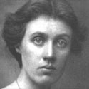 | “We went over to Charleston yesterday. Although thinking quite well of ourselves, we were not well received by the painters. There they sat like assiduous children at a task in a bedroom—Roger, Nessa, & Duncan; Roger on a chair in foreground; Nessa on sofa, Duncan on bed. In front of them was one jar of flower, & one arrangement of still live. . . . Clive was sitting in the drawing room window reading Dryden.” (Woolf, Diary, 6 Aug 1923) | 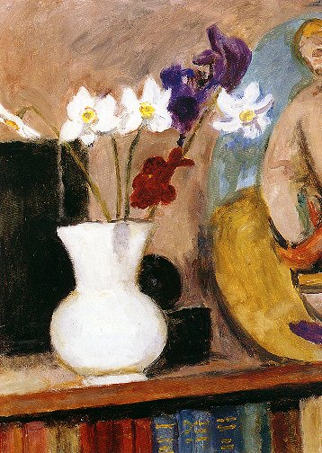  Irises and Narcissi in a White Vase. Vanessa Bell 1950 | 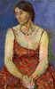  Vanessa Bell  by Duncan Grant 1918

Items Relevant to Woolf at Charleston (from orlando.jp.org/VWSGB/dat/charlstn.html)

Dining-Room
The English glass cabinet in the corner of the room, by the front window, came from 22 Hyde Park Gate, Virginia’s childhood home. It contains decanters and brandy-glasses from that period.
Clive Bell’s Library
The round dining-table in the centre of the room belonged to Dadie Rylands. The famous lunch recorded by Virginia in A Room of One’s Own was eaten at this table.
The Spare Bedroom
The dressing table belonged to Julia Stephen, Virginia’s mother. In writing about her mother’s death, Virginia mentioned this piece of furniture: ‘I remember the long looking-glass; with the drawers on either side ... and the great bed on which my mother lay’ (Moments of Being, Hogarth Press, 1985, pp. 91-2).
The Garden Room
Above the radiator is a painting by Vanessa Bell, ‘46, Gordon Square’, the Stephens’ first home in Bloomsbury.
Wall Between The Garden Room And Vanessa Bell’s Bedroom
G. F.Watts’ portrait of Maria Jackson, Virginia’s grandmother.
Vanessa Bell’s Bedroom
Beside the tall cupboard is a pastel by Duncan Grant of Angelica Bell, aged seventeen, dressed as Ellen Terry for her role in Virginia Woolf’s play, Freshwater.
The Studio
The Dutch walnut glass-fronted cabinet once belonged to the novelist, W. M. Thackeray. Vanessa inherited it from her father, Sir Leslie Stephen, whose first wife had been Thackeray’s younger daughter, Minnie. Presumably it came from 22 Hyde Park Gate.
For some of Virginia’s references to Charleston, see Diary, 16 August 1918, 5 March 1919, 26 September 1920, 26 August 1922, 6 August 1923; Letters, no. 2307, 5 January 1931.
Note: These descriptions are verbatim from the website cited.

“Bloomsberries” (see also http://therem.net/bloom.htm and http://www2.truman.edu/~pgately)
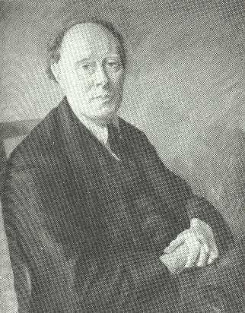 |  | 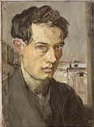 | 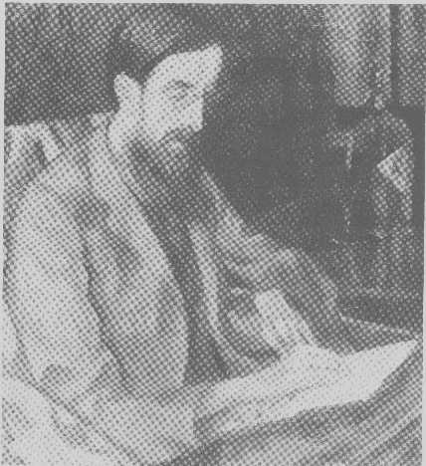 | 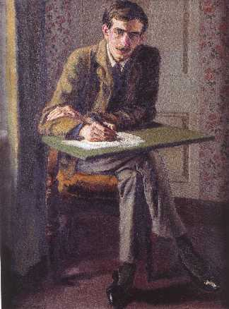 | 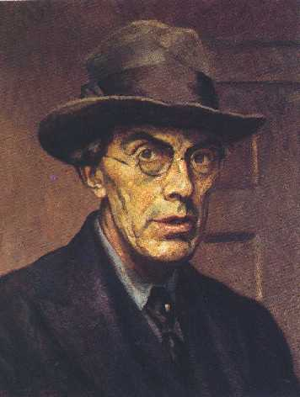
Clive Bell by Roger Fry  1925 |  | Duncan Grant self-portrait, 1910 | Lytton Strachey by Roger Fry  1917 | Maynard Keynes by Duncan Grant, 1908 | Roger Fry self-portrait, 1928
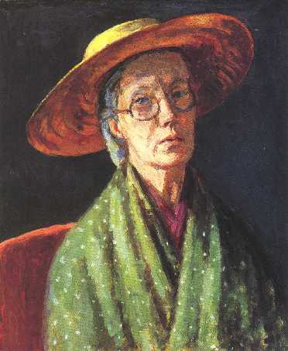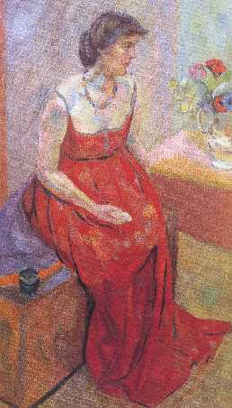 |  |  | 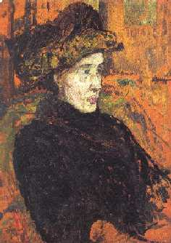 | 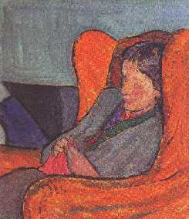 | 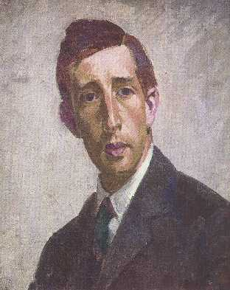
Vanessa Bell  self-portrait, 1959 | Vanessa Bell  by Roger Fry, 1916 |  | Virginia Woolf  by Duncan Grant, 1911 | Virginia Woolf by Vanessa Bell (1911-12) | Leonard Woolf by  Henry Lamb (1912)

