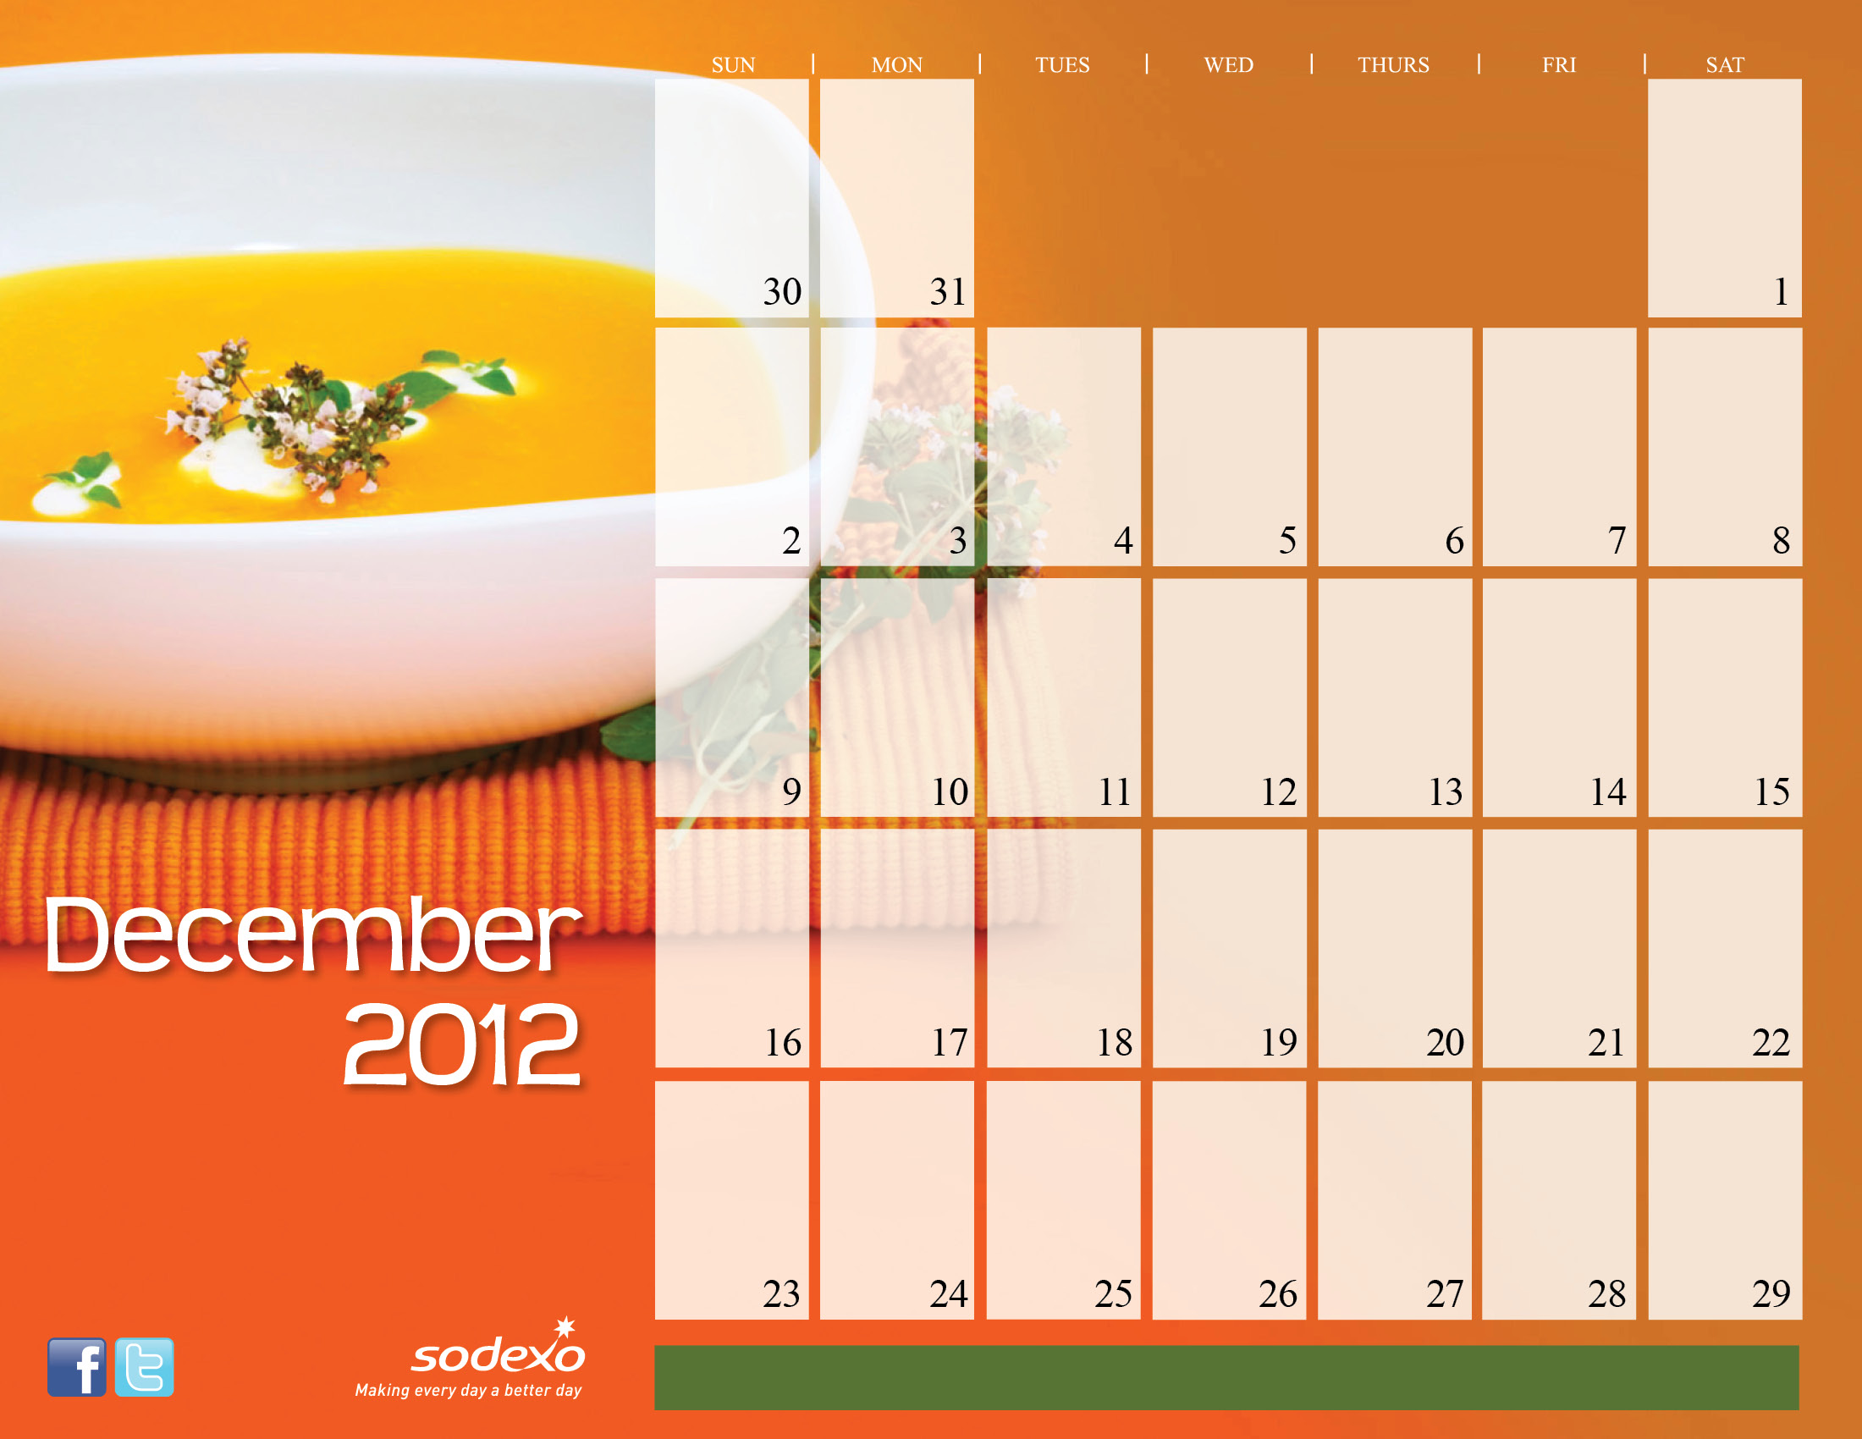

LATE
NIGHT Breakfast


Holiday Break


Christmas Day

UAHuntsville Dining Services Website: www.uah.edu/dining

