GPA calculator

Locate your transcript at: http://register.uah.edu, click on Student & Financial Aid, click on Student Records, click on Academic Transcript

At the end of 1st semester your transcript will look something like this:

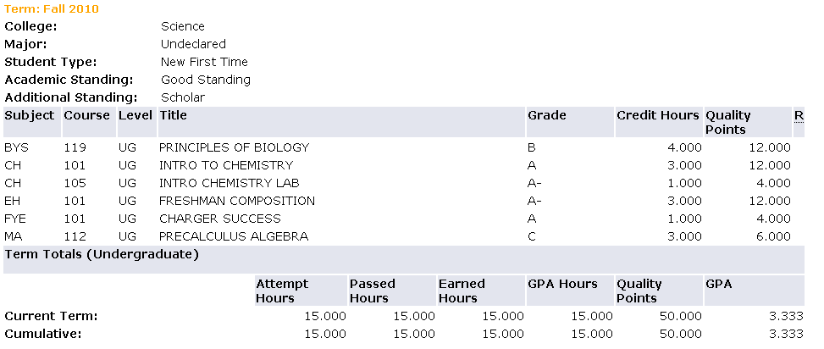

At the end of the year (Fall and Spring semester) your transcript will look something like this:
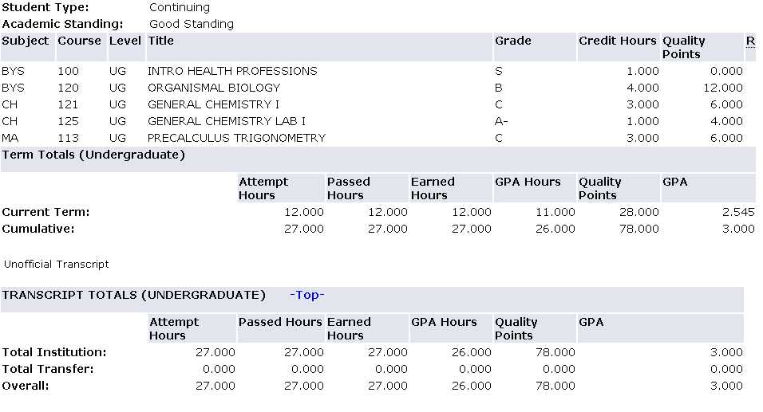

Total Insitution = UAHuntsville courses

Total Transfer = Credits earned from: Community Colleges, other 4 year colleges, AP, IB and CLEP tests.

* Your GPA is based on UAHuntsville courses only*
Transfer courses, AP, IB and CLEP courses do not count toward your UAHuntsville GPA!
What does this all mean?
- Attempt Hours = All courses you have taken at UAHuntsville.
- Passed Hours = Number of hours earned from the classes you have passed at UAHuntsville.
(includes non-credit & P/F courses)
- Earned Hours = Number of hours earned from courses you have passed. MA 004 will not count here.
- GPA hours = The number of hours used to calculate the GPA
- Quality Points =The grade (A, B, C, D, F) multiplied* by the quality hours for the course.
- GPA = Grade point average

Current Term = Semester GPA = Semester Quality Points/semester GPA Hours

Cumulative = Overall GPA = Cumulative Quality Points /cumulative GPA Hours

Assignment 1: Compute your predicted GPA
- Column #1: Copy the courses you are taking from your transcript.
- Column #2: Copy the hours each course is worth.
- Column #3: Copy your GPA hours. Usually, the same as column 2.
Note: MA 004 does not count towards your UAHuntsville GPA.
- Column #4: Fill in your expected grade.
- Column #5: Fill in the appropriate Multiplier (see the table below)
- Column #6: For each row multiply GPA hours (column 3) by the multiplier (column 5) to get the quality points (column 6).
- Add up your totals for columns 3 and 6.
- Divide the total column 3 total by the column 6 total to get your predicted semester GPA.

#1 | #2 | #3 | #4 | #5 | #6
Course | Hours | GPA hours | Expected grade | Multiplier see below * | Quality points
MA 004 | 3 | 0 | S | ---- | ---- | example
EH 101 | 3 | 3 | B | 3 | 9 | example
#8

Predicted

GPA

(Quality pts / GPA hours)

#7 Predicted semester totals |  |  | ------- | ---------

* Multipliers:
A = 4.0 | B = 3.0 | C = 2.0 | D = 1.0 | F = 0.0
Grades of P, S, U, AU, W and I do not count toward GPA

Assignment 2: Compute your predicted GPA again!
Change one three credit course grade down one letter grade.
For example, if you predicted you will earn a B in English 101,
change the grade to a C and recalculate your GPA.

Notice the difference one letter grade can make!

- Column #1: Copy the courses you are taking from your transcript.
- Column #2: Copy the hours each course is worth.
- Column #3: Copy your GPA hours. Usually, the same as column 2.
Note: MA 004 does not count towards your UAHuntsville GPA.
- Column #4: Fill in your expected grade.
- Column #5: Fill in the appropriate Multiplier (see the table below)
- Column #6: For each row multiply GPA hours (column 3) by the multiplier (column 5) to get the quality points (column 6).
- Add up your totals for columns 3 and 6.
- Divide the total column 3 total by the column 6 total to get your predicted semester GPA.

#1 | #2 | #3 | #4 | #5 | #6
Course | Hours | GPA hours | Expected grade | Multiplier see below * | Quality points
MA 004 | 3 | 0 | S | ---- | ---- | example
EH 101 | 3 | 3 | B | 3 | 9 | example
#8

Predicted

GPA

(Quality pts / GPA hours)

#7 Predicted semester totals |  |  | ------- | ---------

* Multipliers:
A = 4.0 | B = 3.0 | C = 2.0 | D = 1.0 | F = 0.0
Grades of P, S, U, AU, W and I do not count toward GPA

Assignment 3: Compute your predicted GPA F vs. W
Calculate your GPA with one 3 credit course with a grade of F

#1 | #2 | #3 | #4 | #5 | #6
Course | Hours | GPA hours | Expected grade | Multiplier see below * | Quality points
MA 004 | 3 | 0 | S | ---- | ---- | example
EH 101 | 3 | 3 | B | 3 | 9 | example
#8

Predicted

GPA

(Quality pts / GPA hours)

#7 Predicted semester totals |  |  | ------- | ---------

A = 4.0 | B = 3.0 | C = 2.0 | D = 1.0 | F = 0.0
Grades of P, S, U, AU, W and I do not count toward GPA

Calculate your GPA with the same 3 credit course with a grade of W

#1 | #2 | #3 | #4 | #5 | #6
Course | Hours | GPA hours | Expected grade | Multiplier see below * | Quality points
MA 004 | 3 | 0 | S | ---- | ---- | example
EH 101 | 3 | 3 | B | 3 | 9 | example
#8

Predicted

GPA

(Quality pts / GPA hours)

#7 Predicted semester totals |  |  | ------- | ---------

