CALCULUS A REVIEW SHEET

Derivative Definition
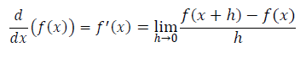
Basic Properties of Derivatives
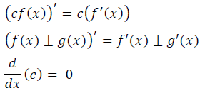
Product Rule
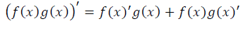
Quotient Rule
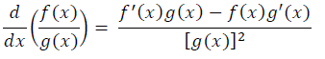
Power Rule
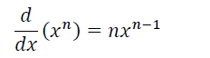
Chain Rule
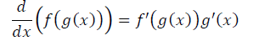
L’Hopital’s Rule
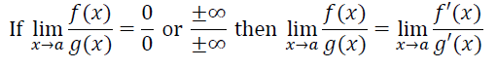
Limit Properties
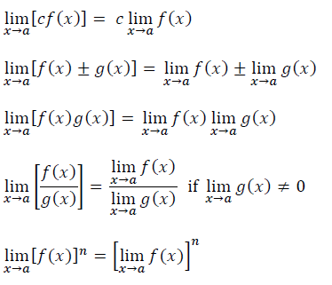
Common Derivative Formulas
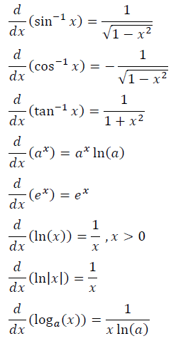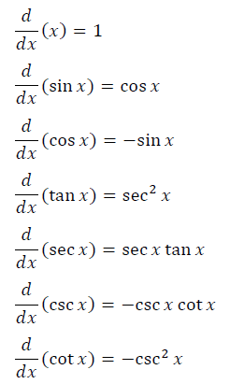
CALCULUS A REVIEW SHEET

Integral Definition
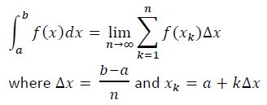
Fundamental Theorem
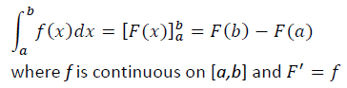
Integral Properties
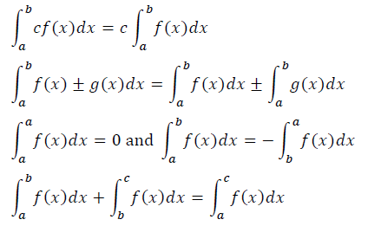
Integration by Parts
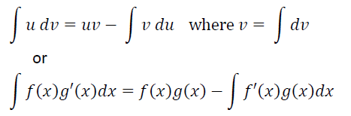
Integration by Substitution
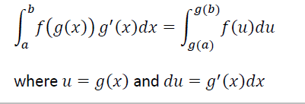
Common Integrals