OUTREACH
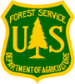
Monongahela National Forest
GS-0499-04, PATHWAYS Soil Scientist Trainee
Duty Station: Elkins, WV
Date of this Notice: February 26, 2014
Outreach Closes: March 19, 2014

The Monongahela National Forest is outreaching for a PATHWAYS Soil Scientist Trainee. The purpose of this Outreach Notice is to determine the potential applicant pool for this position and to establish the appropriate recruitment method and area of consideration for the advertisement (e.g., target grade or multi-grade and service-wide, region-wide, government-wide, or DEMO). Responses received from this outreach notice will be relied upon to make this determination.

This position is assigned to the Ecosystems Group and supervised by the Forest Soil Scientist. Primary duties will include training as a soil scientist for the Monongahela National Forest. The duty station is the Monongahela National Forest, Supervisor's Office in Elkins, WV. Individuals needing additional information on duties of the position may contact Stephanie Connolly, Forest Soil Scientist, at 304-636-1800 ext. 244 or via email to sconnolly@fs.fed.us.

FOREST SERVICE EMPLOYEES ON THE WORKFORCE REDUCTION PLACEMENT SYSTEM LIST WILL RECEIVE PRIORITY CONSIDERATION AND CTAP/ICTAP CANDIDATES WILL RECEIVE THE APPROPRIATE CONSIDERATION.

THE POSITION
This position works directly with a professional soil scientist on the Monongahela NF (Supervisor’s Office), to learn how the Forest Service conducts soil resource assessment, management and restoration. The person selected will learn to perform field assessment and conduct mapping exercises to evaluate soils issues in specific project areas, and make management interpretations for various soil types. This information will be used to inform management and other natural resource specialists about the inherent capability of the landscape to meet desired management objectives and to predict potential future impacts and prescribe mitigations for any proposed activities to help maintain the productivity of the soil resource on the landscape. The employee will work in an interdisciplinary environment with other natural resource specialists to help them meet their land management objectives, without degrading the soil resource. Once training is completed permanent placement of the candidate will be within the US Forest Service. This placement is indefinite with possible conversion to a permanent position within the agency for which the graduate meets OPM qualifications. Work will be to bring information about the soil resource forward to help create informed land management decisions during project planning. To meet the expectations of this permanent position the candidate will need to meet OPM qualifications for a professional soil scientist upon competition of their education.

OPM QUALIFICATIONS TO BE A SOIL SCIENTIST (Series 0470)
Basic Requirements
1.Degree: soil science or a closely related discipline that included 30 semester hours or equivalent in biological, physical, or earth science, with a minimum of 15 semester hours in such subjects as soil genesis, pedology, soil chemistry, soil physics, and soil fertility.
or

2.Combination of education and experience: courses equivalent to a major in soil science or a related discipline that included at least 30 semester hours in the biological, physical, or earth sciences. At least 15 of these semester hours must have been in the areas specified in A above, plus appropriate experience or additional education.

Qualifications Requirements for this position can be found in the Office of Personnel Management (OPM) Operating Manual for Qualification Standards for General Schedule Positions, which is available from any Federal Government Personnel Office and OPM website (http://www.opm.gov/qualifications/index.asp).

About the Monongahela National Forest:
The Monongahela National Forest consists of over 921,150 acres of Federal ownership in 10 West Virginia counties, making it the fourth largest National Forest in the 20 northeastern states. The Forest is within a day’s drive of one-third of the population of the United States and is a recreation destination and tourism attraction hosting over 3 million visitors annually. The topography is varied with elevations ranging from 900 feet at Petersburg to 4,863 at Spruce Knob, the highest point in West Virginia. The Forest has four Ranger Districts, 2 Visitor Centers, 5 Wilderness Areas, and the Spruce Knob – Seneca Rocks National Recreation Area (the nation’s first Forest Service National Recreation Area).

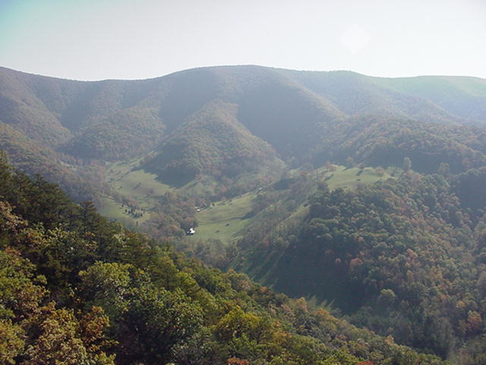

Community Information:

The Monongahela National Forest is located in the central portion of West Virginia’s Appalachian Ridge and Valley and Allegheny Plateau physiographic regions. The species diversity combined with the rural setting and interesting cultural environment, contribute to the unique lifestyle of the region. Add to that the friendliness of the people and recreational opportunities and you have the reasons why Elkins has been consistently rated among the top 100 small towns in the United States.

Elkins, in Randolph County, West Virginia is a community of 8,000 and boasts a reasonable cost of living, low crime rate, and enviable location nestled in the Appalachian Mountains. Surrounded by primarily forested landscapes interspersed with mountain meadows and rangeland, opportunities abound for outdoor recreation enthusiasts. Recreation opportunities include three nearby downhill ski areas, cross-country skiing, five golf courses, whitewater boating, rock climbing, fishing, hunting, backpacking, mountain biking, caving, and nature watching. The proximity of the Monongahela National Forest to numerous State Parks and Forests adds to the number of locations available for such recreational activities in the Elkins area. The position is located at the Forest Supervisor’s Office, which is easily accessible and within walking distance of all amenities.

As a trade center for one of the largest rural communities in the eastern U.S., Elkins has many of the services of a larger city, including Davis Memorial Hospital which has 90 beds and includes a Family Birthing Center, Pain Management Center, surgical services, Cardiac and Vascular Diagnostic Center, Imaging Services, and Sleep Disorder Services.

Also in the Elkins community is a new high school, middle school, vo-tech center, four K-5 schools, a Montessori pre-school, and Davis and Elkins College, a small liberal arts school within city limits.

There are a number of other state and private colleges or universities, including West Virginia University, Alderson-Broaddus College, West Virginia Wesleyan College, Salem International University, University of Charleston, Fairmont State University, and Glenville State College within one-half to two hour commuting distance.

Shopping choices range from large chains to locally owned specialty stores. Driving distances to metropolitan areas include 4 hours to the Washington, D.C. – Baltimore area, 2.5 hours to Pittsburgh, and 4.5 hours to Philadelphia.

Named one of the hundred best small arts communities in the U.S., Elkins has an active theatre and concert schedule, opportunities to learn or buy fine arts, take dance lessons, or enjoy a wide variety of live music (from bluegrass to symphonic bands) on a weekly basis. The internationally recognized Augusta Heritage Program, a 5-week celebration of cultural and folk arts, offers a tremendous range of classes, concerts, and dances right in the heart of town. Each year, Elkins hosts the Mountain State Forest Festival, one of the largest festivals in the state. The Randolph County Community Arts Center offers visitors and residents year-round opportunities for cultural enrichment.

Elkins is a short distance from three major ski resorts—Snowshoe Mountain Resort, Canaan Valley Resort, and timberline. The area offers an array of outdoor activities, including kayaking/canoeing, hunting and fishing, caving and rock climbing and access to numerous golf courses. Elkins was recently named the top mountain biking destination in the country.

The area supports several fitness centers for adults and presents a diverse assortment of organized sports and recreation activities for children. Randolph County is the home of a Rail to Trails project that converts unused railroad tracks to finished trails, perfect for walking, jogging, biking, or cross-country skiing.

Elkins is one of the top five tourist destinations nationally. In recent years, not only was Elkins named one of the 100 best small towns to live in but one of the 100 best small arts communities. Quality of life is supported by a low crime rate, a low cost of living, good school systems, and communities that foster the growth and development of children, both intellectually and physically.

National and international airports are located within 175 miles.

Additional information on the Elkins area can be obtained at http://www.elkinswv.com/

For more information about the position, please contact:

Stephanie J. Connolly
Forest Soil Scientist
Monongahela NF Supervisor’s Office
304-636-1800 ext. 244
sconnolly@fs.fed.us

Interested applicants and those wishing to be notified of the Vacancy Announcement when it’s available, please complete the enclosed form and send via e-mail or fax.

OUTREACH NOTICE
Monongahela National Forest
SOIL SCIENTIST (PATHWAYS)
Respond to sconnolly@fs.fed.us by March 19, 2014
Fax: 304-637-0582

Position Title/Series/Grade: PATHWAYS SOIL SCIENTIST TRAINEE GS-0499-04
Duty Station: Elkins, WV

PERSONAL INFORMATION:

Name: Date:

Address: Phone No:

E-mail address:

WORK EXPERIENCE:

Are you currently a Federal employee? Yes No

IF YES: Current Agency, position and location: ____________________________________

Type of Appointment: Permanent Term Temporary

(Optional) If you are not a current permanent (career or career conditional) employee, are you eligible for appointment under any of the following special authorities?
Person with Disabilities
Veterans Readjustment
Former Peace Corps Volunteer
Disabled Veteran w/30% Compensable Disability
Student Career Experience Program
Veterans Employment Opportunities Act of 1998
Other

Briefly describe why you will be a quality candidate for this position:

Thank you for your interest in this position!

Office of Personnel Management.

