THE UNIVERSITY OF ALABAMA IN HUNTSVILLE
CHARTER OF UNIVERSITY CYBERSECURITY AND POLICY ADVISORY COUNCIL
-INTERIM-
Number 02.01.37
Division Office of Information Technology (OIT)
Date August 2015
Purpose The purpose of this policy is to establish and state the charter of the University Cybersecurity and Policy Advisory Council.

Policy This policy establishes The University of Alabama in Huntsville (UAH) Cybersecurity and Policy Advisory Council (CPAC). The CPAC’s purpose and charge shall be to serve in an advisory function in the area of cybersecurity. In carrying out this role, CPAC shall work to promote better understanding, cooperation, and communication regarding the cybersecurity and cybersecurity policy within the campus community for the benefit and betterment of all.

The CPAC shall respond to issues presented to it by its own members and committees, the university administration, or university affiliates.
Procedure
1.0 Membership

The CPAC is chaired by the UAH Chief Information Security Officer (CISO) and includes representation from the university population. Members of the CPAC will be distributed as follows:

- Office of the Provost and Executive Vice President for Academic Affairs (1 member)
- Faculty Senate (2 members)
- Office of Research and Economic Development (1 member)
- Office of Finance and Administration (1 member)
- Office of Counsel (1 member)
- Office of Internal Audit (1 member)
- Division of Student Affairs (1 member)
- Student Government Association (1 member)
- UAH Chief Information Officer (CIO) (1 member)
- UAH Chief information Security Officer (CISO) (1 member)

The UAH CISO and CIO will be ex officio, non-voting members of the CPAC except in the case of tie. In cases of tied voting, either the CISO or CIO will cast the tie-breaking vote.

Membership will be reviewed annually, or as needed due to staffing changes.

- Meetings

The CPAC will meet once each academic semester, at a time and location, which is sensitive to work schedules. The CISO will be responsible for scheduling and the agenda for CPAC meetings; however, floor discussions are always open at the meetings.

Special meetings of the CPAC shall be called by the CISO in cases where urgent university issues must be addressed before the next regularly scheduled meeting is to occur.

- Committees

The CPAC is self-regulating with respect to its organization and purpose, and, as such, may create such committees as are deemed necessary to facilitate its work. Committee membership is solicited from the CPAC. Committees shall serve as advisory bodies for specific matters falling within their province.

Review The UAH Cybersecurity and Policy Advisory Council is responsible for the review of this policy every three years (or whenever circumstances require).

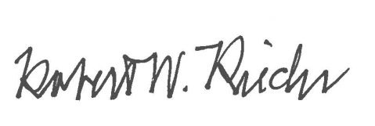
Approval

Chief University Counsel
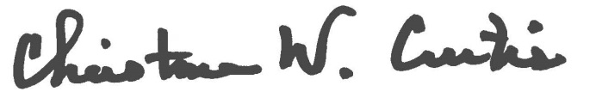

Provost and Executive Vice President for Academic Affairs
APPROVED:

President

