Administrative Brief for Faculty Senate for September 2020
Prepared by Dr. Darren Dawson and Dr. Christine Curtis
10//21/2020
Faculty Senate Report
Facilities Report
- Spragins Hall Exterior Renovations – Pearce Construction Company is still completing roof flashing installation, exterior sealant installation and modification of exterior metal trim details. Pearce Construction Company was also the successful low bidder for the Exterior Column Wrap project. Construction is tentatively scheduled for completion by the end of the year.
- Bevill Conference Center Cooling Tower Replacement – After review and approval of the Construction Schedule with all project stakeholders, JK Johnson Mechanical Contractors began work on September 14, 2020. The required HVAC shutdown and new equipment tie-in will be conducted at the end of the semester, after the students are gone. Therefore, project substantial completion is anticipated for December 21, 2020.
- Shelby Center Exterior Renovations (Phase 1) – The project revised UAS Stage II Submittal received approval by the Board of Trustees on September 17, 2020 including an updated scope of work and project budget. The project is currently in the Construction Documents phase with the Design Professionals scheduled to submit a preliminary design review package to DCM this month. The project remains on schedule for bidding in January with the start of Construction scheduled for March 2021.
- Altenkirch Lawn “Greenway” Phase III - The project UAS Stage III Submittal received approval by the Board of Trustees on September 17, 2020. The project is currently in the Construction Documents phase. A preliminary design package has been reviewed and approved by DCM. The project remains on schedule for bidding in November, submission of a Stage IV Submittal to the UAS Board of Trustees in February, and the start of construction in March 2021.
- Campus IT Data Center Hardening Upgrades – the project UAS Stage I Submittal and Stage II Waiver received approval by the Board of Trustees on September 17, 2020. The project is currently in Schematic Design as we work with the Design Professionals and OIT to determine the most optimum location on campus and the required programmatic needs for the new facility. Currently, we are planning to submit for a Stage III Submittal to the UAS Board of Trustees in February 2021.

Miscellaneous Items
- Update on recent police incident
- Proceeding with a pilot program proposal to Board of Trustees for in-state tuition rate for students from Tennessee – November 2020

Academic Affairs
Academic Affairs Dean Search and Dean Reviews
- Dean of Science. The interviews for the top two candidates for the College of Science dean search will be completed by the end of the week of October 23rd.
- Dean Karen Clanton of the College of Professional and Continuing Studies has been reappointed.
- Green review
Policies
- Interim Policies – Due December 1, 2020
02.01.51—Communicable Disease Policy (interim)

- Interim Policies – Due February 1, 2021
02.01.52—Summer School Operations Policy (interim)
02.01.70—NC SARA Professional Licensure Notification (interim)

- Outstanding Policies -- Due November 20, 2020
These policies were sent to the Faculty Senate in December 2019 with return comments and recommendations due in the late spring 2019.
02.01.xx—Authorship and Classroom Material Selection Policy
02.01.xx—Electronic Signatures

Commencement
The Commencement Committee met on Friday, 10/16/2020, to discuss further details of Fall Commencement. The ceremony will be held at Von Braun Center on December 14 and 15, 2020. Two ceremonies are planned for each day. Ceremonies will be by college or several colleges combined. 240 to 260 graduates can be seated on the floor. Each graduate will receive four tickets for guests. Faculty may attend, will be given a ticket, and can sit in either the lower or upper tier. The ceremony will be simple with the emphasis placed on the graduates walking across the stage and having their picture taken with the President. Music will be piped in. Details of the ceremony were discussed with the committee. There will not be any receptions after the ceremonies.

Spring Class Schedule
Spring 2021
(Classes Begin on Wednesday)
January 1 Friday Winter Break – University Closed
January 4 Monday University Re-Opens
**January 6 Wednesday Classes Begin Moved
**January 13 Wednesday Classes Begin
January 18 Monday MLK Holiday (University Closed)
**January 21 Thursday Last day to add class without special approvals
**January 21 Thursday Last day to drop and receive a refund
February 1 Monday Application deadline for Graduate degree Spring and
Bachelor’s degree Summer semester candidates
**February 3 Wednesday Last day to apply Pass/Fail
**February 10 Wednesday Last day to change from credit to audit
**February 26 – March 5 Mid Term grading available for 100 & 200 level courses
March 23 Tuesday Honors Day – No classes
**March 25 Thursday Last day to withdraw
**March 29 – April 2 Monday-Friday Spring Break Holiday (University Closed) Cancelled
April 6 Tuesday Last day to submit Thesis/Dissertation Spring candidates
April 23 Friday Classes End
April 24 & 25 Saturday/Sunday Study Days
April 26 – April 30 Final Exams
May 3-4 Final Exam Makeups
May 5 Wednesday Commencement, TBA
Staff will be able to take the spring break holiday leave during spring semester.

ACT Test Optional Admissions Pilot
The University of Alabama in Huntsville’s Plans for ACT/SAT Test-Optional Admissions Pilot
for Academic Years 2021-2022 and 2022-2023
When news reports highlighted the difficulty high school students are having in accessing ACT/SAT tests during the COVID-19 pandemic, UAH faculty and staff became concerned about the effect of this lack of access on potential applicants. UAH is an institution steeped in the tradition of using ACT test scores not only for admissions but also for placement in different courses, and in the awarding of scholarships. Hence, Academic Affairs established an ACT Task Force charged with examining if UAH should allow ACT test-optional admissions during the 2021-2022 and 2022-2023 academic years. The ACT Task Force was comprised of deans and associate deans of academic colleges, chairs, faculty, staff, and the Vice President for Diversity, Equity, and Inclusion and was chaired by the Dean of the Honors College.
The ACT Task Force evaluated the competitive advantages and disadvantages of not requiring the ACT/SAT test during the pandemic and found that most of the universities with which UAH directly competes already have some form of ACT or SAT test-optional admissions, placing UAH at a competitive disadvantage. Nationwide, many institutions have had a test-optional policy for some time and typically experience a boost in applications and admitted students. The literature reviewed by the ACT Task Force showed that ACT/SAT test scores correlate closely with family income but poorly with academic success in college as measured by freshman GPA or graduation rate. By contrast, high school GPA correlates weakly with family income and highly with academic success in college. An analysis of UAH data agreed with the literature. ACT test scores of UAH students are a weak predictor of student success in terms of grades in freshman mathematics and English courses or of the overall GPA of graduating students. The ACT test scores are intercorrelated with high school GPA for UAH students. However, the ACT Task Force’s analysis further showed that the ACT test scores add little to the prediction of UAH GPA when the high school GPA is accounted for. The ACT Task Force inferred that “students admitted solely by GPA are at least as likely to succeed as students admitted based on both.” The ACT Task Force will continue to evaluate UAH data more extensively to evaluate effective predictors of academic success.
The ACT Task Force recommends a pilot test-optional policy for the 2020-21 and 2021-22 admissions cycles for admission in fall 2021 and fall 2022 due to the COVID-19 pandemic.
UAH proposes to run a pilot study to allow applicants to choose whether they submit ACT test scores for admission during the academic years 2021-2022 and 2022-2023. Applicants who choose to submit ACT scores will be admitted using the current admission criteria of an applicant with a 2.9 high school GPA and an ACT test score of 20 is a strong candidate. Applicants who are unable to submit or who choose not to submit an ACT or SAT test score will be admitted based on high school GPA of 2.7 or above. Applicants who are rejected may appeal the decision.
The current scholarship matrix that uses high school GPA and ACT test score will be applied to applicants who submit ACT/SAT scores. For those applicants who do not submit ACT scores, scholarships will be based on high school GPA and other academic factors such as core GPA, strength of high school course selection, a writing sample, and a letter of recommendation.
Faculty 180 Governance Committee Report

MEMORANDUM

TO: Faculty Senate

FROM: Dr. Derrick Smith and Suzanne Simpson, Co-Chairs, Faculty 180 Governance Committee

DATE: 10/21/20

RE: Implementation of shifting annual and comprehensive reviews to a digital version
On behalf of the Faculty180 (F180) Governance Committee, we would like to submit this report to the Faculty Senate. During the summer, Suzanne Simpson, Karen Freemon, Malcolm Rice, and I met with Interfolio (parent company that owns F180) to review and receive training on their newest product. The product is named “Review, Promotion, and Tenure”, or (RPT), and this product is the newest software within the Interfolio Suite for universities to use for internal reappointment and appointment decisions. We found that overall, RPT was a much more intuitive product containing features that are merely “drag and drop” and the documentation reviews can be done within the browser window. Throughout the summer, we tested the system and set up a “template” for reappointment and comprehensive files (i.e. dossiers).

Test of RPT for Submitting Comprehensive Files. At this point, we asked Dr. Curtis for permission to pilot test RPT with a few faculty members who were submitting their comprehensive files this fall. We currently have three faculty members in this pilot: two in the College of Education and one in the College of Arts, Humanities, and Social Sciences. All three faculty members have successfully submitted their comprehensive files with limited issues, and external evaluator letters were added by the Department chairs, while the files are now with the Chairs and Department Committees. We are providing training and support to all faculty that are reviewing these dossiers at each level.

Change to RPT from F180 Evaluation Software. The F180 Governance Committee met on 9/10/20 and again on 9/28/20 to discuss RPT. At each meeting, we reviewed the advantages and disadvantages of the new software but ultimately the committee made the recommendation to shift immediately over to RPT from the F180 evaluation software. The primary reason that the Committee decided to make this immediate change to RPT is that Interfolio recently informed us that while F180 will continue to be their benchmark product for data collection, the company will, however, be phasing out development and support for the evaluation features in F180. We WILL continue to use F180 for annual Faculty Activity Reports (FAR) as that system will continue to be supported by Interfolio.

Implementation Plan for RPT. The already established implementation plan called for the Colleges of Education, Business, Nursing, and Arts, Humanities, and Social Sciences to begin using Faculty180 for annual reappointment dossiers in the Spring 2021 semester. The Committee decided to include ALL colleges in the use of RPT starting in Spring 2021 in order to circumvent the challenges of reviewing dossiers in the midst of the COVID-19 pandemic.

Recommendation Approved. The Committee recommendation was submitted to the Provost and Dean’s Council with a demonstration and discussion of the software on 10/7/20. The Dean’s and Provost voted to approve the recommendation on 10/14/20.

Training. The F180 Governance Committee is currently working on a “training plan” for the transition. We are currently creating “How-To” guide documents as well as short videos. We plan to also provide training sessions via Zoom for all lecturers, clinical faculty, and tenure-earning faculty that are required to submit a reappointment file (dossier). We will begin providing the training for faculty beginning in November and continue through the end of January.

We also plan to provide training for all faculty that serve on Department Committees and PTAC as well as Chairs and Deans. This training will occur in January and February.

Pass/Withdrawal for Fall 2020 and Spring 2021

We are instituting Pass/Withdrawal option for Fall semester 2020 and Spring semester 2021 out of concern for our students, some of whom are feeling overwhelmed. We are also concerned about our enrollment for spring and want to give students who are facing challenges a way to continue with their studies. For Fall 2020 and Spring 2021, we will enforce the prerequisite requirements as was stated in the document which was sent out to students, faculty and staff on Friday, October 16, 2020. We are relaying to students the clear message about the possible consequences of electing a P rather than a course grade, as employer, graduate school, and professional school feedback is that they will not look upon such grades favorably.

Pass/Withdraw Grading Option Available for Fall 2020 and Spring 2021
Updated: 10/16/2020
In response to recent surveys, faculty and students expressed concerns over outcomes and successful completion of the Fall 2020 semester. In recognition of the continuing hardships caused by the COVID-19 pandemic on students and faculty and the resulting changes in course delivery, UAH is extending the Pass/Withdraw grading option that was followed in Spring 2020 to the entire 2020-2021 academic year. A Pass, Withdraw, or Incomplete may not be the best option for all students, but may be appropriate in some circumstances. Students are strongly advised to consult with academic advisors concerning their specific situations.
Details are set forth below. Please be sure to read the entire document. In addition, frequently asked questions (FAQs) are attached.
Pass/Withdraw Grade Option
For each course, students have two grading options: keeping the traditional letter grade or choosing Pass/Withdraw. The Pass/Withdraw option is being offered to relieve some of the understandable anxiety that some of our students and faculty are experiencing. This change is also made in recognition of our core principle that the mental and physical health and safety of students, faculty, and staff must remain paramount as we cope with the COVID-19 crisis. Students who wish to keep their assigned letter grade may do so.
Considerations
- Students must understand that a decision to switch to Pass/Withdraw for a given course or for all of their courses may have an impact on scholarship retention, financial aid, academic standing, eligibility for Dean’s List and other academic achievement designations based solely on performance during the Fall 2020 or Spring 2021 semesters.
- Students must earn at least a 3.0 GPA in order to maintain their scholarships. So, at least one course must remain in the traditional letter grade format with a B or higher.
- If a course is a prerequisite for a subsequent course, students must earn a high enough grade in order to advance to the next course, even though they switch to Pass grading. For example, Calculus B requires at least a C- in Calculus A. A student currently taking Calculus A who earns a C is allowed to switch to Pass grading, and move on to Calculus B; a student who earns a D in Calculus A is allowed to switch to Pass grading but will not be allowed to move on to Calculus B.
- Students must understand that Pass/Withdraw grades might not be considered by graduate or professional schools during the application process. Students should consult with advisors concerning their specific situations to discuss the effect of selecting the Pass/Withdraw option for given courses on their major, progress toward graduation, scholarship, athletics eligibility, etc.
- Some courses and programs do not allow the use of Pass grading (see below)

Eligibility
The Pass/Withdraw option applies for all Fall 2020 and Spring 2021 terms (full and partial). Students can select the Pass/Withdraw option on a course-by-course basis. Instructions will be provided in a subsequent message. The opportunity to use the Pass/Withdraw option applies to all levels of courses (Charger Foundations, major courses, minor courses, electives, and graduate courses).
In some circumstances, students or programs may not be able to use the Pass/Withdraw option. Admission to some programs (e.g., nursing) and external accrediting/certifying agencies (e.g., teacher education) may require that students take courses in a traditional grading format. Students in the College of Nursing and in the bachelor’s and master’s degree programs in Teacher Education will not be able to use Pass grading and are advised to speak with their advisors for clarification. Those students would still be able to request a Withdraw in order to retake the course. However, students who choose the Withdraw option may not have sufficient hours for financial aid purposes.
Academic Progress and GPA
A grade of Pass can be awarded for grades of D- or higher for undergraduate courses or a C- or higher for graduate courses.
A Pass grade will not count toward students’ grade point averages (for purposes of scholarships and otherwise), but all hours earned in courses with a Pass grade will count towards curricular, major, continuation, semester hours, and graduation requirements.
A grade of Pass will NOT NECESSARILY satisfy prerequisites for subsequent courses. Students must earn the required grade in a prerequisite course in order to move to higher-level courses, even if they elect to switch to Pass grading. The earned grade will be maintained within the records system in order to certify prerequisite satisfaction, but will not be revealed to anyone outside of UAH and will not appear on the transcript.
Process
For the Fall 2020 and Spring 2021 semesters, students will complete all assignments and exams through the remainder of the semester. Faculty will submit grades as usual after the final exam period. Students will log in to their Banner account to view their grades, then elect to keep the grade assigned or request the grade be switched to a Pass or a Withdraw.
The default option is for students to receive a letter grade. It is vital that you consult with your advisor about the implications of keeping your grades as they are posted at the end of term or changing one or more of them to Pass/Withdraw. Your academic advisor will help you make the best informed decision based on your current academic standing, your current GPA, your current course work, and your plans after graduation.
Students wishing to exercise the Pass/Withdraw option for one or more courses will follow a process currently being finalized. You will receive a separate communication with instructions on how to make any desired changes to Pass/Withdraw grading for your class schedule.
Faculty will not be notified of a student's choice. The decision by a student to use the Pass/Withdraw option is treated with strict confidentiality.
After selected, Pass/Withdraw grades cannot later be changed to letter grades.

Synopsis of Student and Faculty Surveys
- Students and Faculty are deeply concerned about outcomes this semester.
It is not surprising that the top concern among students is grades. Students expressed fears of being able to successfully finish the semester and what that might do to graduation/degree progress. There were also several comments suggesting that students are having greater difficulty than usual, and that the workload in courses and difficulty of exams have been ramped up by faculty to counter perceived cheating. While this is unlikely, students probably are finding the new delivery modes more time consuming and difficult due to the increased level of self-motivation and independence required.
However, concern over grades do not tell the whole story of student outcomes. According to the fixed responses on Question 4, students also rated the lack of connection to faculty and students, inability to communicate, and missed opportunities for extra-curricular activities as significant concerns. Several comments in this question and question 15 also indicated students are concerned about what they are learning, or missing, for future courses.

Q4 (student) - What are your biggest concerns with remote learning (online, remote access)? (Check all that apply.)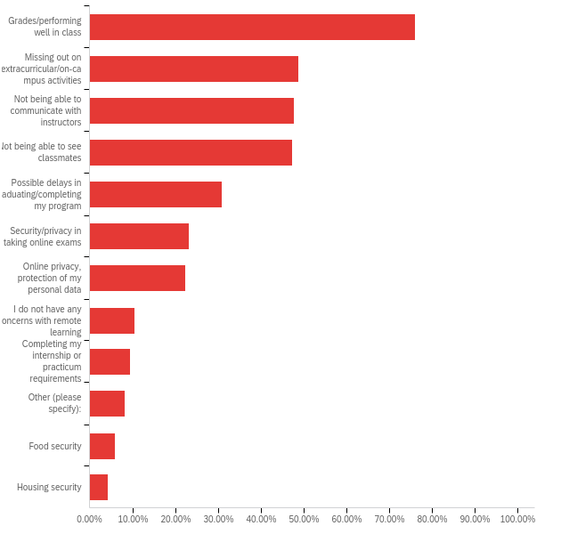

Q2 (student) - Which of the following learning/educational issues are a current challenge for you this Fall? (Check all that apply)

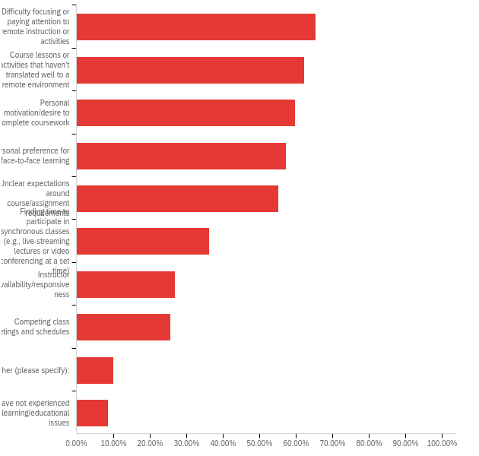

Q14 (student) - How confident are you that you will be able to manage completing your coursework online and on-campus for the remainder of the term?

# | Field | Minimum | Maximum | Mean | Std Deviation | Variance | Count
1 | 0-Not at all Confident; 10-Extremely Confident | 0.00 | 10.00 | 6.33 | 2.68 | 7.17 | 1288
On the faculty side, diminished student learning, security/privacy in online exams, not being able to communicate with students, and negative evaluations of teaching effectiveness were the greatest concerns. In addition, faculty comments expressed struggles with the changes to online/remote in terms of emotional well-being, the burden of managing multiple modes of enrollment of the same course, and their fear that they are not able to deliver a quality course and the subsequent impact on students. Our faculty are working very hard, but struggling in many ways.

Q4 (faculty) - What were your biggest concerns with the transition to online/remote learning for the Fall? (Check all that apply.)

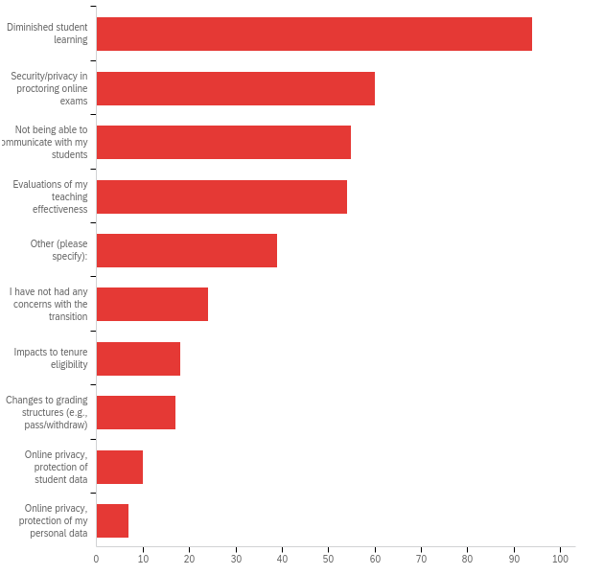

Q3 (faculty) - Which of the following were challenging for you in adapting course design and/or assignments to remote learning for the Fall? (Check all that apply.)

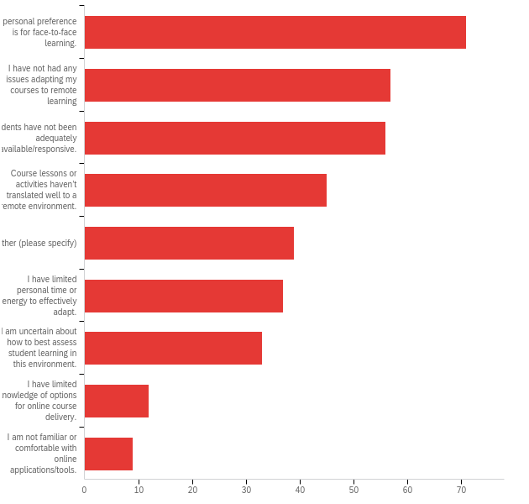

- There’s a slight mismatch between student and faculty preferred teaching modes.

Question 19 on the faculty survey and Question 9 on the student survey asked about the most preferred format for Spring 2021 courses. Faculty were pretty evenly split among the four choices, with Synchronous Online being the slightly favored approach. On this same question, students preferred Traditional, on-campus courses and Asynchronous Online, with Synchronous Online rated least preferred by a wide margin. This preference was validated by question 33 that asked which format has been most appealing this semester. Again, Asynchronous online and traditional were the top two choices, with synchronous online being a distant third.

It should be noted that comments from students indicate they are concerned about maintaining an online schedule in order to avoid meal plan and housing charges. It is possible that their ranking of asynchronous online is partly driven by financial reasons as opposed to true preference.

Q19 (faculty) - What is your preferred teaching format for Spring 2021 courses? (check all that apply)

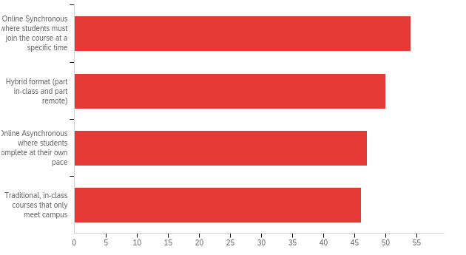

Q9 (student) - What is your most preferred format for Spring 2021 courses?
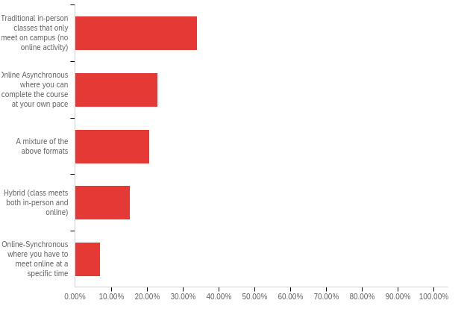

Q33 (student) - Which of the following have you found to be most successful or appealing this semester? (check all that apply)

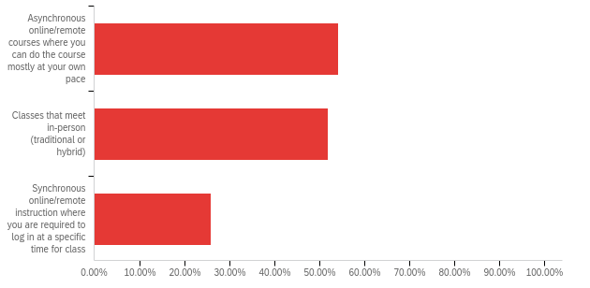

- Students plan to return for Spring 2021 and mode of delivery does not seem to matter in that decision.

There were five critical questions related to registration for Spring semester. Question 18 directly asked students whether they plan to return for Spring 2021. Approximately, 83% responded YES, 4% No, and 12% were undecided as yet. This is approximately equal to the typical persistence from fall to spring semesters.

Questions 35-38, then, asked about likelihood of enrolling in Spring 2021 under different delivery modes. For each question, if you collapse the “extremely likely” and “somewhat likely” choices you get a range of 70-72%; collapsing the “extremely unlike” and “somewhat unlikely” choices, you get a range of 12-16%. So it doesn’t appear as though mode of delivery will significantly impact likelihood of enrollment.

Independent of the impact on likely enrollment, there may well be several other reasons to consider a shift in the distribution of delivery modes. Given the vast number of comments about lack of connection, communication challenges, desire for on-campus activities, worry about grades, and stress from both faculty and students, there may well be reason to have a more open campus in the spring semester.

Q18 (student) - Do you plan to continue your education at UAH next term?

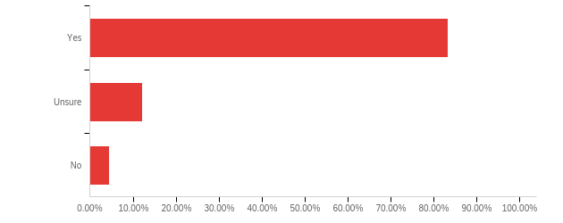

Q35 (student) - If courses are primarily traditional, in-person and only meet on campus, how likely are you to enroll in Spring 2021?

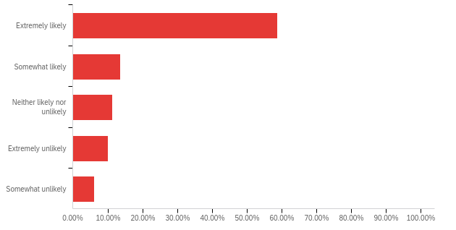

Q36 - If courses are primarily online, how likely are you to enroll in Spring 2021?

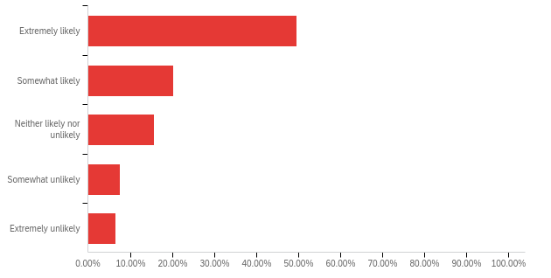

Q37 (student) - If courses are primarily hybrid (class meets both in-person and online), how likely are you to enroll in Spring 2021?

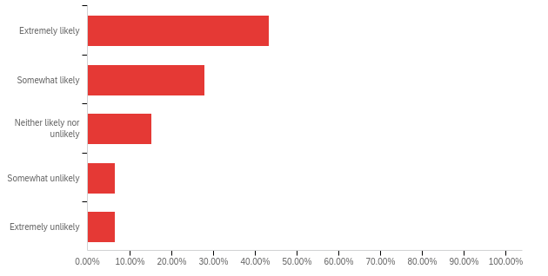

Q38 (student) - If there is a mixture of some traditional courses and some online courses (no hybrid), how likely are you to enroll in Spring 2021?

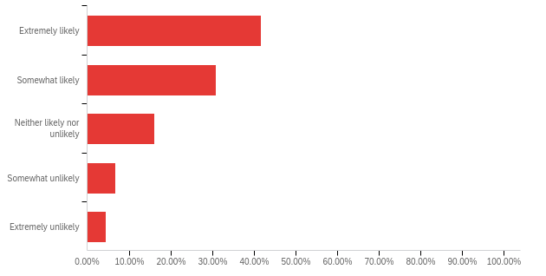

MEMORANDUM

TO: Faculty Senate

FROM: Dr. Derrick Smith and Suzanne Simpson, Co-Chairs, Faculty 180 Governance Committee

DATE: 10/21/20

RE: Implementation of shifting annual and comprehensive reviews to a digital version
On behalf of the Faculty180 (F180) Governance Committee, we would like to submit this report to the Faculty Senate. During the summer, Suzanne Simpson, Karen Freemon, Malcolm Rice, and I met with Interfolio (parent company that owns F180) to review and receive training on their newest product. The product is named “Review, Promotion, and Tenure”, or (RPT), and this product is the newest software within the Interfolio Suite for universities to use for internal reappointment and appointment decisions. We found that overall, RPT was a much more intuitive product containing features that are merely “drag and drop” and the documentation reviews can be done within the browser window. Throughout the summer, we tested the system and set up a “template” for reappointment and comprehensive files (i.e. dossiers).

Test of RPT for Submitting Comprehensive Files. At this point, we asked Dr. Curtis for permission to pilot test RPT with a few faculty members who were submitting their comprehensive files this fall. We currently have three faculty members in this pilot: two in the College of Education and one in the College of Arts, Humanities, and Social Sciences. All three faculty members have successfully submitted their comprehensive files with limited issues, and external evaluator letters were added by the Department chairs, while the files are now with the Chairs and Department Committees. We are providing training and support to all faculty that are reviewing these dossiers at each level.

Change to RPT from F180 Evaluation Software. The F180 Governance Committee met on 9/10/20 and again on 9/28/20 to discuss RPT. At each meeting, we reviewed the advantages and disadvantages of the new software but ultimately the committee made the recommendation to shift immediately over to RPT from the F180 evaluation software. The primary reason that the Committee decided to make this immediate change to RPT is that Interfolio recently informed us that while F180 will continue to be their benchmark product for data collection, the company will, however, be phasing out development and support for the evaluation features in F180. We WILL continue to use F180 for annual Faculty Activity Reports (FAR) as that system will continue to be supported by Interfolio.

Implementation Plan for RPT. The already established implementation plan called for the Colleges of Education, Business, Nursing, and Arts, Humanities, and Social Sciences to begin using Faculty180 for annual reappointment dossiers in the Spring 2021 semester. The Committee decided to include ALL colleges in the use of RPT starting in Spring 2021 in order to circumvent the challenges of reviewing dossiers in the midst of the COVID-19 pandemic.

Recommendation Approved. The Committee recommendation was submitted to the Provost and Dean’s Council with a demonstration and discussion of the software on 10/7/20. The Dean’s and Provost voted to approve the recommendation on 10/14/20.

Training. The F180 Governance Committee is currently working on a “training plan” for the transition. We are currently creating “How-To” guide documents as well as short videos. We plan to also provide training sessions via Zoom for all lecturers, clinical faculty, and tenure-earning faculty that are required to submit a reappointment file (dossier). We will begin providing the training for faculty beginning in November and continue through the end of January.

We also plan to provide training for all faculty that serve on Department Committees and PTAC as well as Chairs and Deans. This training will occur in January and February.

