Administrative Brief for Faculty Senate for February 2021
Prepared by Dr. Darren Dawson and Dr. Christine Curtis
2/9/2021
Faculty Senate Report
Facilities Report
- Spragins Hall Exterior Renovations – Completion of the front entry column, beam & soffit cladding remains on-schedule for completion at the end of February 2021.

- Shelby Center Lab 341 Renovations – Substantial completion is scheduled for late February 2021 with User move-in scheduled for completion in March 2021.

- 2021 Campus Pavement & Drives Refurbishment – Beginning in March, North Alabama Paving will conduct various asphalt and concrete pavement repairs as directed by Facilities & Operations through October 2021.

- BAB Cyber Security Lab – In December, Redmond Construction Company was awarded the project. Construction is scheduled to begin in February with substantial completion and user move-in scheduled for the summer of 2021.

The University has several active projects currently in planning, design and bidding with the possibility of up to six major projects starting construction in the first quarter of 2021.

- Altenkirch Lawn “Greenway” Phase III - Competitive bids for the project were received on December 17, 2020 with all bids exceeding the approved project budget. The design professionals are currently working through cost reduction options in an effort to complete revised construction documents by the end of January. The project is scheduled to advertise on January 31st with bid opening scheduled for February 25, 2021. Pending successful bids and approval from the UAS Board of Trustees in April, the start of construction is scheduled for May 2021.

- Shelby Center Exterior Renovations (Phase 1) – The project is currently in the bidding phase with bid opening scheduled for February 4th. Anticipated start of Construction is tentatively scheduled for March 2021.

- Campus IT Data Center Hardening Upgrades – The project is currently in Preliminary Design as we continue to work with the Design Professionals to finalize the programmatic needs for the new facility. Currently, we are planning to submit for a stage III Submittal to the UAS Board of Trustees in April 2021. The anticipated start of Construction is summer 2021.

- 2021 Roof Replacements Projects – Construction documents are complete for Cramer Research Hall, Johnson Research Center, Olin B. King Technology Hall and Optics Building. These projects are currently planned to receive funding from Alabama PSCA capital bonds. The projects are scheduled to bid in March with the anticipated start of Construction set for summer 2021.

- Roberts Hall Renovations – UAH Facilities & Operations (F&O) has requested design professionals revisit programming and planning efforts conducted in 2017 in order to determine current needs for the project. F&O has also requested for a proposal to conduct a Facilities Conditions Assessment to help determine the full project needs and scope of work. Programming and planning efforts are scheduled to begin this month.

- Shelbie King Hall Renovations – UAH Facilities & Operations (F&O) has been directed to begin programming and planning efforts to determine a conceptual project scope of work and respective total project budget. F&O has also requested for a proposal to conduct a Facilities Conditions Assessment to help determine the full project needs and scope of work.

- Executive Plaza Buildings Demolition – UAH Facilities & Operations (F&O) completed conceptual programming and planning efforts and implemented safety and security site improvements in November. Project funding sources and project delivery methods are currently under advisement with the goal to begin demolition of vacated structures in poor condition in 2021.

- Campus Lake Dredging and Repairs – UAH Facilities & Operations (F&O) has engaged a Design Professional to provide a survey of existing conditions in order to verify the total project scope of work and estimate of probable cost. Construction is anticipated to begin the summer of 2021 upon completion of the spring academic semester.

- Spragins Hall Interior Renovations – UAH Facilities & Operations (F&O) has been approved to move forward with design development to verify total project scope and budget. We have submitted for approval a Stage I Submittal with a Stage II Waiver to the UAS Board of Trustees for the February 2021 Board Meeting. Construction could begin late in the 2021 Spring Semester and continue through the 2021 Fall Semester.

Miscellaneous Items

- Update - Vaccination Plan – In coordination with the ADPH, we have ordered 1000 COVID-19 vaccine doses. We do not know when we will receive the doses. We are developing a plan to vaccinate employees who fall under the Phase 1a - Healthcare Workforce guidelines.

Academic Affairs

Academic Affairs Dean Search and Dean Reviews
- Associate Provost for Academic Integrity and International Services and Dean of the Graduate School: Search is underway. Nominations and applications are being accepted. Associate Provost Brent Wren is chairing the search committee.
- Dr. Sean Lane is serving as Acting Associate Provost for International Services and Dean of the Graduate School while continuing his duties as Dean of the College of Arts, Humanities and Social Sciences.
- Dean Marsha Adams is retiring as July 31, 2021. A search committee for the Dean of the College of Nursing is being constituted. Dean Bill Wilkerson will chair the search committee.
- Dean Karen Clanton is retiring on May 31, 2021. A search committee will be constituted shortly.
- Dean Jason Greene of the College of Business is undergoing his fifth-year review.
- Dean Sean Lane is undergoing mid-term review as Dean of the College of Arts, Humanities and Social Sciences.
Policies
Academic Misconduct Policy was sent to Faculty Senate on January 19, 2021 for review. All recommendations from the Faculty Senate and SGA were incorporated into the policy. The policy was shortened by eliminating redundancies. Please review the policy and return by the end of April so that the policy can go into effect fall semester.
Status of Reappointments in RPT

110 our 116 faculty have submitted their files; one resigned; one has an extension; four have not yet submitted.

SACS COC CV Submission Deadline Extended from March 1 to April 1, 2021

Although most faculty have already submitted their CVs for the SACS COC Fifth -Year Review, the deadline has been extended to April 1 in case anyone needs extra time.

Spring Semester 2021 Schedule

January 13: Start of Classes
January 18: Martin Luther King Day
April 23: End of Classes
April 24 & 25: Study days
April: 26 Finals begin
May 5: Commencement
Enrollment and Retention Data for Spring Semester 2021
Census Enrollment
Spring 2021 vs Spring 2020 COVID-19 Pandemic Enrollment Summary
 |  | This Year |  | Last Year |  | Difference | %
Undergraduate |  | 7316 |  | 7388 |  | -72 | -0.97%
Graduate |  | 1892 |  | 1821 |  | 71 | 3.90%
Total |  | 9208 |  | 9209 |  | -1 | -0.01%
As of Date |  | 1/28/2021 |  | 1/21/2020

Fall to Spring Retention - First Time Freshmen Cohort
 | Column Labels
 | NOT RETAINED |  | RETAINED |  | Total STUDENTS | Total %
Row Labels | STUDENTS | % | STUDENTS | %
Fall 2018 | 79 | 5.51% | 1356 | 94.49% | 1435 | 100.00%
FULL-TIME | 75 | 5.25% | 1353 | 94.75% | 1428 | 100.00%
PART-TIME | 4 | 57.14% | 3 | 42.86% | 7 | 100.00%
Fall 2019 | 113 | 7.55% | 1384 | 92.45% | 1497 | 100.00%
FULL-TIME | 109 | 7.32% | 1380 | 92.68% | 1489 | 100.00%
PART-TIME | 4 | 50.00% | 4 | 50.00% | 8 | 100.00%
Fall 2020 | 124 | 9.22% | 1221 | 90.78% | 1345 | 100.00%
FULL-TIME | 113 | 8.51% | 1215 | 91.49% | 1328 | 100.00%
PART-TIME | 11 | 64.71% | 6 | 35.29% | 17 | 100.00%
Grand Total | 316 | 7.39% | 3961 | 92.61% | 4277 | 100.00%

Class Distribution for Spring 2021
Spring 2021 Credit Hours by Instructional Method
Sum of TOTAL_HOURS | Column Labels
Row Labels | HYBD | ONLN | TRAD | Grand Total
1-UNDERGRADUATE | 16,845.0 | 74,076.0 | 6,167.5 | 97,088.5
2-GRADUATE | 921.5 | 9,281.0 | 2,182.0 | 12,384.5
Grand Total | 17,766.5 | 83,357.0 | 8,349.5 | 109,473.0
Percentage | 16.2% | 76.1% | 7.6%
Spring 2021 Sections by Instructional Method
Count of CRN | Column Labels
Row Labels | HYBD | ONLN | TRAD | Grand Total
1-UNDERGRADUATE | 378 | 1,049 | 344 | 1,771
2-GRADUATE | 66 | 344 | 284 | 694
Grand Total | 444 | 1,393 | 628 | 2,465
Percentage | 18.0% | 56.5% | 25.5%

Summer/Fall Registration Timeline
Registration for Summer 2021 and Fall 2021 semester will be separated this year, with Summer following the currently defined dates/deadlines and Fall registration delayed approximately three weeks. The following dates and deadlines are proposed.
Summer 2021
- Colleges provide draft plans to Registrar by February 8
- Registrar conducts review and final entry by February 12
- Schedule Posts to web for student viewing by February 15
- Registration Begins: March 1
Fall 2021:
- Colleges provide draft plans to Registrar by March 8
- Registrar conducts review and final entry by March 13
- Schedule Posts to web for student viewing by March 15
- Registration Begins: March 28
Spring 2021 Final Exam Options
For Online courses and/or Remote sections:
Final exams, as with other course activities, will generally be conducted online. Any exception to online delivery must be approved by the college dean and provost prior to the beginning of the semester so that students can be notified upfront of the need to be present on certain dates.
For Traditional and Hybrid courses:
Faculty may elect to give final exams online or in person. If faculty give in-person exams, the university defined final exam schedule will be followed, with exams given on the date/time prescribed in the Spring 2021 Academic Calendar. All students, regardless of blue/silver classification will take the exam in person on the same day/time. Social distancing guidelines must still be followed. This means that the exam must be given a classroom large enough to accommodate all students in a socially distanced manner. Alternatively, the class may be split into two groups, utilizing two or more classrooms in order to ensure social distancing. Departments will assist faculty in finding proctors as needed. As stated above, students in remote sections of traditional and hybrid courses will be provided online exams.
Please keep in mind that changing health and safety guidelines may necessitate the closure of the university. Faculty are encouraged to have a contingency plan for the administration of exams in case we are forced to complete the semester in a remote fashion.
Spring Commencement Announcement

Although the outlook regarding the pandemic has begun to brighten with the rollout of the COVID-19 vaccines, it is unlikely that enough of our campus community will have received the vaccine to conduct our Commencement safety in person. For the health and safety of all concerned, UAH will host a Virtual Commencement ceremony on Wednesday, May 5, at 2 p.m. Graduates will also be invited to participate in our next in-person commencement ceremony when we can safely host large events.
All graduates of the spring 2021 semester will be recognized at the Virtual Commencement for their hard work in achieving this proud milestone. Graduates, family, friends and Chargers across the globe are invited to gather virtually to celebrate the Class of 2021!
Those students earning their degrees at UAH will have recognized a significant accomplishment, a journey we will celebrate together in person as soon as we can. Visit the UAH Commencement webpage as the semester progresses for Virtual Commencement developments and information as plans are finalized.
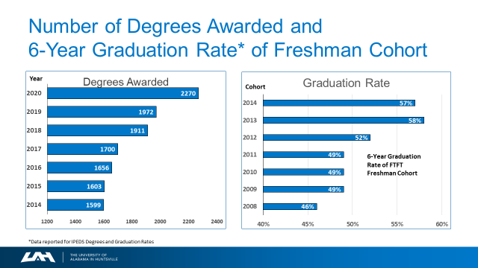

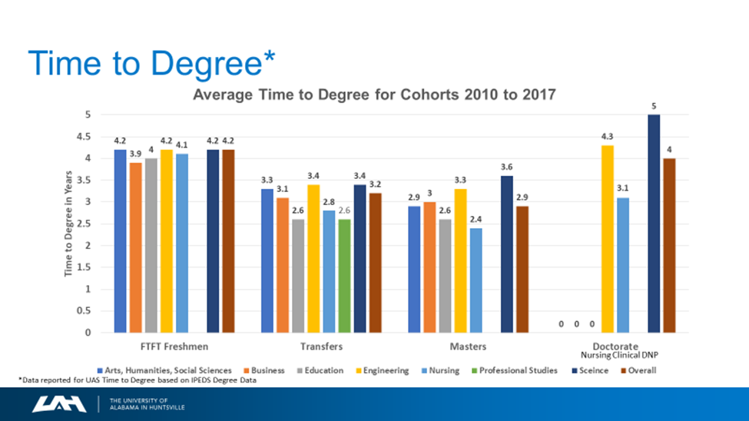

Academic Success Advocacy Program (mid-February 2021)

Purpose
Develop proactive, centrally coordinated effort to identify, track, and intervene using a “cohort-of-student” model

Strategic Goal
Increase student success at UAH as measured by
- Retention rate (Freshman to Sophomore)
- Persistence rates at UAH (Sophomore to Junior and Junior to Senior)
- Graduation rate (6-year)

Key Issues
- While strides have been made in the past 10 years,
  - 6-year graduation rate of 58%/57% still lags behind peers (average >70%)
  - Retention rate is stalled in the 82%-84% range
  - Persistence at UAH is a challenge
  - We lose 12% of Sophomores
  - We lose 9% of Juniors
- State legislature is discussing “Performance Based Funding”
  - Ties state funding to student success measures
- Campus support is largely reactive rather than proactive

Peer and Research Issues
- Most successful peers have an organizational structure focused on student success
  - Leadership dedicated to retention, persistence, and graduation
  - Staff support
  - Data
- Peers are using data to provide early alerts to struggling students and systematic early interventions
- Students often struggle due to a multitude of factors that they cannot navigate on their own
- Academic Recovery Program in SSC has piloted proactive concept

Goal: Identify students at risk and intervene
Support the campus commitment to student success with a structure that has responsibility, authority, and accountability for student success
- Analyze pre-enrollment data
- Utilize real-time data (e.g., Canvas, Banner, etc.)
- Invite referrals from associate deans, faculty, and staff
- Ensure and coordinate interventions
Report on effectiveness

