THE UNIVERSITY OF ALABAMA IN HUNTSVILLE
CHARTER OF UNIVERSITY IT GOVERNANCE FRAMEWORK
-INTERIM-
Number 02.01.39
Division Office of Information Technology (OIT)
Date August 2015
Purpose The purpose of this policy is to establish the charter and framework of University IT Governance.

Policy This policy establishes the charter and framework for The University of Alabama in Huntsville (UAH) IT Governance. Leading universities use IT governance to maximize academic and business value through strategic and sustainable investment, provide for risk management via cybersecurity best practices, policies and procedures, and create dialogue and transparency around IT practices that impact the entire academic, research, and business missions of the university.

Procedure
1.0 General Framework and Definitions
The Provost and Executive Vice President for Academic Affairs and her/his delegate, the Associate Provost/CIO, may, from time to time, create such IT Advisory Councils, Committees, and Task Forces as needed to ensure the effective and efficient use of technology in enabling the enterprise to achieve its strategy and goals within acceptable levels of risk. Advisory Councils are standing (permanent) bodies that represent a cross-section of the entire campus and provide input and advice to the CIO. An Advisory Council may also create either standing or temporary Committees or Task Forces to assist with the research and work of the Advisory Council. Task Forces are temporary bodies usually comprised of experts or specialists, formed for analyzing, investigating, or solving a specific problem.

- Standing Advisory Councils and Committees
The initial UAH standing Advisory Councils and Committees within the UAH IT Governance framework are:
IT Investment Advisory Council
IT Cybersecurity Advisory Council
OIT Change Management Committee

Review The CIO is responsible for the review of this policy every three years (or whenever circumstances require).

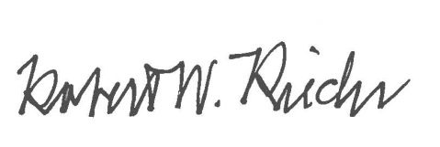
Approval

Chief University Counsel
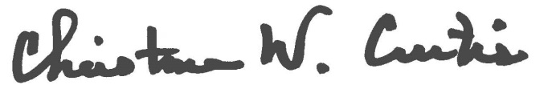

Provost and Executive Vice President for Academic Affairs
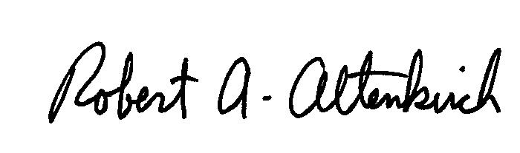
APPROVED:

President

