THE UNIVERSITY OF ALABAMA IN HUNTSVILLE
CHARTER OF UNIVERSITY IT INVESTMENT ADVISORY COUNCIL
-INTERIM-
Number 02.01.38
Division Office of Information Technology (OIT)
Date August 2015
Purpose The purpose of this policy is to establish the framework of university IT Governance.

Policy This policy establishes The University of Alabama in Huntsville (UAH) IT Investment Advisory Council (ITIAC). The purpose of the ITIAC shall be to serve in an advisory capacity to ensure the effective and efficient use of technology in enabling the enterprise to achieve its strategy and goals within acceptable levels of risk. The ITIAC is tasked with ensuring that technology services deliver the highest academic and business value for UAH, and that expected benefits from new investments are fully realized.

The ITIAC shall work to promote better understanding, coordination, and communication within the campus community regarding the selection and deployment of technology solutions, and the prioritization of capital, operating, and human resources needed for sustainability of technology solutions for the benefit and betterment of all.

Procedure In carrying out this role, the ITIAC shall respond to project proposals submitted to it by its own members and committees, the university administration, or university affiliates. Project proposals may take the form of hardware, software, or IT-enabled work requests; software procurement, design, development, integration, or support work requests; or system administration work requests that a) require integration with Banner or UAH’s trusted identity management system; or b) exceed $100,000 in overall procurement costs over a 3-year period; or c) comprise more than 80 hours of total labor from OIT.

- Membership

The ITIAC is chaired by the Associate Provost/Chief Information Officer (CIO) and includes representation from the university population. Members of the ITIAC will be distributed as follows:

- Office of the Provost and Executive Vice President for Academic Affairs (1 member)
- Office of the President (1 member)
- Academic Deans (1 member)
- Faculty Senate (1 member)
- Office of Research and Economic Development (1 member)
- Office of Finance and Administration (1 member)
- Office of University Advancement (1 member)
- Division of Student Affairs (1 member)
- OIT Director of Enterprise Applications (ex-officio)
- OIT Chief Information Security Officer (ex-officio)

The OIT Director of Enterprise Applications, and OIT Chief Information Security Officer will be ex officio, non-voting members of the ITIAC. The CIO will also be an ex officio non-voting member of the ITIAC except in the case of a tied vote. In cases of tied voting, the CIO or her/his designee will cast the tie-breaking vote.

Membership will be reviewed annually, or as needed due to staffing changes.

- Meetings

The ITIAC will meet once each month or at least 10 times annually, at a time and location that is sensitive to work schedules. The CIO will be responsible for scheduling and the agenda for ITIAC meetings; however, floor discussions are always open at the meetings.

Special meetings of the ITIAC shall be called by the CIO in cases where urgent university projects must be addressed before the next regularly scheduled meeting is to occur.

- Committees and Task Forces

The ITIAC is self-regulating with respect to its organization and purpose, and, as such, may create such committees or task forces as deemed necessary to facilitate its work. Committee and task force membership is solicited from the ITIAC. Committees and task forces shall serve as advisory bodies for specific matters falling within their province.

The meeting dates, times, and agenda of the ITIAC will be published on the OIT web site. Project/work request proposals must be submitted, in writing, at least 15 business days in advance of the monthly ITIAC meeting to be considered on the agenda. The ITIAC will consider proposals and prioritize projects to be undertaken by OIT within the footprint of existing resources and best security practices.

Review The IT Investment Advisory Council is responsible for the review of this policy every three years (or whenever circumstances require).

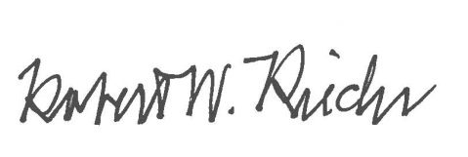
Approval

Chief University Counsel
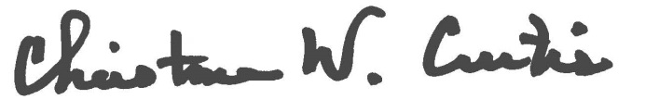

Provost and Executive Vice President for Academic Affairs
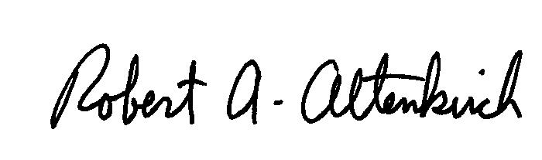
APPROVED:

President

